Art – Silly ‘Selfie’ Portrait

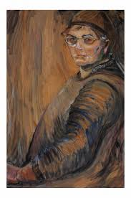
Most self-portraits are quite serious. Look at these ones:
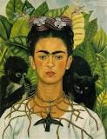
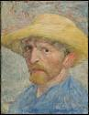

Freida Kahlo Pablo Picasso Vincent Van Gogh Emily Carr
You may have made your own serious self-portrait. Today, you are going to make a silly self-portrait.
Steps:
- You could start by taking a silly selfie. Make your silliest face and take a picture with a phone or a camera. Or you can just look in a mirror while you make a silly face.

- Look at your silly face and draw it.

- Colour it in any way that you want.

- Take a picture and send it to me.

