Art – Create a Robot

You created a simple robot for the coding activity today. Now, you can make a different robot in any way that you want.
You could use recycled items to make robots like these:
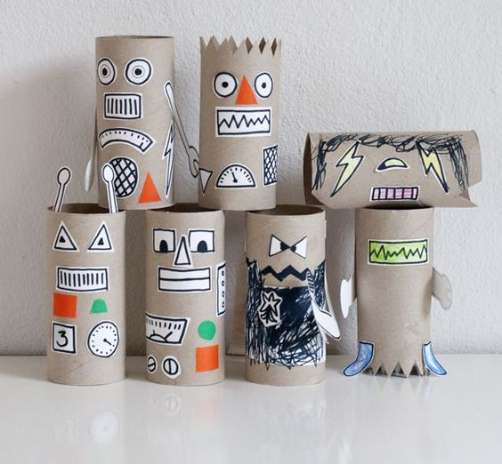
- make buttons, dials, and other parts by drawing them on white paper with a black marker
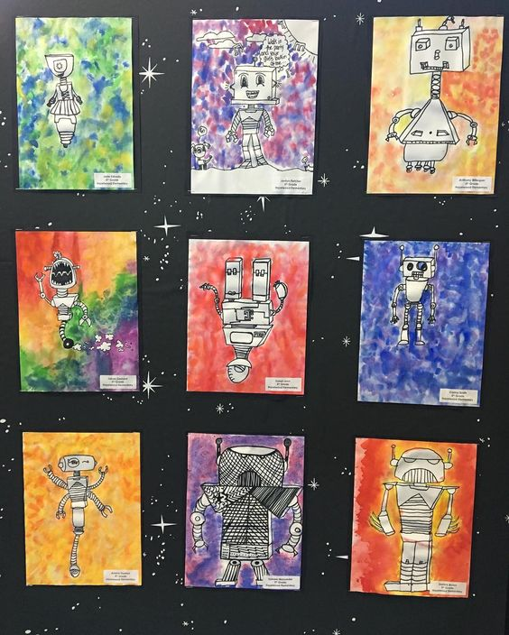
- cut out your drawings and glue them to recycled items

You could draw more detailed robots and give them colourful backgrounds using paint.

There were so many interesting collages last week. You might want to try collage again to make a robot creation.
