Who Would Win Animal Project – Measurement
Note: We will be talking about this activity in our carpet time meeting on Wednesday.
This week, we are going to think about how we can measure our Canadian and African animals. What are some ways that you can measure your animal?
How tall/long is it?
How heavy is it?
How long does it live?
These measurements have names. They are called height/length, weight, and life span.
For those of who have played cardline at school, these are the measurements that are on the back of the cards.
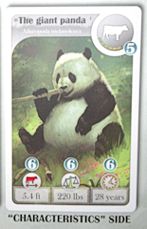
Can you find these measurements for your animal?
Try to find the height/length and weight using the metric system of measurement that we use in Canada. Your measurements will be in centimetres or metres and kilograms.

Once you have found your measurements, you can see Who Would Win for each animal.
You might these measurements in the books that you have found on Ms. Lynka’s library page or you might need some help doing an internet search for these answers.

Measurement | Canadian Animal | African Animal
Height/length
Weight
Lifespan

What else could you measure about your animals?

