Learning Activities for Wednesday, April 8th
Drama
Puppets!
During second term, we worked with puppets during drama and math. Now you are going make your own puppets and scripts at home. What kind of puppet will you make? What materials do you have at home to make a puppet? Here are some ideas that I was thinking about:
- A sock that has no match
- Paper
- Pictures from magazines
- A chopstick or a pencil
- Recycled cardboard
What other materials do you have?
Don’t forget to:
- Give names to your puppet characters
- Try out some different voices for your puppets
- Think about where you can stage your puppet show
Thanks to Theia and her mom for reminding me about the idea of making puppets.

Language Arts
Hopefully, you were able to make a puppet or a few puppets during drama. Now it is time to write the script for your puppets. Remember, writing a puppet show takes time. Today, you will get started. How does your show start? How do the characters meet? Do they introduce themselves? What do they do in the show?
Math
Today’s math activity is a little bit of math and a bit of art and even a bit of mapping. You are going to draw a map of your room. Architects and designers call these maps floor plans. To do this, you need to imagine that you can climb or fly up to your ceiling and look at your room from above just like a bird looks at the earth. What does your room look like from up there, what shapes do you see, what are some of the things that you can’t see?
Alexa has already made one of these floor plans for her room. Here it is:
Alexa also gave us some tips about how to make a floor plan:
1. Always use a ruler (or another straight edge) to draw straight lines
2. Use a pencil in case you make a mistake
3. Do a draft copy to practice
4. A sharp pencil helps
5. Draw where North is on your paper
6. Only draw large furniture, windows, and doors
7. When you are ready, use a black marker and draw over the pencil

Next week, we are going to start thinking about measurement. How could measurement help you to make your floor plan?

Music
Now you are going to head over to Ms. Ishii’s blog for some music time. Check out her blogroll for music games and activities. Explore the games and let me know which one your favourite was.

Physical Education
Before the break, I promised to show you the person who had the Guinness World Record for holding the plank position for the longest time. Take a look at this link to see him. He held a plank for 8 hours and 15 minutes and 15 seconds. Can you believe it? Today, I want you to make your personal record for the plank. Ask someone in your family to time you. Make sure that you are in the right position. Your entire body should be flat like a plank. How long can you hold it? Write down your time today. Try it again tomorrow and see if you can beat that time. Keep a record of your time each day to see if you get better. Now let’s try for another record. How many burpees do you think that you can do in two minutes? Get someone to set a timer for two minutes and count for you. Try this again in a few days and see if you can beat your record.
Do you remember all the steps in a burpee? Here is a picture of what it should look like.
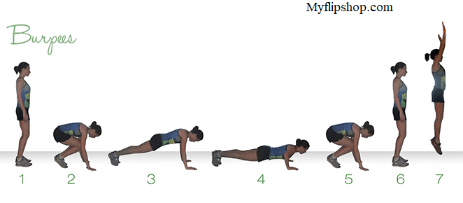
Centres
Alexa and Theia gave us some ideas for today’s activities. Is there something that you are working on at home that you think your friends might like to do? I will be sharing some more ideas from other other students next week. Let me know if you would like to share one of your activities.

