Learning Activities for Monday, April 6th
Art
Today, I want you to try drawing an animal using step-by-step instructions. You could start by trying to draw some rabbits. If you don’t have markers or crayons at home, don’t worry about colouring the rabbits just focus on the drawing. You could make your own background for the rabbits. Do your rabbits have names? Later this week, you could write a story about your rabbits.
Here is a link to the instructions for drawing the rabbits.
If you don’t feel like drawing rabbits today, you could try drawing one of these other animals:
Alligator
Cheetah
Otters

Math
This week, you are going to practice subtraction.
You can start by writing down the tens partner subtractions.
Here are some examples:
10 – 2 = 8 10 – 5 = 5
Now write down the other ones. Can you remember all of them? Remember, the biggest number always goes first, so they will all start with 10.
Now that you have warmed up with 10. Let’s start working with 20. You are going to use counters for this. Since you probably don’t have counters in your house, I want you to find a collection of 20 items in your house that are the same. We tried this in the classroom once, but you had to collect 100 items. Today, you only need to collect 20. What could you collect: coins, lego blocks, rocks, buttons, crayons? Let me know what you choose. Now, you need a piece of paper to make a splat. A thicker piece of paper will be better so that it is not too easy to see through. Cut out your splat. It will look something like this.

Using your collection of 20 items and your splat, make a subtraction sentence using 20. Make sure to use all 20 items by spreading them out on a table or floor and splat some of them.
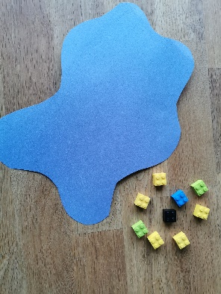
Here is what mine looks like.
I started with 20 blocks. I put the splat over some of the blocks. How many are not under the splat?
I count 9 blocks.
So how many must be under the splat?
20 – 9 = 11

Let’s check.
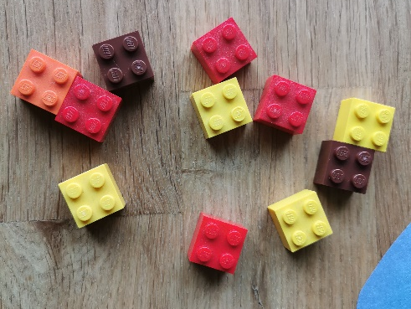
Do you count 11? I do.
Now, try it on your own. How many can you do?

If you want to practice some subtraction on-line, here is a good game to try. https://www.mathplayground.com/puzzle_pics_subtraction_facts_to_20.html

Language Arts
On Mondays, we usually switch our class jobs. Now that you are at home, you don’t need someone to take attendance or to be the line leader but there are still many jobs to do around the house. Make a list of the jobs that you can do to help around the house. Do you clean up your toys, help set the table, make your bed? What other jobs could you add to your list? What is your favourite job around the house? What job do you not like to do? Your writing activity today is to write about jobs that you can do in your house.
Here is an example of how it might look:
At my house, I help my family by:
- ___________________________________________________
- ___________________________________________________
- ___________________________________________________
I could also start helping by:
- ___________________________________________________
- ___________________________________________________
- ___________________________________________________
My favourite job is: ___________________________.
I really don’t like to ___________________________.
Quiet reading – take some time to read by yourself or read a book with a family member. You could also read along with on of the literacy resources on the district website.
Physical Education
Practice your plank and your v-sits today. We are going to start a plank challenge later in the week. Stay tuned.
Centres
You might want to start collecting items (toilet paper rolls, tissue boxes etc) to make your own make-it station at home.

