Fitness Friday – Cardio Cards
For today’s workout, you will need a deck of cards. Start by removing the face cards from the deck. You will need to pick 4 different excercises. Here are some that you might want to try:
- Burpees
- Sit-ups
- Push-ups
- Jumping jacks
- Squats
- Star jumps (jump up and make a star in the air)
- Tuck jumps (jump up and tuck your knees as high as you can in front of your body)
Pick 4 excercises that use different parts of the body. Each exercise will be matched to a suit from the deck of cards.
Her is my example. You can choose to use different exercises.
Clubs = Jumping Jacks
Hearts = Burpees
Diamonds = Squats
Spades = Tuck Jumps
Shuffle your deck of cards and deal yourself 10 cards. Put the cards in a pile in front of you. Turn over the first card. The suit tells you which exercise to do and the number tells you how many times to do it.
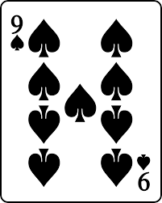
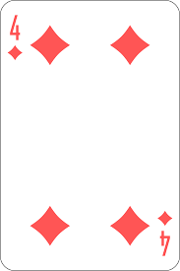
When you turn over this card, you will do 9 tuck jumps.
When you turn over this card, you will do 4 squats.

Can you do all 10 cards without getting too tired? If you finish the 10 cards and you still have energy, pick 5 more cards.

