Math – Splat Style
Find Some counters in your house. You can choose how many counters to use today for Splat math. You can choose 9, 19, or 29. Your counters could be coins, lego blocks, rocks, buttons, crayons? If you have your splat from the last time, go get it or make another one. It should look like a big puddle.
Using your collection of items and your splat, make a subtraction sentence. Make sure to use all your items by spreading them out on a table or floor and splat some of them.
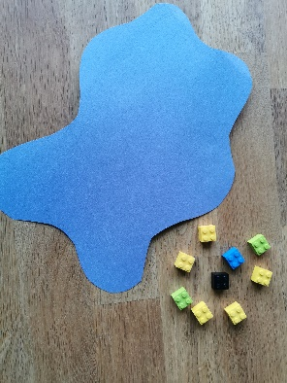
Here is what mine looked like
I started with 20 blocks. I put the splat over some of the blocks. How many are not under the splat?
I count 9 blocks.
So how many must be under the splat?
20 – 9 = 11

Let’s check.
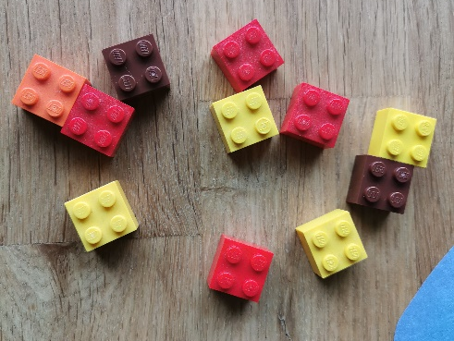
Do you count 11? I do.
Now, try it on your own. How many can you do?
Try to do at least 9 splat subtraction sentences.

