Math – Measuring the Old Fashioned Way
To start today’s math lesson, you are going to visit this site Tumble Math. https://www.tumblemath.com/
This site is like Tumblewood books except that all of the books on this site have a math theme.
To login, you will need to use this:
Login: confedpark
Password: login

Today, I want you to read or listen to the book named, The Royal Treasure Measure by Trudy Harris.
What did Arzo use as his unit of measurement in the book?
You are going to use the same unit to measure things in your house. Please measure from one place to another using your feet. How far is it from:
Your front door to your refrigerator
Your bed to the bathroom door
Your bed to the couch
Pick another distance to measure inside or outside your house.
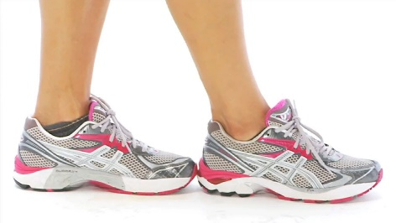
Remember when you measure with your feet, you need to make sure that you are walking heel to toe, heel to toe. It should look like this. Try estimating how steps it will take before you measure.

