Math – A Measurement Challenge
Goal: To make the longest paper chain possible with one piece of paper.
Materials:
- 1 piece of paper
- Scissors
- Tape or stapler or glue
Activity:
- Cut up the paper and make a chain by taping, stapling, or gluing links together
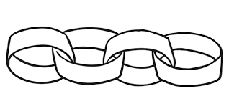
- Use all of your piece of paper
- Try to make the longest chain possible

Can you make a chain that is taller than you are?
Do you think that you could make an even longer chain, try it with another piece of paper?
If you have a ruler or a tape measure, try measuring your chain in centimetres.

