Write and Tell – Full Week Activity*

Write and Tell is like Show and Tell except that you will write about the object first and then present it. Some of you may want to present it in a video meeting with the class but if not, you may just want to try presenting it to your family. Here is what you need to do:
- Pick something that is special for you – it can be anything you choose (toy, souvenir, ribbon/medal from a sporting activity, collection …)
- Make a planning web to think of as many ideas as you can about your object
- Think about what you want people to know about your object (questions to help you are listed below)
- Write about your object
- Make a picture of your object
- Practice presenting your Write and Tell to a family member
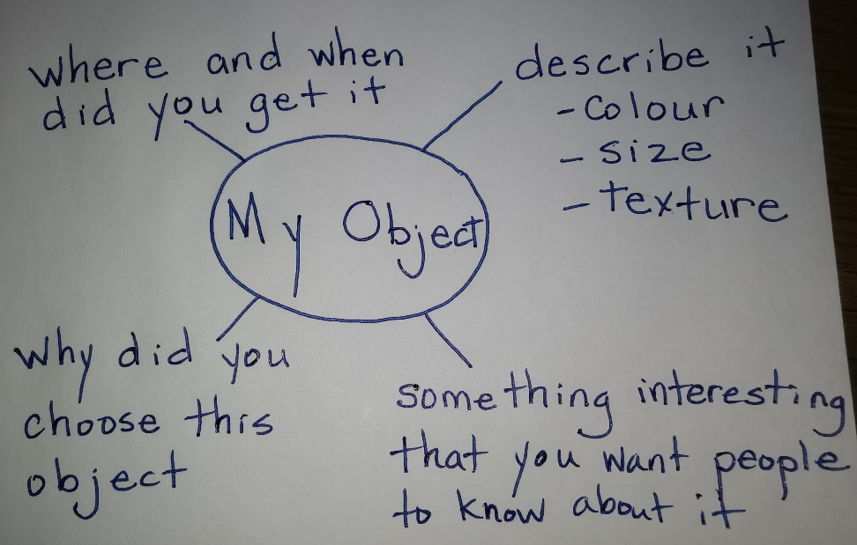
Remember, a planning web looks like this:

When you are writing about your object, you may want to use one or more of these sentence starters in your writing:

I like my object because . . .

I chose this object because . . .

The best thing about my object is . . .

The important thing that you need to know about my
object is . . .

My object is special because . . .

*Family members – this activity would typically be spread out over the week at school.
Day 1 - Pick the object and make a planning web.
Day 2 and 3 – Complete the writing.
Day 4 – Make a picture of the object
Day 5 – Practice presenting in front of a mirror, a stuffy, a family member, or video and watch it themselves.

