Hearts in the Window
Have you noticed hearts in the windows in your neighbourhood? Have you already put heart or a positive message in your window at home? Today, during centres you may want to do this. Make a heart or many hearts. Remember, how to fold the page to make a heart like we did at Valentine’s.

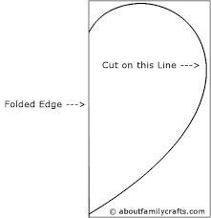

Decorate your heart and write a message of kindness on it to brighten someone’s day. Maybe, you could a write a thank you to someone in your neighbourhood who is a community helper on their way to work.

