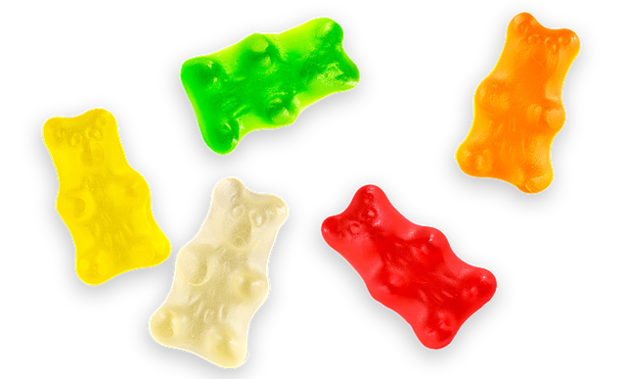



[This Photo](http://talk.maemo.org/showthread.php?p=1363393) by Unknown Author is licensed under [CC BY-SA](https://creativecommons.org/licenses/by-sa/3.0/)

25  5

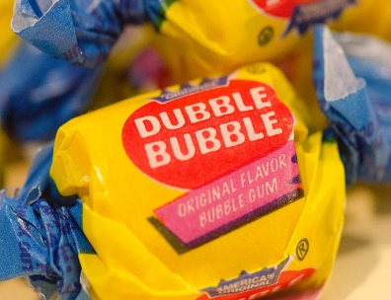

[This Photo](https://www.flickr.com/photos/jaygee311/5864065007/) by Unknown Author is licensed under [CC BY-SA](https://creativecommons.org/licenses/by-sa/3.0/)

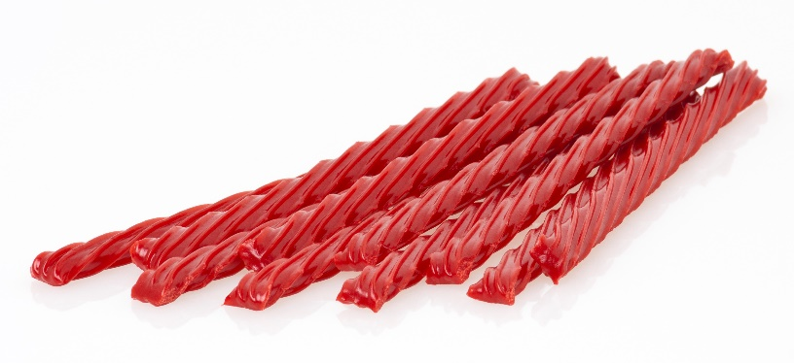

5 15

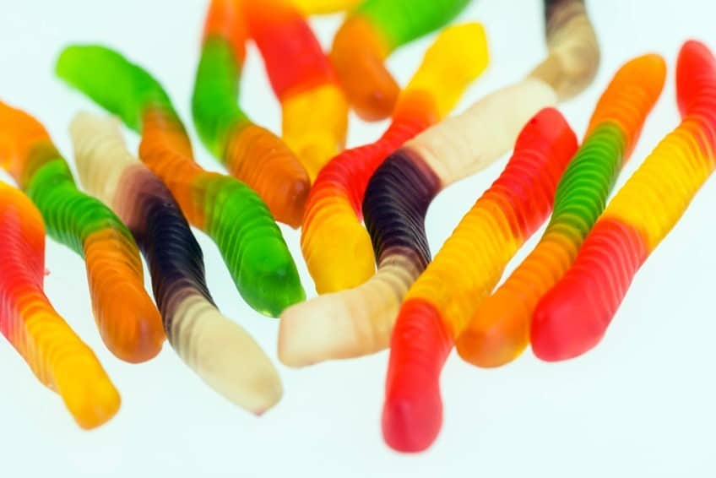

[This Photo](https://ministry-to-children.com/gummy-worm-object-lessons/) by Unknown Author is licensed under [CC BY-SA](https://creativecommons.org/licenses/by-sa/3.0/)

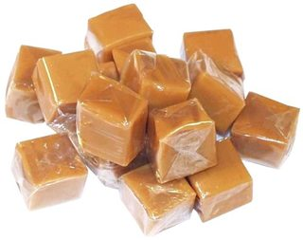

10 50 