Music Time!
Here is a really fun website for you to check out, called Chrome Music Lab.
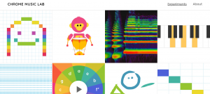
The Chrome Music Lab has 13 different experiments with unique ways to play, create, and visualize sound and music. Can you figure out how each experiment works? What kinds of creative patterns and sounds can you make? Can you write your own song (or re-create one you already know)? Try some of them out!
Now let’s look at the first experiment called Song Maker.
Choose an instrument and create a melody. Use low notes and high notes, and play it back so you can hear what you composed. Don’t forget to click SAVE if you don’t want to lose your song!

