Music Activities

-Choose one activity this week!
-Do the response. Take a picture or video and send to your Teacher if you can.
 | Listening | Singing  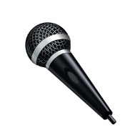 | Learning | Creating  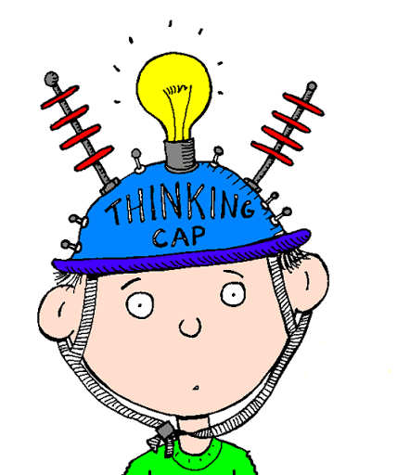
 | Ballet of the Unhatched Chick! It’s Spring!  https://www.youtube.com/watch?v=8cJSbWtTia4 | This Pretty Planet – Earth Day is on April 22!  https://www.youtube.com/watch?v=t7h8nGfodoI | Echo these patterns! Can you remember which one is Ta and Ti Ti?  https://musicplayonline.com/rhythm-practice-new/ | Watch this video for ideas of instruments to make to use at home  https://www.youtube.com/watch?v=7sUNXA4NYKI
Response  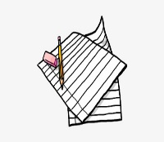 | Draw what the music made you think or write how the music made you feel. | Draw a picture of you singing your song or write what you like about the song and/or how it made you feel. | Take a video of you echoing the pattern. | Take a picture of what you made!

