Science 8 Course Outline | 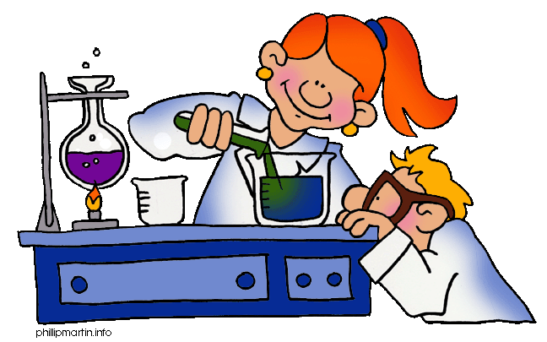
Ms. Lam (Day 2: Rm 311-AM, Rm 327-PM)
Email: jenny.lam@sd41.bc.ca
Homework Website: http://blogs.sd41.bc.ca/lamj

TEXT: BC Science 8 (McGraw-Hill Ryerson $60 if lost) A digital “pdf” version is available – bring your USB if you would like a copy or use the link on the blog to access Google Docs.

EQUIPMENT & MATERIALS:
- 3-ring binder with dividers
- 8.5” x 11” lined paper
- Scientific Calculator
- Writing materials (blue/black pen, pencil, eraser, ruler, white-out, highlighters)

ATTENDANCE:
You are expected to arrive to all classes on time and ready to work. Absences must be excused by your parent/guardian calling the office, emailing the teacher, or by bringing a written note to class the next day detailing the date and reason. Also have parents contact me if you know you must be away for a future date. Check the website for missed work!

EVALUATION:
You will be evaluated on homework, projects, lab reports, in-class assignments, quizzes, tests.
40% Tests/Quizzes
60% Labs/Assignments
Term and Final marks are cumulative – meaning they add up throughout the entire year and each term’s marks will continue from the previous one.

EXPECTATIONS:
- Bring all materials/books, and a good attitude!
- Ask questions if you are curious about the topic or need help.
- Work to be handed is due at the START of class. Late work may not be accepted.
- RESPECT the equipment, the classroom, the school, your books, yourself, and others.
- Keep notebook and handouts organized in chronological order!!!!!
WORK HABITS:
Start the year right! To be successful in Science 8, strive for good work habits!
Good | Satisfactory | Needs Improvement
- On time for class, with all materials  - Actively involved in learning; asks Qs, participates respectfully, works well with all students & in groups, shows initiative  - Completes all work to the best of ability  - Uses class time wisely  - Responsible use of equipment & clean up  - Uses personal technologies responsibly | - Usually on time for class, with materials  - Usually actively involved in class, participates respectfully, works w/others  - Completes most work to the best of ability  - Usually uses class time wisely  - Usually uses equipment appropriately  - Sometimes needs reminders to use personal technologies responsibly | - Often late for class, missing materials / in excused absences  - Needs support to become involved in class activities/participate/ to work with others  - Work is incomplete, lacks effort or copied  - Struggles to use class time wisely  - Often inappropriate use of equipment  - Personal technologies interfere with learning

THE SCIENCE 8 CURRICULUM:
Science 8 will focus on teaching students both curricular competencies and content.
SCIENCE CONTENT – BIG IDEAS | CURRICULAR COMPETENCIES IN SCIENCE (SKILLS)
1. Life processes are performed at the cellular level  - characteristics of life  - cell theory and types of cells  - photosynthesis and cellular respiration  - the relationship of micro-organisms with living things  - basic functions of the immune system  - vaccination and antibiotics  - impacts of epidemics and pandemics on human populations  2. The behaviour of matter can be explained by the kinetic molecular theory and atomic theory  - kinetic molecular theory  - atomic theory and models  - protons, neutrons, and quarks  - electrons and leptons  3. Energy can be transferred as both a particle and a wave  - types and effects of electromagnetic radiation  - light:  - properties  - behaviours  - ways of sensing  4. The theory of plate tectonics is the unifying theory that explains Earth’s geological processes  - plate tectonic movement  - major geological events of local significance  - First Peoples knowledge of:  - local geological formations  - significant local geological events  - layers of Earth | - Questioning and Predicting  - Planning and Conducting  - Processing and Analyzing Data and Information  - Evaluating  - Applying and Innovating  - Communicating  *Lab Safety  *Scientific Method & Literacy  *Making Measurements
  CORE COMPETENCES (IN ALL LEARNING)
  
  Communication
  
  
  Thinking
  Personal & Social

