- Labelling how you're feeling
I found this article comforting and some good practical practices
https://hbr.org/2020/03/that-discomfort-youre-feeling-is-grief
That Discomfort You’re Feeling Is Grief
Let’s go back to anticipatory grief. Unhealthy anticipatory grief is really anxiety, and that’s the feeling you’re talking about. Our mind begins to show us images.
hbr.org

2. Look After Your Well-being By Finding Balance (this was what was attached, but I found the below most helpful which was is on page 6)

With the current health situation many of our normal routines and daily activities are changing. Naturally this can be unsettling, and we can and that the things we usually did to look after our well-being have become difficult. Whether you are working from home, or in some form of physical isolation or distancing, it can be helpful to organise a daily routine that involves a balance between activities that:

• give you a sense of achievement,
• help you feel close and connected with others and
• activities that you can do just for pleasure. Pleasure Achievement Closeness / Connection Wellbeing

We are social animals so we need and naturally crave closeness and connection with other people. With the current health crisis many of us may be physically isolated or distant from others, so it’s important that we consider creative ways to connect in order that we don’t become socially isolated and lonely. How can you continue to connect with family and friends and have social time in a virtual way? Perhaps using social media, phone and video calls you could set up shared online activities e.g. a virtual book or film club. You could also explore local online neighbourhood groups, and see if there are ways to be involved in helping your local community.

An imbalance of pleasure, achievement, and closeness can affect our mood. For example if you spend most of your time working with no time for pleasure or socialising then you may start to feel low and isolated. Conversely, if you spend most of your time relaxing for pleasure and not doing other things that are important to you then this can also impact your mood. At the end of each day could you check in with yourself and reflect on ‘what did I do today that gave me a sense of achievement? Pleasure? Closeness with others?’ Did I get a good balance, or what can I do differently tomorrow?

3. HOW TO TALK TO YOUR KIDS ABOUT THE CORONVIRUS
a. Here's a short video by Lisa Dion (Founder, President, Lead Instructor of Synergetic Play Therapy) about considerations for parents in how they talk to their kids about the Covid-19. Potential relevance for educators and counsellors as well.
https://vimeo.com/397701387?utm_source=Synergetic+Play+Therapy+Community+Conversations&utm_campaign=3190142e51-EMAIL_CAMPAIGN_2020_01_13_12_47_COPY_01&utm_medium=email&utm_term=0_c2693e8f08-3190142e51-269964845&mc_cid=3190142e51&mc_eid=3cc2f71cd8

b. A New York Times article crediting pediatricians and clinical psychologists
https://www.nytimes.com/2020/03/17/parenting/coronavirus-kids-talk.html?ct=t(COMPLEX_TRAUMA_RESOURCES_CTR_WEEKLY_INSP6_14_2017_)&mc_cid=1007bf6daa&mc_eid=8d14cd8528
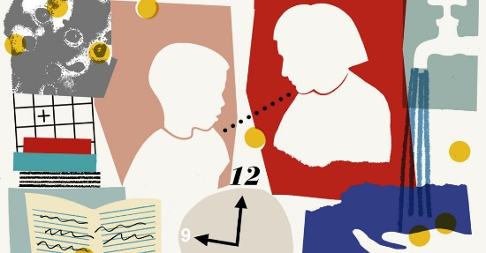 | How to Talk to Kids About Coronavirus  Keeping your own anxiety in check is key.  www.nytimes.com

4. https://www.secondstep.org/covid19support

COVID-19 Support
We know this is a stressful time for students, families, and educators. Concerns about the spread of COVID-19 are growing. Here, we’ve compiled a list of resources you can use to help young people learn the social-emotional skills they need to get through these challenging events.
Take care, Tina Camara

***You have previously provided consent for the school to send you electronic information related to your child’s educational experience. To unsubscribe please contact the school office at 604-296-9005.***

