Unit Four: Exploration and World Power

Overview
Introduction
Perhaps one of the most revolutionary periods In History, the Renaissance brought advancement in art, architecture, science, mathematics and the Printing Press. With society booming better than it ever had before, the Church got unprecedented power. This Church would abuse this power until Martin Luther stands up for his fellow citizens.
Key Questions
- Is sacrifice necessary for the success of an empire?
- How did Modernization in weaponry cause a collapse in the Aztec empire?
- Identify and explain the significance of the Song Dynasty
- Which dynasty progressed Chinese society the most?
- Is Africa’s weather patterns its biggest obstacle in maintaining a powerful empire?
- Why was Africa such a critical trading partner for Europe, Asia and Islam?

Lesson 1 - Voyages and Exploration
Exploration Begins
Spices, silk, oils and gold were becoming massively popular items in Europe and the only place to get them from as Asia. Until navigation improved, all expeditions into Asia had to be done on land.
Constantinople, which was a part of the Byzantine Empire fell to the Turkish army. Since it was under Roman control, this forced Asia to halt all trading with anyone un Europe. Venice, Florence and Genoa took major hits because majority of their items came through their ports and eventually to its main city. This was a dream come true for England, Spain, France and Portugal because they saw an opportunity. If they could establish trade routes overseas with Asia, they could effectively take away Italy’s main trading channel. If they were the only places receiving these items, they could also overcharge. Europe desperately needed gold and silver because that was used to produce all of their coins and when the mines were running out of both of those products, the demand only increased.
Technology Improves
In order for trading to work with Asia, ships had to be improved. Europe came up with two different ways to make that happen.
- Make all ships easier to handle this would be called the caravel
- All navigation instruments used for voyages had to be on the ship
Caravels had lateen sails (triangular sails on a mast). These ships were large so that a lot of cargo could be place onto the ship without any issues. Additionally, navigators started to learn more about how the winds blew and build their ships around that premise.
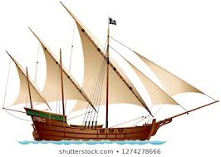
Image 1: This is a caravel. By having more sails and shaping them into a triangle, the speed and control were far more efficient than they previously had been.
Voyageurs still had limited knowledge of the open seas. Therefore, they sailed with land in sight and tracked everything that was seen. This was done so that the next series of voyageurs would know which direction to travel. Prince Henry of Portugal sponsored many voyages and created a school primarily for cartographers (someone who makes maps), mathematics, sailors, navigators and astronomers.

These instruments for navigation improved greatly. They had an Astrolabe, compass, Cross-staff (used to measure the altitude of the Sun so that latitude could be determined) and the back-staff (used to measure the altitude of the sun/moon so that latitude could be determined). Note that with the cross-staff, you are going towards the Sun and the back-staff away from the Sun.
Where is Everyone Going?
Everyone on ships really had to rely on their captain as they were typically the only ones on the ship who could read maps and use the instruments. With each voyage being long, not all sailors would survive the expedition. Scurvy (a fatal lack of vitamin C, usually brought on by a poor diet) would kill many sailors and often a mutiny would occur.
Portugal was not a powerful country, nor did they have the wealth to sustain themselves comfortably. However, their location meant everything as they were right along the west coast (bordering the Atlantic Ocean).
Bartolomeu Dias became the first European to sail around the southern tip of Africa. He wanted to sail around the Indian Ocean, but his sailors refused due to it being a dangerous journey. Vasco de Gama would then try to explore the sea route to Africa. He was a ruthless solider who did not take orders from his sailors. De Gama sailed into the Indian Ocean and received help from the Arabs so that he could reach India. De Gama set up trading ports everywhere he went and now Portugal was on the rise.
Henry VII had given John Cabot permission to sail west and north as a way to find new territories. He was given the letters of patent (an official document giving someone King like powers to do something). These letters enabled Cabot to take any new territory he saw, regardless of who may be living there. Cabot reached eastern Canada, set up a colony and returned to tell the King what he found. The King then sent sailors through Northern Canada hoping to find a passage directly into Asia. Though the route to Asia would not be found, they did make alliances with the Inuit peoples already living there.
Jacques Cartier made three voyages across the Atlantic into Canada. He setup the St. Lawrence River colony in the name of France. Though a few decades behind, the Dutch would also reach their destinations. They would find Asia and begin a trading industry with them. Led by Oliver van Noort, he formed the Dutch East India Company and dominated the spice industry.
King Ferdinand of Spain was eager to get into the spice business with Asia. He sponsored Christopher Columbus who claimed he could get to Asia. Columbus went in the wrong direction and found the Caribbean. He would work with the Arawak people’s and trade with them.
Ferdinand Magellan was an experienced sailor who had often went into Asia (specifically the Philippines). The Spanish wanted access into this area, but the Treaty of Tordesillas (an agreement to separate Portuguese and Spanish areas) prevented them from doing so. Magellan was tasked with reaching Asia via the Americas route. He was given five old ships to sail around the world. Despite frequent storms, Magellan made it to Asia. He was killed in a war shortly after. Sebastian Cano (who commanded one of the five ships), was able to completely go around the entire world.

Lesson 2 - The Aztec Empire
Land Influences the Aztecs
When Columbus arrived in the Caribbean he was greeted by the indigenous peoples (original inhabitants of a land and their descendants). This would eventually lead to the European Colonization (settling and establishing control over the Indigenous peoples).
The Aztecs (who originated from northern Mexico) built a vast city on a swampy island. This would attract the attention of many as time progressed. This was inspired by their God Huitzilopochtli. The land in which their God wanted a city built was not exactly ideal. However, this society was religious and would do everything in their power to make it work. Their big city would be called Tenochtitlan.
The mountains that surrounded their city protected the Aztecs from invaders. However, this blessing also led to a major repercussion. The mountains would often have water flowing down into the city which would lead to dangerous floods. Eventually, the empire created a dam that would solve this issue from causing further devastation.
Being around a lake often made travel difficult. The Aztecs would engineer many bridges and causeways (a track across wet ground). This empire of just a few thousand would expand into several hundreds of thousands of people in just 200 years.
The Aztecs had tremendous farming experience and even created the idea of chinampas (floating islands on a shallow lake bed that were perfect for farming purposes). They would make rectangular lake beds and drive them into the ground. They would pile soil on top and mix it with mud. This process would be repeated until it floated above water.
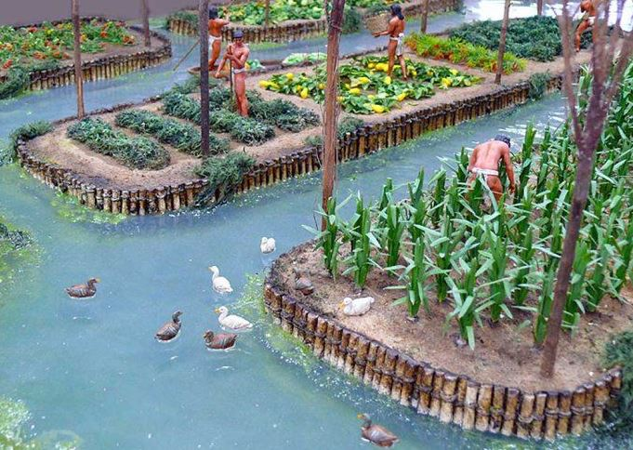
Image 2: The Chinampa helped the Aztec empire grow in the agricultural industry. Most farmers had to access their farms via canoe.
Sacred Aztecs
The Aztecs believed their Gods lived in the skies and valued mountains tremendously. In order to practice their faith, they built hundreds of temples across each city as a way for priests to conduct rituals. The Aztecs believed in the idea of human sacrifice. Specifically, this means that their Gods needed “nourishment” and the only way to receive that was through human blood. This meant that in a war, they could “feed” their Gods their enemies’ blood. This is why the Aztecs fought often.
Social Pyramid
Women did have quite a high amount of power in the Aztec empire. They could own businesses, inherit goods and own property. They were often weavers, which was a highly respected position in society (cloth was very valuable. Cloth could be traded, sold and used to pay taxes. Regardless of social status, women could weave clothes for their families without worry that an upper-class citizen will steal your resources. Elderly women had to be respected and their children often learned how to cook, weave and sing for religious ceremonies.
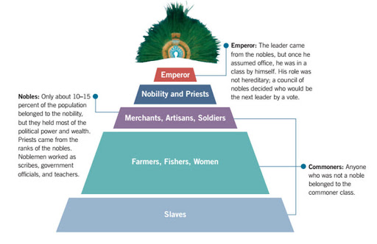
Image 3: This is how the Aztec empire was organized. Their pyramid different quite significantly from their European counterparts.
Aztec society was organized into units called a Calpolli. Most Calpollis were built on which occupation you had during this time. Another common calpolli would be family based. Everyone had to contribute in society by paying taxes. However, you were permitted to hunt, fish and gather as much food as you could. This could be consumed by you or sold in their open markets. Society had high respect for slaves because they felt it was more situational than anything else. Therefore, laws were created to protect them from abuse, murder or neglect. Children of slaves were given automatic freedom.
Society took their military duties very seriously. In order to be an Aztec warrior you must be prepared to sacrifice yourself for the good of the empire. The Aztec empire had five critical virtues each citizen had to follow:
- Courage
  - No complaining was tolerated when serving the military
- Self-Sacrifice
  - Possessions, comfort and life itself had to be sacrificed if it meant progressing society
- Modesty
  - No boasting about personal achievements was allowed
- Clean Living
  - No over-eating and society had to remain healthy
- Obedience
  - Social order had to be respected (both ways) disrespecting a Noble was a serious offense
Lesson 3 – The Spanish vs. The Aztecs
Cortes Invades the Aztecs
A Spanish conquistador (Spanish ruler who is focused on conquest) named Hernan Cortes is focused on expanding his wealth. In order to expand his fortune, Cortes visited the Caribbean. Despite coming in somewhat hostile, the locals offered Cortes a large piece of land to farm. However, the value was not in the land he received, but rather information. Cortes learned that a society in the west coast was quite advanced. Cortes then put together 11 ships, 500+ soldiers, 100 sailors and over 200 indigenous peoples and decided to pay the Aztecs a visit.
Cortes was on his way into the Aztec empire when he accidentally ran into the Tabascans (a group of indigenous peoples). Cortes emerged with a decisive victory and left them with food, clothing, gold and some slaves. Cortes would take a young woman named Malinche whom could speak both of the Aztecs languages. She learned how to speak Spanish as well. As Cortes continued on his march towards the Aztecs, he found various groups of peoples willing to support his cause.
Battle of Tenochtitlan
The Aztecs were thrilled the Spanish had come for a visit. They gave them places to stay, took them to places of worship and showed the Spanish their vast wealth. The Spanish were thrilled because the rumors were true. The Spanish took the Aztec king as prisoner and were met with a stern reaction. The Aztecs destroyed them in combat, but Cortes managed to escape. Cortes returned a few months later for a second battle. However, the Aztecs had their population decimated by smallpox (a fatal, contagious disease). With the population decimated, the Spanish easily won the second battle. They decided to destroy the entire city built by the Aztecs and Cortes colonized the land in the name of Spain.
Weaponry was also a huge issue for the Aztecs here. The Spanish had crossbows, swords and horses. The Aztecs had never even seen horses until this point, and they were not prepared for this kind of mobility. See the chart below for a comparison of Aztec versus Spanish weaponry.
Comparison of Aztec and Spanish Weaponry
Aztec Weapons | Spanish Weapons
War Club  - Made out of wood and could cut like a knife broke on impact with Spanish armor  - Required both hands to wield | Sword  - Made out of steel and were very sharp  - One meter long, light and could be used with just one arm. Meant to have both slashing and stabbing effects
Wooden Spear  - Very sharp and meant for close combat | Halberd  - This two-meter long spear/axe also had a hook. It was devastating from all angles.
Spear Thrower  - Almost like a crossbow, this device could throw spears great distances.  - They did have bows | Crossbow  - Wooden arrow was shot so forcefully it would penetrate all armor.

Spanish Conquest
Three years after the Spanish conquest of the Aztecs, a group of Franciscans arrived and converted many of the survivors into Christianity. The Franciscans then educated their children to read, write and pray. The missionaries also burned almost everything the Aztecs had. There are a few surviving books that managed to escape.
The Spanish were given a piece of land to farm and they received Aztec settlers to help in this regard. However, the Spanish abused the Aztecs and did so in such a bad manner, the King had to create a law to prevent these indecencies from happening. However, due to it being located far away, the King’s law had no effect. The Spanish further abused their power when they created Gold and Silver mines. They forced the Indigenous peoples to work in horrible conditions. Many committed suicide due to the nature of these plantations.
The Spanish had such a negative effect on the Americas that all of the following happened.
- 3.5 million Aztecs died of Smallpox (disease brought in by Spain)
- Indigenous population went from 25 million to 5 million in just under 80 years
- In 100 years the population reached a mere one million
The wealth obtained from the Aztecs helped Spain grow into an even more powerful empire. Most of this wealth went into the hands of the Nobles, rather than all of Spain’s citizens. This also caused the price of goods to increase (which again only serves the rich). The Europeans did gain foods such as corn, potatoes, pumpkins and chilies which acted as the main sources of food for a long time.
Discontent in the Spanish Colonies
In order to fund the King of Spain’s constant wars, many resources from the Americas had to be shipped. The colony in the Americas, New Spain, was now struggling to make ends meet. They had shipped gold, silver and majority of their food to support their true King. This made New Spain unable to make roads, schools and afford proper housing. With tensions rising, Mexico would gain their separation from Spain in the 19th century.

Lesson 4 – The Song Dynasty
The Song Dynasty Begins
The Song Dynasty (960 CE – 1279 CE) spent a ton of money into the arts, science and technology. Their generosity would eventually lead to a renaissance in China. Their first emperor was a man named Taizu who reunited China from a collection of city-states into one unified country. Taizu built a powerful army to prevent any foreign invaders from trying to attack. Their biggest adversary, the Mongols, would occasionally attack, but would be largely unsuccessful during the Song Dynasty.
Three factors contributed to why the Song Dynasty was so successful.
- The economy was growing with government support
- New farming techniques and the introduction of Champa Rice (grows rapidly)
- Well-organized government
The Song Dynasty Government
Taizu concluded that if you tax the citizens too heavily, they will dive right into poverty. Therefore, Taizu used his authority and influence to convince his government officials to be kinder to the citizens needs. Taizu divided China into Provinces and appointed each with a governor. He created a system where the governor could be overruled by the central government (that way nobody abuses their power).
Each governor had to be literate, intelligent and kind. They were tested in many areas such as literature, history and poetry. The most powerful body of government was the Council of State (a group of individuals who would make key decisions for the country). The Council of State could not be overruled and had to listen to citizens from all social classes.

Lesson 5 – Song Dynasty Art
Painting and Calligraphy
Chinese art was on the rise during this dynasty as many items were made of porcelain (delicate type of ceramic) and carvings were made out of Jade (a semiprecious stone).
Chinese writing is made up of characters rather than letters. Calligraphy becomes important because traditionally most people used certain brush strokes. This also helped develop everyone’s skills in painting. Calligraphy gave everyone the ability to make large/powerful strokes or the chance to print in fine detail. The ink was made of charcoal so that all lettering could be dark.
Painting people realistically and nature were two of the most common types of paintings during this time period. A poem written in calligraphy was typically on each painting because it could express further emotion.
Theatre
Theatre was widely practice well before the Song Dynasty began. Thousands would gather and listen to these storytellers on a daily basis. Despite a low social status, actors were expected to educate their children on how to tell a story so that traditions could continue. Theatre was centered around acting, singing, reciting and dancing. Plays were often focused on love or historical events. Actos would usually have on masks, makeup and act in front of a large crowd (typically thousands).
Architecture
Most buildings in China were constructed out of wood; which did not hold up well over time. However, most buildings followed the same design, so the ideas lived on forever. Wealthier homes would typically have their roofs made up of ceramic and all roofs were curved to avoid any damage caused by the rain.
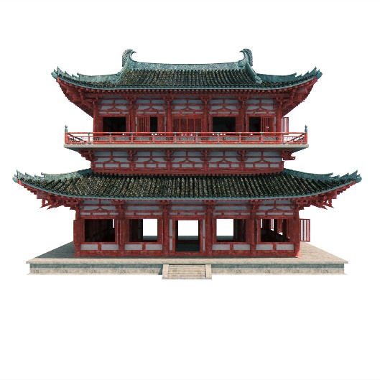
Image 4: This building has a timber frame with wooden pillars to support the roof. This was the common design during this architectural period.

The Decline
China became a wealthy society under the Song dynasty which accidentally generated too much negative attention. The Song were able to defend their country for a long time, but a bit of corruption in the government made it vulnerable. As a result of this, famine occurred, peasants began revolting and the Mongols kept attacking. The Mongols were highly successful in the 13th century at defeating China that they even captured and tortured their emperor.
Though the Song dynasty would ultimately survive for another 150 years, the damage had already been done in a number of ways.
- The economy was weakened, and higher taxes were requested
- The best generals had perished
- The Mongols kept attacking and weakening the empire
- The government remained corrupt

Lesson 6 – Foreign Rule and China’s Comeback
The Mongols
The Mongols lived north of China. The Mongols were never much of a threat because they were divided into multiple territories and were never united. However, a man named Genghis Khan took control of the empire and united all of the territories. His grandson, Kublai, inherited an empire that was finally ready to conquer China once and for all.
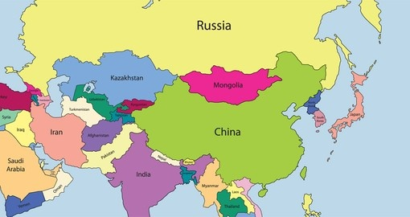
Image 5: Mongolia being located directly north of China posed a massive problem. This was the only area in China that was not protected by mountains, jungles or dessert.
Khan decided to use river fleets as opposed to horses because of China’s rivers posing an issue to cross. The Mongols used catapults to help break down any of China’s walls. This would eventually lead to the fall of the Song Dynasty and the rise of the Yuan Dynasty.
The Yuan Dynasty was run by Mongols all the way from their military to the government. The Mongols felt superior to the Chinese and they let the citizens of China know this on a daily basis. The empire was divided into three races.
- The Mongols
- Various Races (excluding Chinese)
- Chinese
A law was immediately passed that you could not marry someone outside of your race group. Interestingly, the Mongols ruled with absolute ruthlessness which drove fear into any outside country looking to invade. This made trade far easier for the citizens of China because Bandits feared robbing them. The Mongols permitted people from other countries to come in and trade with the citizens as a way to boost the economy.
Following the death of Khan, his successors treated the Chinese horribly. They imposed harsh taxes, and treated them terribly on a daily basis. However, the Mongols were taken down due to their own law back home. All rulers in China had to return to Mongolia to vote in a new King. This meant that nobody was in Charge of China for a long time. Realizing this, the Ming Dynasty attacked when the rulers were gone and began a new dynasty.
The Ming Dynasty
The first emperor, Hongwu, attempted to make China powerful by reuniting the fallen country. He was a ruthless individual that killed thousands of individuals. However, he was able to reunite China, boost the economy and create a new social system. Hongwu and one of his successors (Yongle) reinforced the Great Wall to keep the Mongols out.
The Government
China had created a hierarchal system of government that was based around certain people making decisions. To obtain these jobs, extensive work was needed, and you had to speak properly in public so that nobody would be offended. The Ming Dynasty made it clear who was responsible for what in a government position.
The government was supposed to rule with love, wisdom and kindness. However, a thirst for power often led to many issues with government officials. Hongwu hired a secret police force, the Eunuch (people who protect women of the royal household after being castrated) to spy on his own officials. These men controlled everything; from taxes, government and the military.
An Economy on the Rise
In order to rebuild a destroyed economy, food, animals, seeds and shelter were offered to peasants who agreed to occupy land that was not being used. If you agreed to this move, you were given three years of not paying taxes as a gift. This solved the issue of unoccupied land as these peasants put everything into good use. Canals and reservoirs were rebuilt, and the forests replanted. In order to achieve what the Ming Dynasty did, most citizens had to suffer with long hours. However, a united China was the result.
Ming Society
Ming society was about embracing who you are. Therefore, trying to move up the social pyramid was frowned upon (so it rarely happened). For organizational purposes, tax collecting was divided into groups of 10 families. These groups collected their own taxes and decide who would complete whichever public service was needed at the time. With so much reliance on this family idea, peasants were treated significantly different from one another. There were three easy ways to move up the social pyramid.
- Use wealth to buy land
- Marry into the upper-class
- Pass government exams
The Mongols did consider women inferior to men, but they did give them tremendous respect in society. They were allowed to own businesses, gain property and marry whomever they wanted (as long as it was within your own race). However, the Ming Dynasty did not respect women and stripped away most of their rights. This social change would ultimately cause a lot of conflict going forward.
Lesson 7 – The Ming Dynasty
China and the World
China was in an interesting position because the world wanted what they had, but China did not trust foreigners. China wanted all foreigners to know they were inferior to the Chinese empire. They forced any trader to bring them gifts. Massive sea expeditions were carried out to show the world how powerful China truly was. A man named Zheng He was tasked with leading these expeditions and his ships were large enough to carry a thousand sailors. His first journey had nearly 30,000 people which was significantly greater than anyone else around this time (typically 100-300 people).
China Cuts Ties
Zheng He brought a lot of goods back into China (gold, ivory, animals, medicines). Voyages were becoming popular at the time, but would not always have the Emperor’s blessing going forward. After Zheng He passes away, the new emperor ends voyages altogether. They did not just eliminate voyages, rather they made it illegal to build large boats. All 3500 ships in the Navy were destroyed and constant Pirate attacks made the empire crumble. The Ming Dynasty justified their stance on voyages with 4 reasons.
- Voyages were too expensive
- Merchants were benefitting too much
- China was no longer being kept “pure”
- The Eunuchs lost their power struggle
The Ming Dynasty Collapses
China kept cutting itself off from the world as each day passed by. Trade was barely tolerated and pirates kept attacking. Japan attacked China and the Mongols returned a few more times. Droughts led to bad harvests and the Ming government became even more corrupt. The empire collapsed and China was once again disorganized.

Lesson 8 – Africa’s Geography
Physical Geography
The southern and eastern parts of Africa are filled with plateaus. When the Earth’s crust moved a long time ago, the Great Rift Valley was formed. Most of Africa’s largest cities are located along the coastline.
Some of the largest rivers in the world are located in Africa and they plunge right into their plateaus. This creates dangerous waterfalls. Africa is not home to large mountains like the other continents we have discussed. Rather, any mountainous regions were the result of volcanic activity (an eruption of hot magma, gases and ash from deep in the Earth). Mount Kilimanjaro is the highest mountain in Africa and its peak is covered in snow.
Climate Zones
Africa is the hottest continent in the world as most of it (60%) is covered in desert. There is hardly any rainfall which makes vegetation very difficult to grow. The only area in Africa that does experience rain is in the center of the continent. Other regions can experience terrible droughts which devastates the ecosystem (an ecological community together with its environment). Africa’s geography leads to famine across the entire continent.
Along the Equator is a tropical rainforest. Rain is experienced on the daily, but it is hot and wildlife is rampant. In both the north and south of Africa there are massive deserts (Sahara and Kalahari). The Sahara takes up over a quarter of the region. The Sahara used to have streams and grassland, but its weather changed and made it completely uninhabitable.
The bottom top of South Africa does experience a fair amount of rainfall which makes it a powerful region. Though the rainfall its unpredictable, it does create a lot of farmable land.
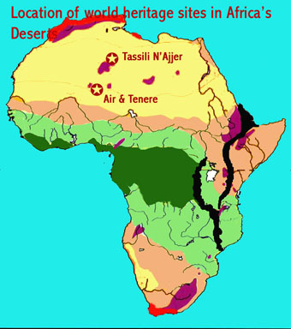
Image 6: The yellow on this map indicates which areas of Africa are covered by desert. This is nearly one third of the entire continent.
The Sahel (transition zone between the desert and Savannah/Grassland) can grow or shrink depending on the level of moisture. Growing crops here is also difficult because rainfall is minimal.

Migration
The drying of the Sahara had massive effects below the Equator. As a result of this, many people (especially the Bantu) came to central and south Africa hoping to find change. Many migrated here because of three key reasons.
- Desertification too many droughts
- Overcrowding population was getting too large
- Farming people just wanted land that could be farmed
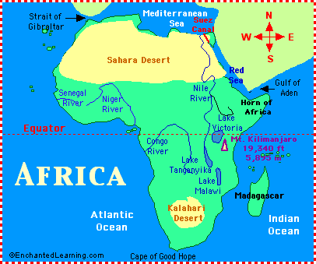
Image 7: The citizens of Africa kept moving below the equator because it was a bit better for farming purposes. However, rainfall was still minimal and it made Africa a tough place to grow food.

Lesson 9 – Environment Takes Shape
Agriculture
Fish was the main food source and it would be exchanged for cattle, any crops that grew and grain. Africa began to develop small-scale farms which make up more than 90% of the food production today. Farming is difficult due to the climate, but another major issue is that the soil lacks humus (an organic material produced by decaying vegetation). Unfortunately, farming is really only meant for each individual family which makes famine common.
Farming was the main occupation in the south as rainfall was a bit more consistent. The two main crops that were grown were sorghum and millet. These two grains produced flour that was high in protein and vitamins. Men were responsible for clearing the field and women weeded and winnowed the crops.
In order to provide fertilizer, trees were cut down and burned. The major issue with this strategy was that the field could only be used for a few years once this process began. Yams became the main source of food due to its high calorie content. Eventually, it was mixed in with boiling water to produce a porridge. This porridge was mixed into a stew that was also filled with vegetables and protein.
African Art
The most common expression of art in Africa is done through song and dance. All important occasions (birth, death, marriage) had a special dance. Dance was a community building activity as an entire village would band together during these times. With the drum music, costumes and important timing of each step, these dances were meant to tell a story.
Africa produced a lot of important sculptures that were centered around religion. These pieces of art would be used to make a spiritual connection with the spirit world. All artists served long mentorship programs with their masters.
Religion
Religion in Africa was centered around their culture and beliefs. Eventually Christianity and Islam will spread through the continent once exploration increases. The most common religion was called animism (the belief that natural things, such as trees, rocks, rivers, stars and locations have spiritual existence).
Unlike European culture, those that practice witchcraft and magic were highly respected in society. All problems were expected to be solved by magicians through intercession (a spiritual request on behalf of others). Anybody who became sick was deemed “possessed by evil spirits.” This meant that an exorcism (a ceremony to drive the evil spirit out of someone’s body) had to be completed by a Shaman.

Lesson 10 – Rise in Power
Trade Develops
Often trade would happen in Africa when someone was able to gain a surplus of a product (fish, grain etc.). Africa was in an interesting scenario as the west wanted agricultural products and the north and east wanted gold, salt and slaves. This made trading between the two empires necessary and common. Getting across the Sahara Desert was nearly impossible until the introduction of camels. Camels could store large amounts of fluids in their bodies which made them needing water uncommon. They also produced milk which acted a source for butter and cheese.
Going through the Sahara had a few major issues.
- The day could reach as high 45 degrees Celsius
- The night could reach -5 Celsius
- Sandstorms could generate within minutes and destroy an entire clan of people
- A lot of water needed to be consumed daily (4 liters)
These problems created a lot of obstacles for trading, but the resources each nation needed were too important to allow geography to hinder their quest.
Popular Trading Items
The most important commodities were salt, gold, slaves and horses. Specifically, salt was a valuable resource because it could preserve meat and fish. Merchants would purchase salt often and some places valued it as highly as gold. This was interesting because Europe constantly wanted gold and Africa kept their gold mines hidden.
Trade was rather unique during this time as one merchant would leave a portion of salt on the ground. If the gold miner was happy, he would leave the gold and everyone went on their way. Almost no words were spoken during this time. Slaves were usually criminals or prisoners of war. They were unpaid and had to work long hours. However, unlike Europe slaves were not “property.” They had legal rights and could pay for their freedom. Slaves were permitted to marry anyone
Trading Kingdoms
The earliest known kingdom in the Sudan was Ghana. Ghana had a lot of gold deposits in its region and they controlled trading routes along Western Africa. They wore gold ornaments and had a grand court. The Islam would defeat Ghana in a battle, but found it hard to maintain their empire due to size and distance.
Mali would eventually rise into a powerful kingdom that would dominate the trade routes. Mansa Musa was their leader and he went to the Mecca where he arrived in Cairo with nearly 60,000 men. He was able to bring a ton of resources back for his country and build them into an unbeatable empire. However, a lot of internal conflict over his successors would doom Mali.

Songhai developed along the Niger River and was led by a man named Sunni Ali. He was able to capture both Ghana and Mali and his successor Askia Muhammed united them both. He built another unbeatable empire that was eventually undone by internal conflict. This internal conflict weakened them and when another army (the Moroccans) marched in with muskets, it put an end to the Songhai dynasty. The Moroccans would eventually be undone by a series of sandstorms, size and a devastating famine that ravaged Africa.

Lesson 11 – Trade Develops
Geography Impacts Trade
Location is key when analyzing who can be strong trading partners. Trade between Africa and the Arabs was quite common. Trade in Africa stretched as far out as India. There are four reasons why this happened so effectively.
- They learned how the wind blows during which season this enabled them to move across the Indian Ocean with relative ease
- Though harbors were not as common as they were in Europe (Italy) there were enough ports that trade was easy to complete alongside both West and East Africa.
- Rift Valleys made trade via land difficult this forced moving out by sea which opened endless possibilities
- Rivers also made trading inland difficult to achieve (rivers are far too rapid) which once again force trading along sea/ocean routes
Trade Centers Develop
East Africa had an abundance of resources that ranged from: oil, wine, ivory, incense, spices, sugars, gold and grain. This variety of goods is what made Africa so desirable for trading purposes. Bantu-speaking individuals first travelled to South Africa (specifically Zimbabwe) in search of Gold. Zimbabwe became really powerful and began taxing other rulers within their region. Zimbabwe became so powerful and rich that they brought famous artists to live in their area and had them produce work consistently.
Axum (modern day Ethiopia, Yemen and Southern Egypt) became a massive trading empire with two huge ports right off of the Red Sea. All trade from the interior came through Axum. Axum became so powerful at one point that many historians argue it could have rivaled Rome at its peak or any Chinese dynasty. Axum survived for 1000 years as a top trading entity and managed to keep a strong relationship with their Islamic neighbors. Unfortunately, time, other growing empires and resources becoming abundant in other places began to take away from the once mighty kingdom.
Islamic civilization began taking over some major African trading routes and even expanded them to include more ports along the coastline. This made East Africa a strong trading partner with Arabia, Persia, China and Indonesia. Most African cities built a mosque, a palace and various other spiritual buildings.
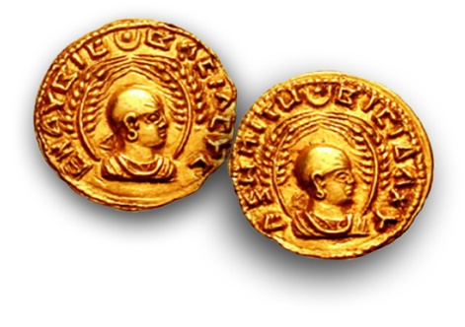
Image 8: The Axum Empire custom made their own coins out of entirely silver. This made Europe, Asia and other Islamic cities view Axum as a critical trading empire. They coined this the aksumite

