Unit Three: The Renaissance and Reformation

Overview
Introduction
Perhaps one of the most revolutionary periods In History, the Renaissance brought advancement in art, architecture, science, mathematics and the Printing Press. With society booming better than it ever had before, the Church got unprecedented power. This Church would abuse this power until Martin Luther stands up for his fellow citizens.
Key Questions
- Why was Italy the perfect place for the birth of the Renaissance?
- Are city-states an efficient way to run an entire country?
- What are the similarities and differences in the development of society between Italy and Northern Europe?
- Is the Printing Press the world’s greatest invention? Explain.
- How did the reformation change Europe forever?
- Was limiting the Churches power a good idea for society?
- How did Elizabeth the I revolutionize British society forever?

Lesson 1 – Why Italy?
At the time of the Renaissance, Italy was not a country but rather a collection of city-states (politically independent city and the rural area around it). City-states also had their own form of government and armed forces.
Geography
With Italy being a collection of city-states, trade increased rapidly and location mattered. Therefore, Italy’s two port cities, Venice and Genoa, became powerhouses financially and with their military. Venice was located on the East Coast and Genoa in the West.
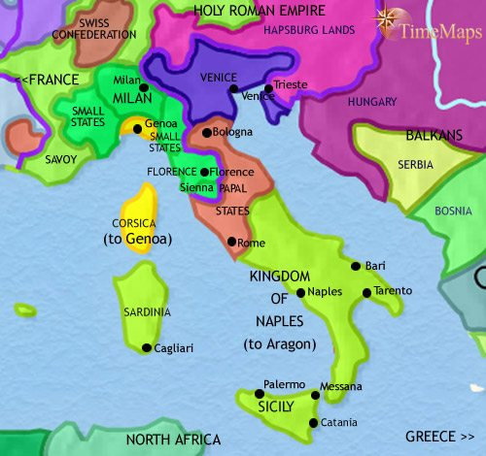
Image 1: We can see in this image why Venice and Genoa are such massive trading ports. They are easy to access and have the ability to travel throughout the city-states.
Italy is a mountainous region with tons of busy roads. These roads were developed into trade routes and many cities flourished as a result. Florence became Italy’s most powerful city because it acted as the epicenter of all trading. With a booming population and most resources being located here, Florence was a magnet for citizens and foreigners.
Italy has an excellent climate that enables trading all year. Because the weather is generally mild, trading and travel would not be disrupted in the winter seasons. Olives, grapes and oil were huge trading items and could be produced yearly and consistently.
With Italy’s location being close to North Africa, it enabled trading between the two nations to be much easier than anywhere else in Europe. Additionally, it was cheaper for Italy to engage in trade with North Africa than any other European nation. The Muslims were also quite prevalent in Italy and as a result, Italy was far more advanced in science, mathematics and medicine than their European counterparts.

Italian History
Ancient Rome and Greece were the most innovative cultures in terms of architecture, art, poetry and philosophy. This acted as the inspiration for many during this time as they focused on displaying nature and the world.
During the Middle Ages, people looked at all previous works with a Christian perspective. Since the Renaissance valued education, it enabled people to look at everything with a more open-minded perspective. This would allow them to discover the potential a person can bring to the world. These new-found ideas would include:
- People could shape their lives through their own efforts and talents
- Questioning and learning were important
- Human beings should use reason to find truth for themselves

Lesson 2 – City-States
City-states helped Italy during this time because it let everyone control their own networks and not be controlled by an empire. Though Feudalism existed in Italy, it was never that enforced as Nobles respected citizens more and were very involved in businesses.
Trade Leads to Prosperity
Despite city-states bringing riches, it did lead to various conflicts. Specifically, Venice and Genoa went to war often for control of the Mediterranean Sea. Venice was difficult to invade, and their trading center was massive. At their peak Venetian Merchants had thousands of trips traveling through the Mediterranean Sea with tens of thousands of workers.
Commerce
Merchants would quickly rise throughout Italy due to their ability to buy an item from somewhere else and resell it at a much higher price. Italian merchants also bought manufacturing products such as wool so that they could produce the highly sought item of cloth. Italy’s economy rose so significantly that they allowed loans to be distributed with an interest rate.
Money for the Arts
Art was also on the rise during the Renaissance era. Rich patrons (people who put money into the arts) invested a ton of money into aspiring local artists. These wealthy citizens did this for a few reasons:
- They genuinely enjoyed beautiful pieces of art
- They wanted to make Italy look beautiful by adding paintings and sculptures
- They wanted Italy to remain prestigious this would show foreigners how rich Italy had become
The Medici family was the most powerful in all of Italy. Their family was around in Florence for over 300 years. They made a fortune as silk merchants and bankers and used their wealth/power to build alliances with the church. They also married into Europe’s royal families as a way to expand their wealth and maintain it.
Lorenzo de Medici was a great patron of both art and literature. He sponsored Italian greats such as Michelangelo and Leonardo da Vinci. Poets and philosophers had frequent meetings with him to share their ideas and gain his support. Everything he invested into these fields would help Italy reach even further success.

Lesson 3 – Humanism
Humanist Thinking
The Renaissance was a much different time than the Middle Ages. Though literacy rates will not be high until after the Printing Press, it was still much better than what the Middle Ages offered. Most importantly, merchants and businessmen were educated and had a lot of wealth/time at their disposal. This caused society to view things under a new perspective; humanism (a system that centers on humans and their values, capacities and worth.
Humanists were more concerned with the goals of human beings as opposed to spiritual matters. They believed the power of reason was more valuable in finding truth than religious teachings. This viewpoint would lead to people believing they made their own destiny. This would be a stark contrast from the Middle Ages believing God decided everything.
Giovanna Pico della Mirandola was an important individual during his time as he brought in the idea of free will. This idea of free will suggested that you are not bound by government or any other factor, but rather you pave your own way in this world. While he may refute the power religion should have on you, most humanist thinkers were still spiritual and believed in Christianity.
Francesco Petrarch
An Italian writer and poet, Francesco Petrarch was one of the first humanist thinkers. He strongly admired ancient Rome and spent a lot of time finding old manuscripts of what they deemed important. He believed that if we use ancient paintings or masterpieces it can give us ideas on how to grow our industry during the Renaissance. Petrarch read good books, travelled and saw excellent pieces of art worldwide.
Niccolò Machiavelli
Born in 1469, Machiavelli began his life working as a civil servant for the Republic of Florence. He was constantly sent on expeditions to foreign courts where he saw the corruptness of Italian politics. Machiavelli produced a book called “The Prince” where he did not tell leaders how to be honorable. Rather, he informed them how to win and maintain power.
Many people believed he was evil as he constantly advocated that a government needs to put fear into society as opposed to love/respect. Machiavelli believed that humans by nature were not good people. He believed that everyone is self-interested and unreliable. Though his views were harsh, he did have many supporters of his philosophy.

Lesson 4 – Renaissance Art
Filippo Brunelleschi
One of the most famous architects during the Renaissance era was Filippo Brunelleschi (1337-1446). Brunelleschi helped build many famous monuments with his precise measurements. This would include the Cathedral of Santa Maria in Florence.
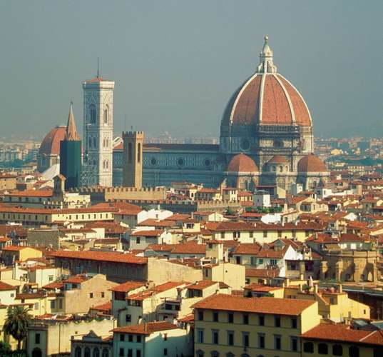
Image 2: The Cathedral of Santa Maria still stands today and is one of the most famous buildings in all of Italy. It was built nearly 600 years ago which shows how advanced the Renaissance truly was.
Brunelleschi did not stop at architectural advancements. His advancements in mathematics/art were remarkable as he helped discover the ideas of perspective (making things in the distance appear smaller than things closer to the viewer) and proportion (things are the right size in relation to each other).
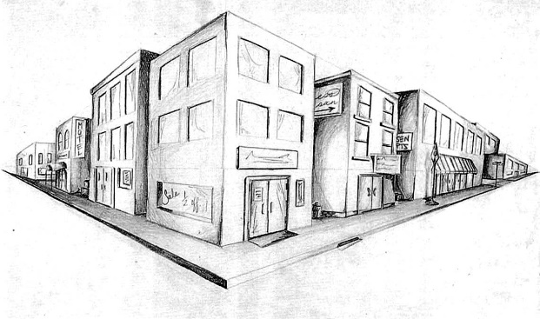
Image 3: This idea of “perspective” was discovered during the Renaissance era. Notice how everything in this distance is smaller than what is closest to you
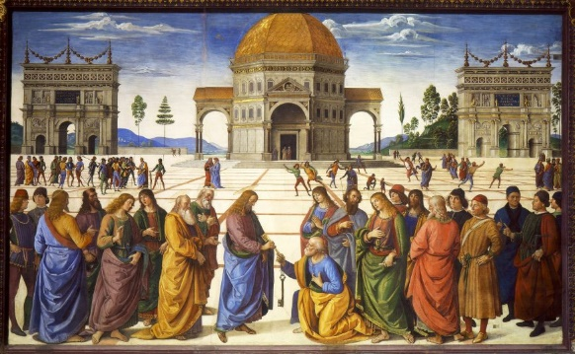
Image 4: This idea of “proportion” is meant to show scale. Specifically, this means that people will not be as tall as buildings. This was a big advancement from the Middle Ages.
Donatello
A student of Brunelleschi, Donatello (1386-1446) would become one of the most famous sculptors during the Italian renaissance era. Donatello would be sponsored by Cosimo de Medici and was asked to produce many different sculptures. Donatello believed that everything needed to have “realism,” which means that all work he was going to produce could not be exaggerated. This would force him to break all societal rules and create the first nude sculpture, David (different than Michelangelo’s David) and produce the Equestrian Statue of Gattamelata.
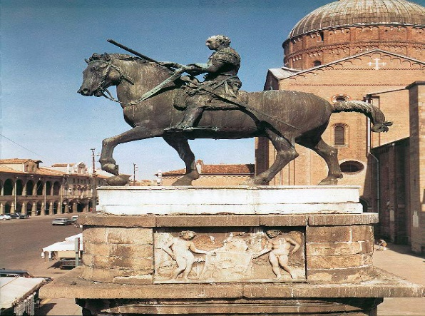
Image 5: The Equestrian Statue of Gattamelata was depicted to show a realistic soldier on his horse. Interestingly, this was the first every statue constructed entirely out of bronze.
Raphael
One of the greatest painters in the Renaissance era was Rafaello Sanzi (Raphael). He was given a big task by both Pope Julius II and Pope Leo X. Raphael’s task was to decorate almost all of the Vatican (where the pope resides). His most famous piece of art that he produced for the Vatican was the School of Athens. This painting depicts many famous philosophers attending a single gathering. Though he passed away at a young age, 37, he was given the ultimate form of respect by being buried in the Pantheon (famous Roman temple).
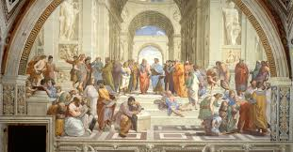
Image 6: The School of Athens is considered one of the most prestigious paintings. It was produced so that it could hang up in the Vatican and bring beauty to its palace.

Michelangelo
Considered one of the greatest artists in history, Michelangelo Buonarroti had produced a number of works that still live on today. He was widely considered the best sculptor by the young age of 25. He was sponsored by Lorenzo de Medici who had put a lot of faith and wealth into the hands of Michelangelo. Michelangelo was tasked with producing a number of different artworks such as the Statue of David, painting the Sistine Chapel and creating The Pieta.
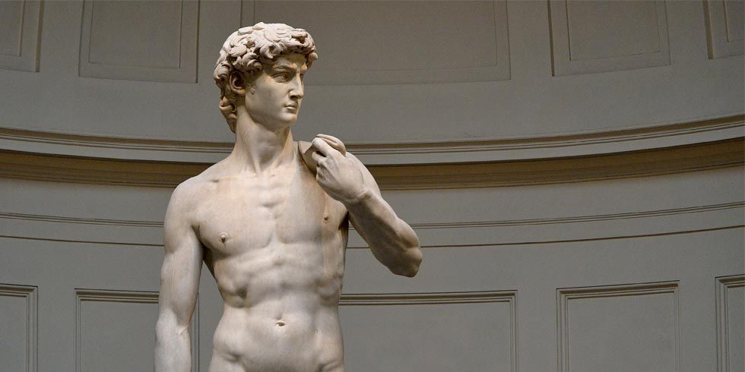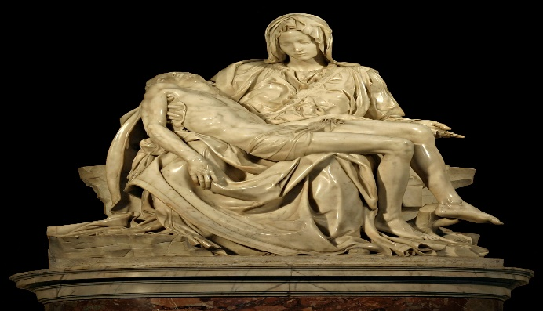
Image 7: The Statue of David and the Pieta were carved entirely out of marble. Michelangelo took years to produce these works, but they are still in existence today.
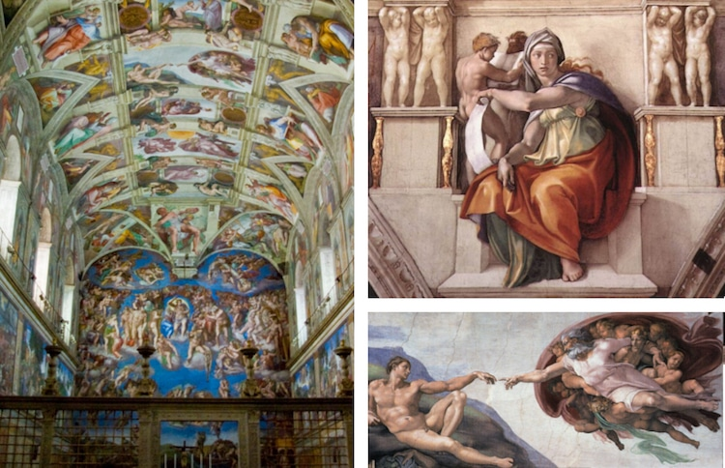
Image 8: These works were painted by Michelangelo on the roof and walls of the Sistine Chapel. There were very few people that would be trusted with this task.
Leonardo da Vinci
Leonardo da Vinci was well versed in many areas. Beginning his career as a painter, he would go on to be an inventor, engineer and a scientist. Da Vinci wanted to learn about how the world operated through experiments. This led him to design the first helicopter, tank, parachute and a flying machine. Da Vinci would often start a project and quickly move onto something else. Most notably, he used to cut up dead bodies to truly understand how human anatomy worked. Da Vinci was literate as he could write/read. His greatest art piece was the Mona Lisa which is one of the most valuable paintings in the world today.

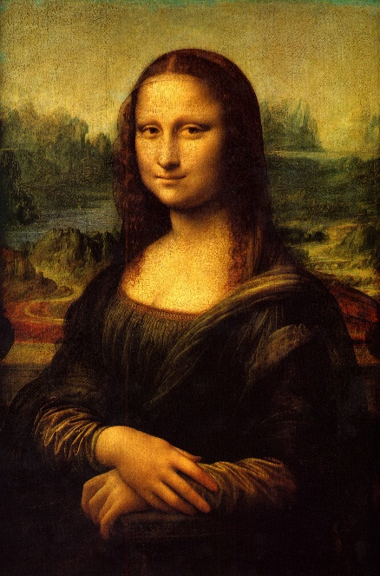
Image 9: The Mona Lisa is a prestigious painting that took nearly 3 years to produce. Its valued well into the hundreds of millions of dollars.
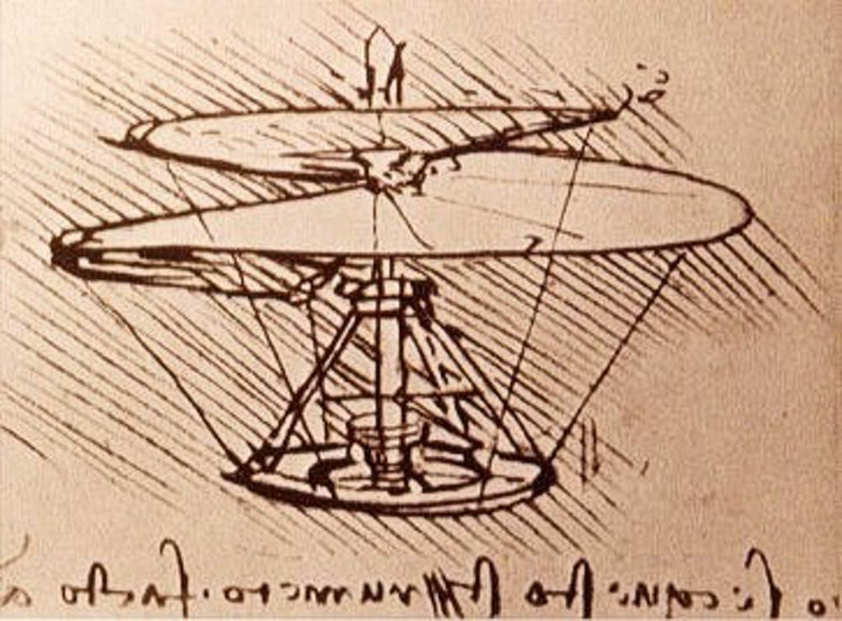
Image 10: This was a design of a helicopter by Da Vinci nearly 500 years before it was actually produced.
Women of the Renaissance
Women during the Renaissance era were given more rights than their Middle Ages counterparts. This could include an education (upper class nobles only) or learning painting through your family. Many women became famous artists during this time period and were compensated well for their efforts.
Sofonisba Anguissola was a daughter of a wealthy family who went on to apprentice many famous artists such as Michelangelo. Her paintings were often on the walls during religious masses and she was given high praise for her skill level in this craft.

Lesson 5 – Navigation
Tools Pave the Way
The tools available during the Renaissance improved greatly. The invention of the astrolabe (a portable device that measured the distance of the sun and stars above the horizon) helped determine latitude. The magnetic compass (a Middle Ages invention) was improved. Literacy was also higher so navigators would often record information about their findings on maps. Those maps would be used by other navigators in the future and help sailors reach never before seen distances. Sails became infinitely better which helped eliminate the need for male rowers.
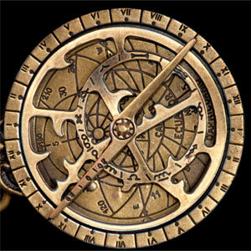
Image 11: This is an Astrolabe. Though it was not perfect, it did enable explorers to find locations easier and may have paved the way for other direction bearing inventions such as the compass.
All of this enabled trading to grow and boost the economy. All roads that connected cities in Europe were typically littered with thieves or poor design. Though roads will improve over time, travelling overseas was the better option due to this new technology. Spices from Asia (cinnamon, peppercorns and nutmeg) became increasingly popular as well as silk. All travel was funded by rich investors because of the wealth travel could bring.
Accessibility
Though travel had improved, individuals of the Renaissance wanted to see how far they could go. Shockingly, they discovered all of the continents except for Antarctica. Christopher Columbus discovered North America when he accidentally went the wrong way across the Atlantic. He was hoping to reach the East Indies and believed he had once he hit land. Reaching the East Indies proved to be somewhat complicated during this time. This may have been due to misreading maps or using tools that were new to a civilization. Williem Janszoon, a Dutch navigator, set sail for the East Indies but completely overshot it and reached Australia. However, all of this was documented and enabled Europe to understand how large the world truly was.

Lesson 6 – Northern Europe
The Printing Press
Before the invention of the Printing Press, it took months to produce a copy of a book. Everything had to be scribed. By scribing these books, it made them expensive (due to the fact there were only a few) and most citizens were not literate.
Johannes Guttenberg built the first Printing Press in 1450. This enabled books to be printed quicker and more frequently. These books were able to be produced on paper (which was much cheaper than parchment). The merchant class was growing and looking for books to read. Libraries were built and could store tons of published books. With books becoming easily accessible, literacy improved significantly, and people began discussing ideas more frequently. Books were translated from Latin into English, French and German.
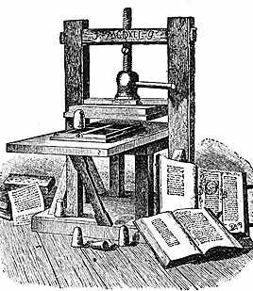
Image 12: The Printing Press made education more readily available for all social classes. With growing industries in science, art, architecture and textiles; an information revolution was ready to begin.
Northern European Art
Northern European artists were fascinated with the idea of Humanism. German artist Albert Durer learned about perspective and proportion. He immediately wrote a book and had it published. His ideas were seen by a massive portion of the population and all art started to take a more realistic approach. They would eventually create many oil paintings due to the variety of colors that could be used and how long it was able to last.
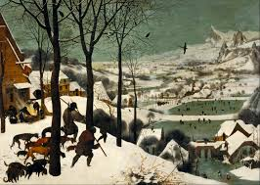
Image 13: “The Hunters in the Snow” was created in 1556 with the use of oil paint.
Lesson 7 – Renaissance Science
Scientific Revolution
Prior to the Renaissance, everyone aligned their scientific views with the Church. This included thinking the Earth was at the center of the universe. This would change during the Renaissance with the scientific revolution (changes in thoughts and beliefs that occurred between 1500-1700). All of this began with Nicholas Copernicus.
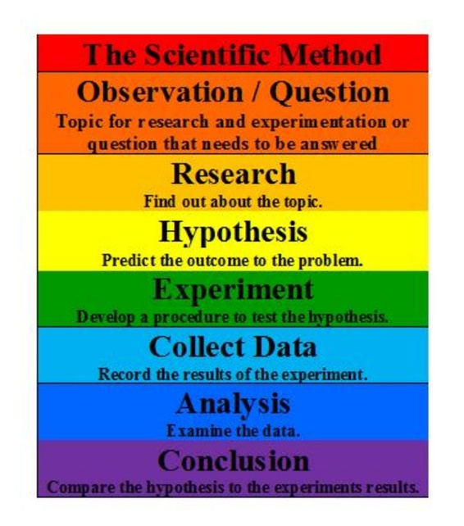
Image 14: This is the Scientific Method discovered by Leonardo da Vinci. It is still widely used today and really forced Renaissance thinkers to analyze all data.
Copernicus
Copernicus discovered that the planets all orbit around the Sun. Copernicus determined that the Earth moves in two ways:
- Revolving daily on its axis
- Orbiting around the Sun every year
Copernicus was able to discover that the Sun was a star as well. Copernicus wrote a book that was filled with his discoveries. This was condemned by the church, but little could be done to stop its popularity.
Galileo Galilei
Galileo developed and built a telescope that could be magnified by 30 times. This technology gave him the ability to see things that nobody before him ever did. Galileo first saw that the Moon was solid and its surface was full of craters. He was also able to confirm that Copernicus was correct about the planets orbiting the Sun.
Galileo was told by the Church that he had to recant (withdraw a statement) his ideas. He was placed under house arrest for violating church policies constantly He is considered to be “the father of modern physics.”
Lesson 8 – The Reformation
The Catholic Church was powerful. They had almost full control of society and nearly all citizens worshipped them. In an interesting way, the Church had almost become an empire.
Changing Attitude
The Church kept imposing taxes and demanding money from each of their citizens. With innovations in science proving the church wrong, it made people believe there was a chance they could live Christian lives independent of the Catholic Church. All of this would lead to the reformation (a 16th century movement in Western Europe to reform the Catholic Church that resulted in the establishment of Protestant Churches).
Change Becomes Needed
The Church was quite rich. They had a lot of land and controlled many local businesses. Most of what the Church spent was on itself. This meant paying its officials a lot of money so they could live lavish lifestyles. This wealth was problematic for two reasons:
- There was no reasoning behind why the Church needed that much money
- Having too much money was supposed to prevent you from reaching Heaven but the Church was practicing the exact opposite of what they said
The Church began building at a rapid pace. However, they needed more money to make this happen. The Church said that all souls would go to purgatory (a place between the Earth and Heaven where people would stay in until all sins were paid off). The Church said they would sell you an indulgence (a cancellation of sins) in exchange for money. Therefore, if you pay an extraordinary amount of money, they would forgive all of your sins so your soul could ascend into Heaven immediately.
The Reformers
The idea of indulgences would be the final blow to a society that followed Christianity blindly. Many citizens decided to reform the Church. In order to “fix” the Church, citizens had to be careful about how they approached society about repairing these problems. It was legal to question the Church’s policies, bit illegal to question their teachings. Completing the latter would often lead to immediate execution.
Desiderius Erasmus was a priest that often wrote humorous books. These books became very popular and often criticized the Church. Erasmus was sure to attack priests, bishops, archbishops and the pope. Erasmus became so hated by the Church and king that reading his books was a criminal offence. However, since he attacked their policies his life was spared.
The Protestants
The Church refused to listen to the constant complains from their citizens. A German priest and teacher named Martin Luther became horrified with what the church was doing. In the German city of Wittenberg, Luther posted a list of grievances on the Church door (which was highly illegal). His grievances were known as the 95 theses. Due to the printing press and increasing literacy rates, this was quickly distributed across society.
Luther believed that God had chosen your fate a long time before the Church ever did. Therefore, he challenged the belief that priests were not allowed to marry. He married a nun and had 17 children (11 of whom were adopted).
The strictest rule the Church had enforced was that nobody could translate the Bible from Latin into any other language. Naturally, Luther translated the bible into German. This would then get translated many more times along the way. Eventually a new protestant reformation will begin known as Calvinism.

Lesson 9 – Counter-Reformation
The Church Reforms Itself
The Church was in trouble as citizens were angry, more intelligent and realizing what the Church had been doing for years. This spawned the Council of Trent (an organization responsible for reforming the Church). They wanted to help reform the Church, but they allowed the selling of indulgences and claimed only the Church could understand the Bible.
Ignatius Loyola was a Spanish solider who got wounded in battle. There, Loyola claimed he had a reawakening and that he needed to stop Protestantism. He created the Society of Jesus (Jesuits). This group preached the Bible and converted many people back to Christianity.
Inquisition
Anyone who was deemed an enemy of the church could be tortured or executed. The court had absolute power regarding this matter and could arrest anyone with even the slightest of suspicions. The torture methods used were the Iron Maiden, The Rack and the Spiked Chair.
Warring Faiths
Conflicts with the Church were on the rise and society in Germany was at war with one another. The Peace of Augsburg was the only time where conflict was avoided. This was because each city-state was given the power to choose their own religion. This enabled Protestantism to be practice without fear of consequence from the Church.
Calvinists (who were a branch of Protestantism) were hard-working people that did not practice Catholicism. This enabled them to gain many enemies across the country (especially the French queen Catherine de Medici). On the day of the Royal Wedding (St. Bartholomew’s Day), Catherine urged that the protestant guests be murdered in cold blood. Many were hunted in the streets of France and executed. This led to a massive religious war for nearly 30 years. This would eventually lead to Protestantism being declared an official religion in France.

Lesson 10 – Nation-State
Wars of the Roses
The modern world is divided into 200 nation-states (a country that rules itself and can make treaties with other states). The Wars of the Roses caused great hardship in English society The Wars of the Roses were a civil war (a violent conflict within a country) that was usually meant to overcome whomever was in power. The War ended with the Lancaster family winning and they appointed their son, Henry Tudor, to be King. He would call himself King Henry VII and have a tall task ahead of him. King Henry VII had little basis for being king, so he married Elizabeth of York (member of a different Royal family) to gain respect in society.
Henry VII
Henry VII wanted to restore law and order within society. Though he was young, Henry was highly intelligent and knew this started with the overpowered Barons. Henry VII wanted a central government and he could not have that if the Barons had their own armies and independent wealth. In order to control them, King Henry VII implemented three ideas:
- Private armies are forbidden
- The Court of Star Chamber would now hold Nobles accountable for breaking the law
- Provide more support to the Middle Class so they can gain power financially and socially
Henry VII also took away the Guild’s power to control prices and their manufacturing system. He put more faith into the cottage industries (a business in which craftspeople are hired to do work from home). He then limited what foreign individuals could purchase so that citizens of France could more easily afford the items they needed. Everything he had done worked well for England. England was finally becoming a powerhouse that they should have been for centuries.
Henry VIII
Henry VIII was the son of Henry VII. Similar to his father, he was highly intelligent and had a keen eye for how to make England even better. It seemed as if an even better successor had risen from the ashes. However, this would not be entirely true as Henry VIII was one of the most ruthless human beings in history.
Henry VIII would then marry Catherine of Aragon. The two were forced into the marriage, but they were reasonably happy with one another. The only issue from the marriage was that Catherine only produced one daughter and no sons. Therefore, Henry started a relationship with Anne Boleyn (a wife in waiting). He truly loved her and could only be with her if his first marriage ended.
Getting a divorce during this time was rather complicated and nearly impossible for a ruler. The only way the Pope would grant this is if the marriage was deemed “unrealistic.” King Henry VIII had his divorce turned down because they were happy together for 24 years. King Henry VIII was not someone who appreciated a “no” answer. Through highly illegal activity, he made himself the head of the Church in England. This enabled him to divorce his wife and marry Boleyn. Henry VIII would then execute anyone who opposed him and steal treasures from the Church he was in charge of.
When his new wife, Anne Boleyn, produced a daughter, Henry VIII was furious. Henry VIII executed his wife and married four other women. Henry VIII would go on to execute majority of these wives but would eventually have a son named Edward VI. During his reign a peaceful protest broke out where citizens asked for monasteries to be reopened. They did not insult the king or break any laws. However, Henry VIII had every single protestor executed. More protests would occur with the same result; immediate execution.

Lesson 11 – Elizabeth the I
King Henry VIII had three children: Edward the VI (who is now King), Mary the I and Elizabeth the I. Edward VI would assume the throne at 9 years old but would eventually die as a teenager. This would then enable his oldest sister, Mary the I to assume the throne. Mary the I was a merciless human being who openly executed citizens and burned protestants to death. Her methods were unpopular, and her youngest sister will take over following her death.
Transformation
Elizabeth the I assumed the throne with multiple enemies that were created by her father, brother and sister. Additionally, she faces more hardships because people viewed her as a weak leader due to her being a woman. Elizabeth advanced society through art and theatre. She was highly educated and knew what England needed to advance its society.
She was constantly asked for marriage, but refused every proposal because she did not want any opposition within her reign. She maintained a good relationship with her parliament and focused on establishing peace within England. Despite being a protestant, she allowed Catholics to openly preach their faith. She managed money well and rebuilt relationships with other nations around her. In just a few short years, her citizens were thrilled with her reign.
English Advancement
Elizabeth the I arguably created the first golden age in England (a nation that desperately needed one). Elizabeth pushed for patriotism (having pride and love for your country). Elizabeth the I was also an excellent leader in regards to the military as she constantly defended England from the powerful Spain and stopped all internal conflicts.
The Spanish were becoming a rich nation as they often conquered other empires and stole their resources. Elizabeth the I was aware of this issue and decided to attack Spain. Spain had a far more powerful army, so Elizabeth the I had a plan. She wanted smaller, but faster ships to sail around the bigger ships. By doing this, these massive Spanish ships would be unable to handle the British fleets speed. She was correct in her assessment as Spain had no clue how to handle these smaller ships.
The English captains of these ships were known as the Sea Dogs (English captains who are authorized to raid Spanish ships). Led by John Hawkins and Francis Drake, they were constantly able to defeat the Spanish armies and steal their resources. With the help of Elizabeth the I, these two captains sailed around the globe. When the Spanish king raised an issue, Elizabeth the I agreed to hear him out and potentially make peace between the two nations.
The Spanish had enough of this war. They decided to attack England with everything that they had and a brand-new defensive formation that would combat the fast-moving ships. Of course, Elizabeth the I had outsmarted the Spanish king once again. She had all small ships loaded with cannons that would shoot more rapidly and accurately than they did on larger ships. She then had small ships (with nobody on them) and equipped it with a flammable substance. This meant that as soon as it crashed into the Spanish fleet, it would blow up and sink whichever ship it hit. This established England as the most powerful Navy and Elizabeth the I as one of the greatest leaders. She was heavily outnumbered in this war and dominated the Spanish Armada (a fleet of Spanish ships).
An Empire is Born
English ships were everywhere in the 16th century. Elizabeth the I had progressed the industry so much that they could freely travel without any worries. England was far behind other countries in Europe and Elizabeth the I was fully aware of this problem. Under her guidance, England was able to seize many territories and establish themselves as a powerhouse.
North America had loosely been discovered before this, but never really colonized. England wanted to change this mentality. Though England would establish colonies in newfoundland and other parts of the east coast, none would last a long time. This was irrelevant to England because this was a new empire being formed and time was on their side. It took around 150-200 years, but England would go on to establish themselves as a powerful nation that would control nearly 25% of the world’s population.

Lesson 12 – Citizen Feelings
Slave Trade
England was selling goods at higher prices than they were worth. Eventually, England would move into buying and selling human beings (most of whom came from Africa). The English army would by them for $10, put them on a slave ship and receive $34 from the Caribbean. 25% of them died on the voyage over due to terrible living conditions.
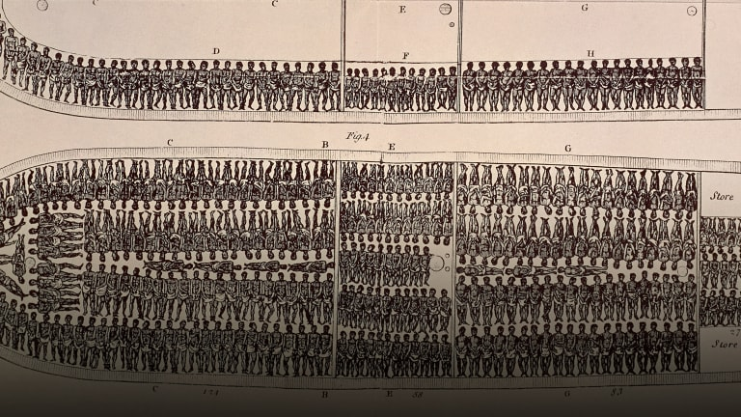
Image 15: This is how a slave ship would be designed. Often disease would run rampant through these ships and the close proximity ensured the disease would spread.
Enclosure ends the Feudal System
Henry VIII had allowed Nobles to enclose their estates. This allowed for tons of sheep to produce wool which became a staple of the English economy. This boosted the economy but made farmers more expendable.
There was no social welfare system in place during this time, so the poor had no choice but to suffer greatly. A poor law was introduced in 1601 that was meant to help them. While this did fail, it was the starting point for the poor getting the help needed.
Towns started to grow significantly in population as many farmers were looking to do any job. Since the demand for works was low and the supply was high, people would work for little wages. This spiked the economy to new heights. People were also producing goods from home and they worked long hours to produce as much work as possible. Children would often learn the craft from their parents and work alongside them. The manufacturing system would grow as well and set England up for a period of innovation.

