**Unit Two: The Middle Ages**

**Overview**

**Introduction**

The Middle Ages brought a lot of change for Europe. Religion was on the rise and countries were starting to learn about the knowledge of the outside world. However, no change would be as big as Feudalism. This new form of government would last for centuries and pave the way for unprecedented change.

**Key Questions**

* Is Feudalism a viable way to operate a society?
* Which of the following is most necessary to build an empire? Trade, knowledge, a strong army or government.
* Was the Magna Carta what England needed the most in the 13th century?
* Identify and explain the significance of the Black Death
* How did government, geography and contact with the Europeans play a role in the development of Japan?
* What similarities do European and Japanese Feudalism have? What are their differences?

**Lesson 1 – Feudalism**

Feudal Contract

This concept was started by William the Conqueror. It consisted of him taking land away from defeated Nobles and rewarding them to his own army. He referred to these as **fiefs.**

**Feudalism:** legal and military customs that ordered society in medieval Europe. It was based on the three F’s

1. Fief (land)
2. Fealty (loyalty)
3. Faith (religion)

Land was the main form of currency in Europe during this time period (11th and 12th century). **Vassals** (a landholder who is always loyal to someone of a higher stature than themselves) had to protect the king. If they wanted land, they had to do the following:

* Serve in the King’s army (usually 40+ days a year)
* Had to find extra knights during a time of war
* Voice their opinion on political matters
* Provide the King money on a special occasion (oldest sign being knighted or daughter being married)
  + In response the king protected his Nobles as well.

In order to help you understand class structure in Medieval Europe, below is a chart that outlines who was where in society.

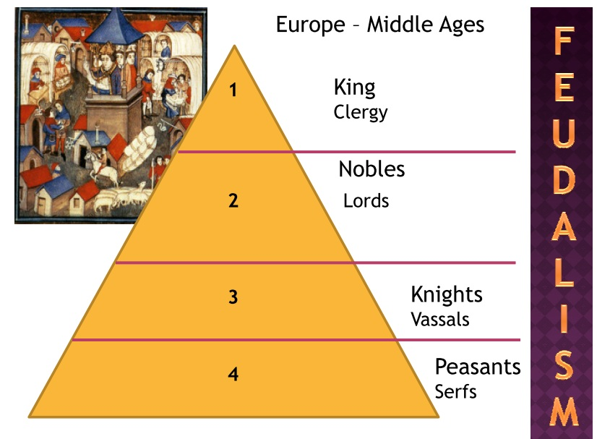

Rules and Obligations

The land was divided into smaller parts which consisted of Manors. It essentially gave Nobles their own home and land. Since you owned your land, you were permitted to profit from it. Additionally, they would hire serfs, peasants and freeholders to work for them and gave them no power at all.

Freeholders however were enabled to make money from the farm, but they had to pay a fee to use the land (almost similar to modern day rent). Additionally, serfs were not permitted to be banished from the land by the Lords.

Family Ties

It was mandatory for a Lord to have children and get married. Failure to do so would result in the loss of land. Most marriages were based off of who owned the most land and had power in society.

Life in a Medieval Manor

Life in a manor was very self-sufficient meaning that everyone did their jobs and it ran smoothly. Very little assistance was ever needed by the King. The land owned by the King was called **demesne** which usually consisted of orchards, fields and gardens.

The Manor House and Village

The manor would consist of many homes, but the most lavish was home to the Lord. Every room was required to have furniture regardless of who was in it. Serfs sometimes lived in rooms, but if they did, multiple people would be in the same room. Usually, they lived in the village in houses they built from wood 🡪 often these were dirty, filled with many people and completely unsanitary.

The village consisted of a church, mill, tannery and a Blacksmith’s shop. Most roofs consisted of **thatch** and only certain individuals knew how to get **fletching** (feathers) on arrows.

Peasant Responsibilities

Peasants always had the lowest standard of living and were often uneducated. Serfs had to give their produce to their “owners,” but if they had a surplus (extra produce) they could eat or sell it.

Freeholders could leave the land whenever they pleased. Serfs did not have this right.

Women’s Rights

Women had their lives controlled by their father and after marriage husband gained control. If a woman is unmarried, she can not own property even if it was inherited. If her parents died before marriage, she would become a **ward** (an orphan).

Women had almost no legal rights when unmarried. However, there was a law that protected widows.

**Lesson 2 – Religion Makes an Impact**

Religion was critically important to the Europeans during the High Middle Ages. However, Christianity (the main religion at the time) would only be officially recognized during this period.

The Catholic Church

They were very wealthy as they owned one third of all land and even had a **tithe** (tax) on everyone living there. They received gifts and financial support from its followers as well.

Every single day was appointed to a different saint. You were only permitted to be Catholic, therefore the church gained extreme power throughout the Middle Ages in Europe. The worse punishment was **excommunication** (losing your membership to the church). People feared this issue because it was said they would go to Hell.

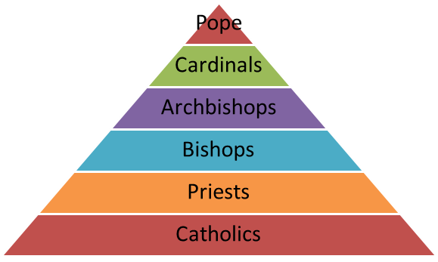

Monastic Life

Most men and women took faith very seriously and would make a promise to live under all of its rules. This meant becoming Monks/Nuns, Praying and Obedience.

Monks and Nuns could both read and write which was very rare during this time period. Monks were so intelligent that they were able to take old texts, modernize them and illustrate these texts to help enhance understanding for its citizens.

St. Francis of Assisi

St. Francis of Assisi was a very well-liked and respected individual. One day he ran into an unknown citizen with leprosy and gave him all of the money he had. He was the descendant of a very rich family but refused everything to preach the message of God. He wanted to spread the positivity of the scripture as opposed to ruling with consequence that had been plaguing Europe for quite some time.

**Lesson 3 – Law, Order and Power**

Medieval Trials

There were two forms of trials in Medieval Europe:

1. Trial by Ordeal
   1. This was the way of “letting the Gods decide.”
   2. Essentially, you would be tortured or would undergo very physical punishments to deem your innocence
      1. Examples:
         1. Swallowing poison 🡪 if you die, you were guilty.
         2. Drowned in water 🡪 if you survived, you were innocent
2. Trial by Combat
   1. This would have two fighters (person accused of the crime and his accuser) fight to the death. The survivor would be innocent and the other would die or hanged if he lost
   2. A woman could appoint a champion (someone to fight on her behalf), but it would cost a lot of money

Medieval Court System

Not everything was settled by combat and torture. A legal system was put into place during this time period in order to ensure everything ran smoothly from both a government and religious perspective. Below is a chart breaking down these legal systems

|  |  |  |  |
| --- | --- | --- | --- |
|  | Manor Court | Royal Court | Church Court |
| Crimes | * Farming/Property Disputes * Assault, theft and small crimes | * Serious crimes such as treason and murder | * Crimes committed against church officials * **Blasphemy** (using God’s name wrongly) or **Heresy** (belief against the church) |
| Process | * Jury of villages * Lord acting as a judge * Witnesses could provide evidence | * Used common law (used previous cases for decisions) | * Followed church law |
| Sentences | * First time in the **stocks** (wooden frame with holes that trapped ankles and wrists) | * Execution or loss of property | * Excommunication |

Henry II of England

The Pope had all power over the King and Queen in religious matters. King Henry II thought it was only fair that all of the clergymen in the Church who were guilty of crimes be sentenced by him.

Thomas Becket who was an Archbishop, refused to sign off on this agreement and as a result he was banished from England. Six years later he was allowed to return, but quickly had conflicts with Henry II. Henry II wanted him dead and his knights murdered Thomas Becket shortly after.

The King had to undergo a punishment 🡪 flogging (beaten with a whip) and banished from interfering with religious matters. Thomas Becket was then canonized (made into a saint).

Medieval Monarch

The King always had to honor his commitment via the Feudal Contract. Failure to do so, would result in a powerful group of Nobles dealing with him. The King could not win this war because he would have to gather knights from all over the region, but his Nobles had their warriors living in their manors.

King John was extremely unpopular as a King. He set ridiculous taxes, punished his citizens and got the whole country placed on **interdict** (nobody could be married or baptized). This was a big problem and his own Barons forced him to create and sign the Magna Carta.

The Magna Carta outlined the following:

* The Monarch had to treat his citizens according to the law
* The Monarch is not above the law
* Taxes had to be approved by the Clergy
* The Church would be free of royal interference

**Lesson 4 – The Crusades**

Most were uneducated throughout Europe. It was also dangerous to venture outside of your own area. Despite constant travelling, Nobles had very little knowledge of what was happening on a global scale.

The Crusades

**Crusades:** military expeditions made by Europeans to gain control of the holy land.

This battle pitted Christians of Europe against Muslims for control of modern-day Israel. Originally, it had been a part of the Byzantine Empire (Christian), however they lost control to the Turks. The Muslims were very religious and did not appreciate anyone coming into their territory disrupting them.

Thousands of citizens from Europe gathered to retake their land. They were led by Peter the Hermit, who claimed to have been given this role by Christ. When they entered modern day Turkey, they were immediately wiped out by the Turks.

Long-Term Consequences

Millions of lives were lost during the Crusades. Most were men which left their lands without an heir. Nobles lands had to be given back to the King. Additionally, those that survived came back with new ideas that would help Europe grow.

Europeans learned a lot from the Muslims; specifically, about mathematics, astronomy and medicine. This would help perpetuate the eventual European Renaissance. This would also lead to trade between the two nations as Europeans often came back with spices and fabrics. Ultimately, this would lead to voyages towards Asia which again increased European knowledge.

Contact with Asia

Europeans were permitted to voyage towards Asia. The main voyageur at this time was Marco Polo. Marco Polo and his family went to China and impressed their ruler so much that he made them an official in Chinese Court. The Polos did not return until 17 years later.

**Lesson 5 – Growth of an Empire**

Trade Increases Globally

After the Crusades, the Western European societies became open to the idea of expanding trade overseas. Specifically, Italy became the epicenter of trade as they often brought in goods from Asia (silk, jewels, rugs) which was unavailable everywhere else in Europe. The two biggest ports in Italy, Venice and Genoa, had a variety of people from all over Europe looking to acquire these goods. This expanded trade from within Europe exponentially and led to an economic growth.

Trade Leads to Growth

Markets and fairs became quite popular during this time as it was filled with exotic goods, entertainment and was a place to socialize. With these markets becoming so popular, serfs finally realized that they could escape their life of misery and have an eternity of success. They would achieve this success by building or making these exotic goods within their own towns. By selling these products, they would make far more than their servant life ever paid.

People would eventually begin to specialize in the trades industry (bakers, tailors, sword/armor makers). In order to qualify as a tradesperson, you had to belong to a **guild** (an organization controlled by the experts in trade). Guilds would become powerful by running all trade business within a town and taking care of their own when they fell ill. Despite equality still remaining an issue, women were permitted to join guilds and became quite popular in the textile industry.

Learning to be a craftsperson was not an easy process and required extensive training.



**Image 3:** This process could take between 15-20 years to become a master. However, guild members would make a lot of money during these times.

Life in Medieval Society

Despite fortifying the walls, closing the markets at night and taking many precautions to prevent attacks, it was not enough to contain the village. The population kept increasing as outside traders moved in. Middle class homes now became overpopulated and townhouses were built higher than ever before. Guilds became more powerful and rich as they would often host entertainment events. These would include pageants and bear-baiting (a spectacle where dogs torment a chained bear).

Freedom became more prevalent during these times. You can marry whomever you wanted, serfs could escape their social class and you could earn money however you saw fit. Women were allowed to trade and if they married a guild member, they could gain an education as well.

The Merchant Class

Money was not important under a Feudalism government. Feudalism was about land, power and property. These skilled tradespeople changed this perception because they began making a lot of money. The most powerful people were those in merchant guilds. These guilds began buying and selling goods on a much larger scale. They were extremely well-organized and arranged to have their own army and navy. The social class system was starting to fade and a new one was created. Rather than a feudal pyramid, a three-class system emerged.

* Top Level: Aristocracy
  + High Church Officials
  + Rulers
  + Noble Families
* Middle Level: Middle Class
  + Merchants and Business Owners
  + Shopkeepers
  + Bankers
  + Priests
* Bottom Level: Lower Class
  + Peasants
  + Unemployed
  + Laborer’s

**Lesson 6 – Technology**

Castles

Castles were an important aspect of Medieval society. Pride, effort and prestige were some of many traits that citizens associated with their empire. All castles were **fortified** (wooden fence built around a castle to protect from invaders). Often the only way to combat and conquer one’s castle was to have a **siege** (when an army attempts to catch a fortified place by surrounding it and cutting off supplies). During the siege, they would use catapults and ladders as a way to gain entry. However, majority of these attempts failed because archers and other warriors would use castle openings to kill anyone ascending.

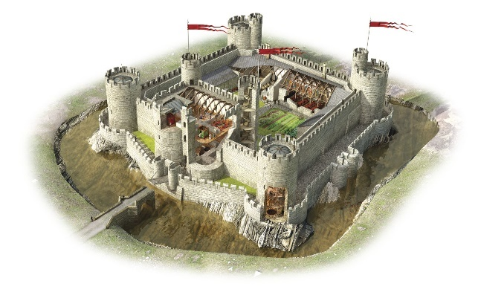

**Image 4:** Castles were often fortified well. Gaining entry was difficult, but the reward was generally worth the risk.

Role of a Knight

One of the most prestigious warriors during this time was the Knight. The Knight had to undergo vigorous physical and educational training. They had to abide by the code of **chivalry** (honor, courtesy and courage). They had a duty to protect women, children and the church and were not allowed to violate these policies. However, much like ancient times there as little respect given to slaves and knights would often attack them. They were well trained and experts at **jousting** (two knights on horseback trying to knock one another off with a lance) which provided their country with entertainment whilst simultaneously practicing a new battle strategy.

Knights also had incredible armor that would amass nearly 100 pounds. It was very difficult to penetrate and would often take a perfect arrow shot or sheer luck in combat.

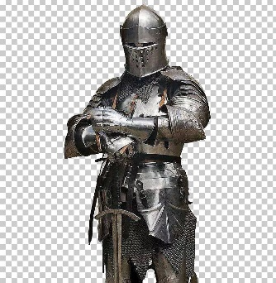

**Image 5:** This knight was well-trained and difficult to kill. Huge drawback to this armor was slow mobility. Eventually, enemies will learn to exploit this fatal flaw.

The Hundred Years War

The Hundred Years War will begin between France and England and lasts from 1337-1453. They spent more time destroying one another’s supplies and homes than actually fighting. This has been a common strategy in Ancient Civilizations, the Middle Ages and even the 20th century. The idea behind this is to keep as many troops alive and win the war long-term. Though this war lasts for 116 years, there were brief periods of **truces** (a period of time where people would stop fighting).

France and England would wage war over a series of issues:

* The French wanted a cousin of the deceased king to take over France
* The English King thought he was the rightful heir since he was the nephew of the deceased French king
* Britain wanted French territory and France wanted to defend their land

Despite long periods of truces and more time being spent on burning supplies, the casualty count was still fairly high. Archers were deadly for Britain as they could attack from long range. France only had one counter strategy to combat this issue: use knights. However, these arrows could penetrate a knight’s armor and led to many of them being wiped out quite quickly. The French had arguably a stronger army but could never get past these arrows. This would last for a long time until a new leader would emerge in France by the name of Joan of Arc.

Joan of Arc

Joan of Arc rallied France to combat England one final time. Unfortunately, Joan of Arc was 16, inexperienced and would not gain the respect of her fellow citizens. The **dauphin** (eldest son of the French King) was doubtful of Joan of Arc as well due to her age and the fact she was never a leader. Despite this, Joan of Arc convinced him otherwise and was given permission to lead a rebellion against the British. Joan of Arc emerged victorious and drove the British out of France. She was eventually captured and put in church court for heresy and witchcraft. She was then executed at the stake at 19 years of age.

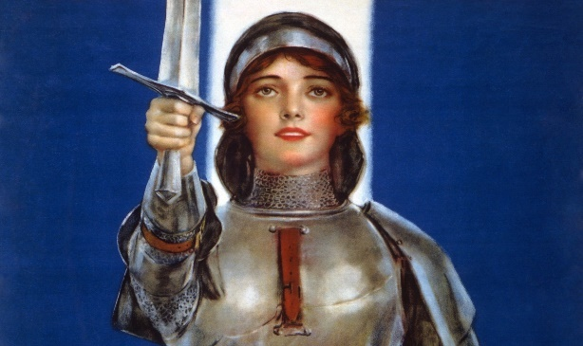

**Image 6:** Joan of Arc was a fierce warrior and strong leader. Her ability to lead France to victory would live forever and gave hope to a society that was crumbling for a long time.

**Lesson 7 – The Black Death**

The Black Death

Similar to Athens, the Black Death will continue to ravage Europe. It is considered to be a form of the **bubonic plague** (a highly contagious and fatal disease). The disease caused swollen lymph glands and caused a high fever mixed with vomiting. You would die within 1-3 days if you caught this disease. This disease got so bad that in some towns, the number of casualties exceeded the living. Majority of doctors and priests perished as a result of this and families had to abandon their sick relatives. To make matters worse, **flagellants** (religious people who whip themselves in public) told people this was a punishment from God.

There was no cure for the plague, and it caused fear in society. This fear created a lot of hate and further division as Jews were blamed for causing the disease. This disease killed around 50-60% of the population and weakened the Feudal Age significantly. With farming being such a key component of this system, it became harder to find serfs to do the work. When they were found, they demanded higher wages and would leave manors without notice.

The black death plagued Europe significantly. Though it has never been discovered why, you could survive this disease (though this was extremely rare). Europe would have to rebound quickly if it was not going to fall once again. However, a long history of mistreatment may have finally caught up to the European nations.

Peasants Revolt

Mistreatment of the peasants would eventually lead to revolts in both England and France. In France, serfs were often assaulted and robbed by mercenaries. Manor Lords kept increasing the rent which made it impossible for serfs to get out of their social class. These peasants banned together and attacked the French Nobles. The French Nobles reacted strongly by publicly killing the ringleaders, torturing those involved and burning each of their homes.

England would have a more difficult time dealing with this revolt. They were hit by the disease harder than France and Serfs had been negotiating for higher wages. England would then pass a law that all wages had to return back to where it was before the plague began. They then rolled a **poll tax** which was meant to offset the cost of the Hundred Years War. Wat Tyler and Jordan Ball (serfs) created an army that attacked London. Shockingly, guilds let them in due to empathy and care for their citizens. This resulted in the death of many English Nobles. When their two leaders were killed, the revolt lacked a leader and failed. When they returned to work on the farms, most Lords killed their serfs. Despite a failure in the end, this would begin the process for ending Serfdom once and for all.

**Lesson 8 – Changing Times**

Faith Through Pilgrimages

The Church eventually encouraged others to undertake pilgrimages (a journey to a sacred place). These were often dangerous and would last from months to years. Social status did not matter here as people would travel together. By visiting the major shrines (St. James of Compostela, Tomb of Thomas Beckett) and praying at them, you would increase your chances of making it to Heaven. If you kissed a relic, it was said it would cure you of any disease. All of these shrines costed money to visit and it would be used to fuel the Churches economy.

Cathedrals

Churches were relatively small until the 12th century. Once knowledge expanded, people learned how to build bigger and stronger establishments. This would begin the age of the **gothic** (steep roofs and pointed arches) cathedral. Cathedrals were big, filled with carvings and stained-glass windows. These cathedrals were meant to show power and wealth to God. These churches would then be given large sectors of land where they would charge taxes and take produce. All baptisms, marriages and last rites were also charged fees. With the church becoming stronger economically, it would not be long before it became a powerhouse in more areas.

Religious Unrest

John Wycliffe, a professor in England, strongly opposed the church. He believed that the church had no right to tell you what to believe in and that you had to make your own decisions. He then converted the bible from Latin to English and infuriated the church. The Church attempted to execute him, but he had friends who were Nobles. Wycliffe also believed the Church should not have absolute authority nor should they be charging for every service. His ideas would spark unrest and get people thinking something was not right. Eventually, someone will enter the mix and challenge the Church on their wrongdoings.

**Lesson 9 – Japanese Geography**

Japan Geography

Japan is made up of four main islands or an **archipelago** (chain of islands)

1. Hokkaido
2. Kyushu
3. Honshu
4. Shikoku

Japan is mountainous and its government is regional. With only 25% of their land being plains and valleys, Japan does not have many areas to farm.

Japan is also quite separate from mainland Asia (China, India) and the ocean between them is very rough. Japan is an interesting location because they are close enough to China and Korea to be in contact, but too far away to be imperialized. Getting to Japan took Europe a very long time (16th century).

Japan is located where the three tectonic plates (Asia, Pacific, Philippines) meet. There are frequent earthquakes and tsunamis in Japan as a result of this. Many of the earthquakes have caused tsunamis and Japan can be hit with nearly 1500 earthquakes a year.

Despite minimal trading, Japan was able to thrive due to its location. Japan’s waters had an abundance of fish, their forests provided wood and they had a lot of cotton for clothing. Despite having little land available for farming, the land that was ready was always fertile. The mild climate, consistent rain and subtropical climate enabled Japan to have longer growing seasons. Their main source of food was rice.

Japan also deals with **typhoons** (rain/wind storm that can be up to 220km an hour).

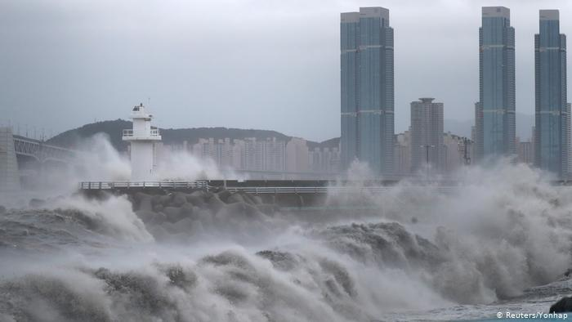

**Image 7:** This is what a typhoon can cause. It can create rapid waters, vicious wind storms and cause millions in damage.

Religion of Japan

The official religion of ancient Japan was **Shinto** (spiritual practices based on Japanese traditions). The most important aspects would include nature, flowers and gardens. Shinto involves pilgrimages to famous shrines. The most important deities of Shinto are Kami. Kami includes mountains, rocks, rivers, streams or ancestors. The main purpose of this was to have anything that drew your inspiration.

Japanese Inhabitants

Japan means “great land of the rising sun.” Japan has been around for thousands of years and their first descendants were known as Jomon. They were excellent hunters, fishers and gatherers (mainly nuts).

The Ainu had also been around for thousands of years, but they had their own form of government. The Ainu were not strong warriors and were often defeated in combat. Their last defeat forced them to surrender their land and it was renamed Hokkaido. The Japanese began to **assimilate** (force into your culture) the Ainu. They forbid them from speaking their language or practicing their customs. They were given some land to farm, but most of their rights have been taken away.

The Yayoi came around 400 BCE. They came from modern day Korea/China and married many of the Jomon. They took Japan in a new direction by focusing on metalwork and agriculture. They had excellent ideas to produce rice and helped everyone maintain a sustainable diet.

**Lesson 10 – China Influences Japan**

The Importance of Rice

Growing rice is a difficult process that puts tremendous strain on farmers. From maintaining the paddies, to planting crops and harvesting the rice; it was so time consuming that women and children had to help. If rice crops failed, famines usually followed right after.



**Image 8:** This paddy field is where rice is grown. It had to be moist and maintained.

For a long time, rice was used as the currency. Your territory could be rich or poor depending on how much rice you were able to produce.

Yamato Period

Around 300CE Japan entered the Yamato period. Yamato is the name of the plain around Osaka. Osaka was the capital city at this time due to its agricultural area being so fertile. The family claimed they were descendants from the sun god (Amaterasu) and planned careful marriages that would enable them to maintain power over Japan. This is how the **sun line** was developed (concept that the emperor is related to the goddess). Japan maintained a close relationship with Korea and even had Buddhism make its way into the country.

After the Koreans began writing everything down in Chinese characters, the Japanese took this idea, adapted their own writing system and called it the **kanji** (characters in written Japanese that represent Chinese characters). This would then develop the new system known as the **Kana** (characters that represent sound in Japanese language).

Buddhism became popular in Japan because it focused on the afterlife which was something that Shinto never did. The Japanese did not want to abandon Shinto, so they kept some beliefs and allowed citizens to practice either faith. However, this would change in 538 CE when Prince Shotoku would mandate Buddhism as the official religion in Japan. Prince Shotoku would also organize multiple expeditions to China as a method for learning new information.

Nara Period

In 710 CE Nara became the capital of Japan. The Nara period also took ideas from China about both government and taxes. They built beautiful temples and allowed Monks into the government. However, epidemics will emerge in Japan and wipe out a large portion of the population.

**Lesson 11 – Feudalism Develops**

Heian Period

The Heian period would last from 794 CE-1192 CE. This period would embark where Japan would disassociate themselves from Chinese culture. Nobles would focus on flower arranging, art and appreciating nature. They would write a lot of poetry that was usually centered around how life will end.

The Heian emperor was the ruler of the country, but most of the power fell in the hands of the Fujiwara family. The Fujiwara family kept power by ensuring their daughters married rich nobles or members of the imperial family. As time went on, many nobles chose to live far away from the capital. This permitted them to have more power due to them controlling land. They would hire powerful armies and pay them well so that their loyalty was to the nobles and not the emperor.

The Fujiwara will eventually come out of power and two families will combat with one another for control of Japan. These two families were the Taira and Minamoto. The Minamoto family was winning a naval battle so the Taira family drowned themselves to avoid capture.

Shoguns Gain Power

Japanese Nobles began hiring samurai warriors to defend them. With a strong army, they would impose a tax on anyone living on their lands. The Minamoto no Yoritomo had a chance to make himself emperor but declined. Yoritomo wanted to become the military commander and would give himself the title of **shogun** (a military ruler of Japan during the Feudal period). Shoguns were widely respected in society and held a ton of power.

The Shoguns ruled Japan and government officials were also soldiers. The Japanese called their government the **Bakufu** (government headquarters). The Bakufu would have their government run into three different parts:

1. The Military
2. Day to Day Affairs
3. Justice

Feudal lords were called **daimyos** and samurais had to be loyal to them at all times.

Feudal Society

From the late 12th century Japan would have little contact with other nations. This result was both positive and negative. While it provided Japan with its own identity, it could not progress at the rate other civilizations were.

Japan made it clear where each citizen was in their ranking system. Despite getting a bit more respect in society, women were still considered inferior to men. Male children had more power than their own mothers. Respect was mandatory (especially if they were high on the pyramid).

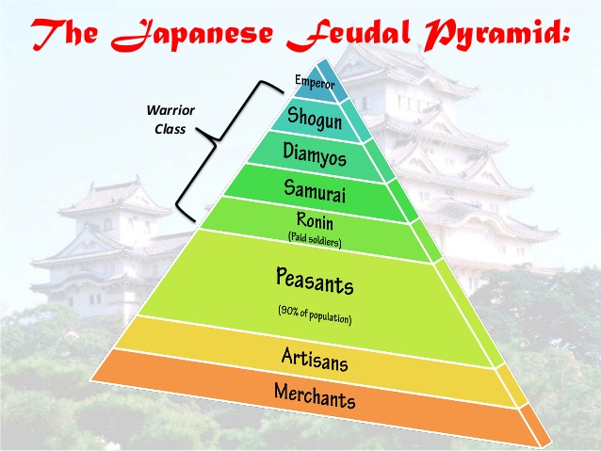

**Image 9:** This is the feudal pyramid of Japan. Most of the population were peasants/farmers.

The warrior class held all of the power. This class was similar to the Lords, Nobles and Knights of Feudal Europe. Bravery and self-control were very important to remain in this class. However, it was legal to kill anyone below the warrior class if they disrespected you.

Everyone else was ranked by how important your job was to Japan. Because Japan did not complete much trading globally, merchants were not given as much respect as farmers. You were also unable to move up the pyramid unless it was an unlikely circumstance (marrying into the warrior class, getting approved for a new job).

Below the merchants was an “underclass” that were not respect enough to even be put on the pyramid. This would include slaves and butchers. They were so disrespected in society that they were not even allowed in the homes of anyone above them.

The Samurai

A Samurai was a highly trained warrior that protected their Daimyo at all costs. They did not have to pay any taxes and were ranked highly in society. The Samurai would often be given gifts and threaten the lower class for some of their money. If a samurai lost their Lord, they would be called a **ronin** (near-outlaw with high skill in combat). Interestingly, Samurai women were given the same rights as Samurai men and were also highly skilled warriors.

The Samurai would eventually be given two swords (one short and the other long) and were forced to fight in wars regardless of the odds to win. They often killed members of the lower class if they said a single word of disrespect to them.

The Samurai had to follow the **Code of Bushido** (a system based on bravery and honor). This required them to protect everyone that was not in the lower class. A Samurai who did not protect his Lord was immediately stripped of his duties and forced to be an outlaw/a man without honor. Asano Naganori, a Daimyo, attempted to kill a court official over disrespect. His attack failed and he had all of his lands and honor stripped away. Since the Samurai had to honor their fallen Lord (despite the government warning them not to), they killed the court official. Due to them following the Code of Bushido, they were given an honorable death.

**Zen Buddhism** (a variety of Buddhism that emphasizes meditation) was growing in Japan. This was meant for people to understand themselves and how to be one with nature. The Samurai practiced this philosophy because it provided them with discipline and peace. Despite being ruthless warriors, they took tremendous pride in beauty.

A series of civil wars would plague Japan and cause a lot of hostility within the country. Oda Nobunaga would reunify Japan by stripping the power away from the Daimyo’s. His close friend, Hideyoshi will take over and continue the legacy of his deceased friend. After Japan goes through a state of small progression, a war breaks out and the Tokugawa family emerges. The Tokugawa family imposed strict laws on the warrior class and brought peace to Japan within just a few decades.

**Lesson 12 – European Contact**

Despite constant failed attacks from the Moguls throughout the 13th century, Japan was left alone by other nations.

**Europe Meets Japan**

By the 16th century, ships had improved and it enabled them to finally reach Japan. Japan was originally happy people were coming to visit because they could learn new ideas. The Portuguese, Spanish and Dutch would all come into Japan.

The Japanese did not get along with the Portuguese because they were considered rude and impulsive. However, Japan forced the relationship because Portugal had brought new resources such as guns and food items.

Francis Xavier, a Spanish missionary, had converted many Japanese to Christianity. This would be the first sign that European influence was on the way.

The Shoguns had feared European contact due to their weaponry. They felt if the Europeans brought Guns, stronger ships or other powerful weapons it could undermine their authority. Shoguns murdered anyone who converted to Christianity and exiled Europeans altogether. An Exclusion Act gets passed which includes the following:

* All Christian missionaries were forced to leave Japan
* Nobody Japanese could leave Japan
* Strong ships meant for voyages had to be destroyed
* Japanese who were out of the country could not return
* Most foreign objects were forbidden

The Japanese would only all those from Korea and of Dutch descent into the country. This was to eliminate all threats entering Japan