**Unit One: Human Geography**

**Overview**

**Introduction**

It is important to understand how population grows, changes and adapts to an ever-changing environment. In order to understand how population works, we must factor in the importance of demographics. In this unit, we will explore population trends, demographics and the environment.

**Key Questions**

* Why is it important to understand how demographics work?
* Why is there such a stark contrast in population growth between Industrialized and Developing countries?
* Should there be a law that limits family size?
* If Canada is ranked so high on the HDI, why is another countries failure their problem as well?
* If money fails developing countries, what is a reasonable solution to help them prosper?
* Should Canada use its water supply as a tradeable resource?
* Justify whether or not Genetically Modified Foods are acceptable in today’s society.

**Lesson 1 – Five Themes of Geography**

What are the Five Themes of Geography?

In order to understand how geography truly works, me must understand why places are in certain areas and how they affect their society and others. The five themes of Geography are: location, place, human/environment interaction, movement and region. All five themes work with one another to help us understand how the world operates.

Location

Location describes where something is on earth. When describing location, we can see it from two different lenses: absolute and relative

* **Absolute Location:** describes exactly where it is located. To do this you could use degrees of latitude and longitude or an exact address.
* **Relative Location:** describe it in relation to another place. You might say it is near, above, west of, etc.

Place

Place describes the physical and human characteristics of a place. Physical characteristics are things like terrain, height above sea level, landforms and climate. One human characteristic, a place has, is population.

Human/Environment Interaction

Human/Environment Interaction describes how humans have changed a particular place (such as through canals, highways, etc.) and how humans adapt to the environment around them (like wearing jackets in cold climates).

Movement

Movement describes how people, goods, information and culture got to a particular place.

Region

Region describes the similarities you may find in a place. These can include language, culture and similar historical background.

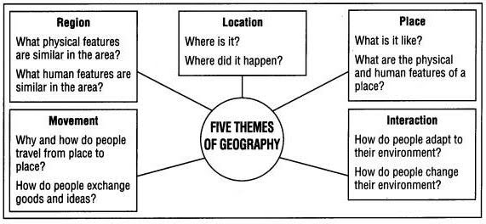**Image 1:** These are questions that Geographers ask themselves when looking at a particular place.

**Lesson 2 – Population Growth**

As of 2020, our population on a global scale is increasing. However, this does not mean that every year will increase by the same number of people or that an increase in population is guaranteed in all countries. Many countries will remain on the rise and some may see a decrease in population size.

Population Density

Population density tells us how many people are living in an area. For example, rather than looking at British Colombia as a whole, we would look at the population of Vancouver. From here, we can see that within B.C. Vancouver would have a far greater density than anywhere in Northern B.C.

The easiest way to calculate the population density is by dividing the total number of people living in an area by the actual area they occupy. For example:

**10,000 people ÷ 100 km2 = 100 people per km2**

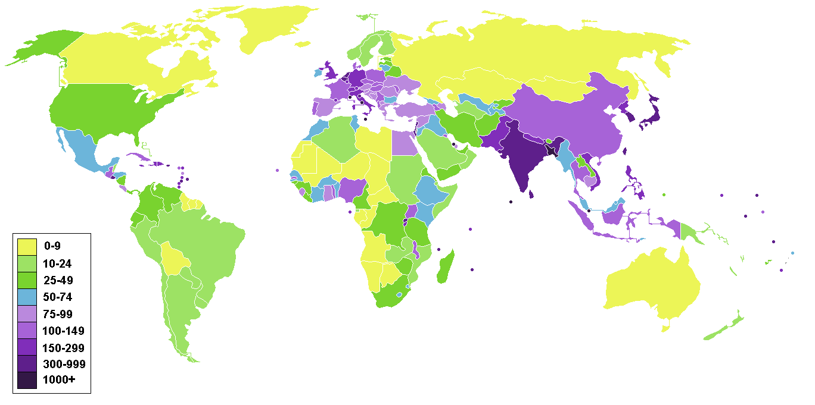

**Image 2:** In image two, we can see the density between America vs. Canada. Simply from this image, we are able to see that the U.S.A would have a far greater population than Canada. You can compare Canada with other countries as well to see if their population is similar in size.

Crude Birth and Death Rates

In order to understand the crude birth and death rates, they will require a small calculation. Specifically, crude birth rate can be determined by dividing the number of births in one year by the population and then multiplying the result by 1,000. For example, Canada has a 37.59 Million population and had 382,533 births in 2019. If we use the formula: births divided by population x 1,000 we can determine Canada’s population growth.

382,533 divided by 37,590,000 = 0.0101765 🡪 0.0101765 x 1,000 = 10.17

This means that per 1,000 people in Canada, we had 10.17 births. It is important to understand population growth per 1,000 people because it allows us to learn Canada’s growth or population decline on a proportional level.

Crude death rates are done very similar to birth rates except we change the birth rate number to the death rate. In 2019, Canada had 287,330 deaths

287,330 divided by 37,590,000 = 0.007644 🡪 0.007644 x 1,000 = 7.6

Therefore, we can see that Canada had an increase in their overall population by quite a large margin (nearly 3 people per 1,000).

Population Growth Rate

When looking at population growth, we must also factor in immigration as they can change the population significantly. There are two factors we must analyze in immigration:

* **Immigration:** those who come into the country
* **Emigration:** those who exit the country

In order to get the population change, you must take the following formula:

Crude Birth Rate – Crude Death Rate +/- Net Migration Rate = Population Growth Rate

Rule of Seventy

It is also important to assess how many years it will take a country to double its population. This can be important because it will enable a country to best prepare for what the future brings. As population increases, food supply, employment and many other things will also need to be on the rise. Luckily, it is not too difficult to estimate when a country will double its population. By using the rule of seventy, we can determine the amount of years it will approximately take for a country to double in population size. You simply divide seventy by the growth rate (percentage). For example, Canada had a 1.9% population growth in 2019. Therefore, we can use the formula to determine the following.

70 divided by 1.9% = 36.8 years for Canada to double its population

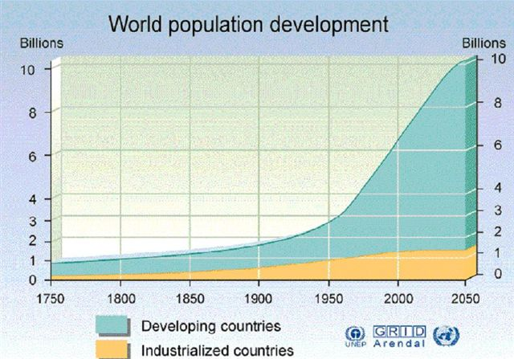

**Image 3:** I this photograph, you can see that developing countries are reproducing at significantly higher rates than industrialized countries. As you look at this image, think of why this could be.

**Lesson 3 – The Demographic Revolution**

Demographic Transition Model

The Demographic Transition Model shows the changes in a population’s birthrates and death rates and growth based on its technological development.



**Image Four:** The Demographic Transition Model shows birth rates, death rates and its relation to population change. It can be broken down into 5 stages (as seen below).

Stage 1:

* High birth and death rates result in small population growth.
* Disease and malnutrition keep infant mortality rates high.
* Life expectancy is very low.

Stage 2:

* High birth rates and low death rates result in population explosion
* Death rates fall due to medical and scientific advances as well as better nutrition.

Stage 3:

* Low death rates and rapidly declining birth rates.
* Social programs, industrialization, and urbanization eliminate the need for large families.

Stage 4:

* Rates of natural increase have stabilized.
* Low birth rates and low death rates lead to slow population growth.
* Factors include changing role of women and family planning programs.

Stage 5:

* Theoretical next natural stage for population change in the future.
* Birth rate drops below the death rate.
* Japan is an example of this stage as their birth rates are decreasing and their life expectancy is increasing.

**Lesson 4 – Population Profile**

Population is very important to the development of a society. We have already seen a developed vs. a developing country looks like in terms of health care, industrialization and life expectancy. However, we need to further breakdown population so that we can best understand demographics. The easiest way to do that is by creating/analyzing a population pyramid.

Population Pyramids

A population pyramid is an Inverted bar graph showing population data as groups (age/gender groups). It is expressed as a percentage of that region’s total population. Below are some examples of what a population pyramid looks like.

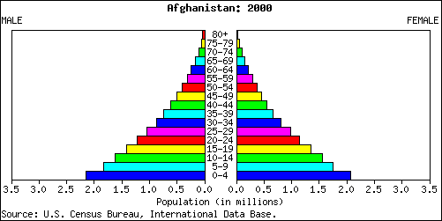

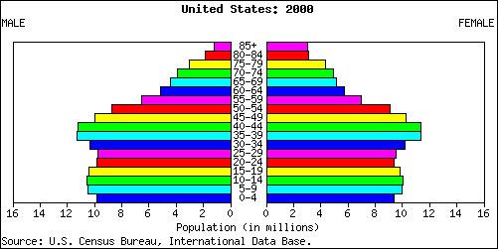

**Male**

**Female**

**Image Five:** In this population pyramid we can see an increasing population since the older generation represents far less than the younger generation. This would likely represent a developing country.

**Image Six:** In this population pyramid we see a far more stable population. It fluctuates only slightly in terms of birth rates which will allow the economy to grow. Additionally, in comparison with *image five*, we can see the life expectancy rates are far greater.

Age Structure of a Population

Demographers divide population up into three groups: ages 3-15, 15-64 (working class) and 65+. This helps them determine the **Dependency Ratio** (people being supported by the working groups).

Demographers will also use **dependency load** (percentage of people younger than 15 or 65+) to determine how reliant we are on the working class. Canada has a high ratio of 50.36% (2019).

**Lesson 5 – Canada’s Population: Past, Present and the Future**

In 2006, Canada’s population over 65+ was only 7.7%. In 2019, that number increased dramatically to 20%. This puts far more pressure on medical systems and social programs to assist the elderly.

Immigration

Canada’s population size will have a direct impact on immigration. This will likely create a scenario where the number of accepted immigrants fluctuates yearly. Immigrants usually account for 70-80% of the net labor workforce each year. This means that if we see an increase of 100,000 labor workers, 70,000-80,000 will be from another country.

Our youth must learn these skills to help offset that increasing life expectancy so that less pressure is put on the economy and health care systems. Globally speaking, it is easier to acquire immigrants to work these jobs than Canadians due to numerous reasons (difficult accreditation processes, fierce competition).

Aboriginal Population

The Aboriginal population in Canada is also increasing exponentially. It has increased to 4.5% of the Canadian population. Majority of this population is under the age of 25 and their population is expected to grow even bigger over the next few decades.

**Lesson 6 – Where do Seven Billion People Live?**

In order to understand population, we must consider another factor and that is simply “where is everyone actually located?” By doing this, we can determine many key factors such as population density and population distribution.

Finding the World’s Population

Demographers must consider a key factor when determining population size and how they will do over time. This factor is known as **Population Distribution**. Population distribution refers to how people are spread over the Earth’s surface. For example, Asia will have a far greater population than North America. When the land is permanently inhabited, we refer to it as **Ecumene**.

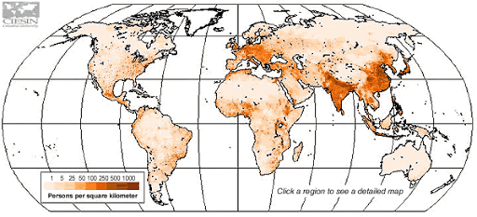

**Image Seven:** We can see here that Asia has a far greater population than North America. This indicates their distribution is greater in this continent.

There is one more key piece that demographers will look at. This key piece is referred to as **Population Density** (where everyone is located in a given area). For example, a city such as Vancouver will have a far greater population size than Winnipeg, Manitoba.

|  |  |
| --- | --- |
| **Population Density** | |
| Physical Factors | Human Factors |
| Climate | Government |
| Resources | Disease |
| Soil | Development |
| Vegetation | Culture |
| Water | Communication |

**Image Eight:** These are the major factors that will impact Population Density. They have been broken down into two components based on people preference. For example, people have a stronger desire to live in a warm climate with clean water rather than a colder climate with potentially contaminated resources. Government, culture and development also play key roles in how a society operates and where people will go.

Nutritional Density

**Nutritional Density** is measured by how much calories can be produced from the land. This is very important to countries because these calories provide the nutrition needed for people to remain sustainable. Canada can not provide enough nutritional density to its citizens due to its climate. Canada in its spring and summer seasons can provide excellent crop output, but minimal (if any) in its fall and winter seasons. In China, their warmer climates make for an excellent nutritional density output.

Overcrowded Population

If the world continues to go on its current trajectory, we will run into some environmental issues and certain countries food supplies could deplete (specifically India and other developing countries).

**Lesson 7 – Measuring Development and Living Standards**

We have discussed population size and why certain countries typically have higher populations. However, what is the quality of life like in these places? How do we even determine a “quality life?” This is where we factor in the **Human Development Index** to give us an indication as to what life is like around the world.

Measuring Development

The Human Development Index ranks standards of living across all countries. It includes life expectancy, literacy rates and GDP (total number of goods and services provided by a country in one year divided by its population).

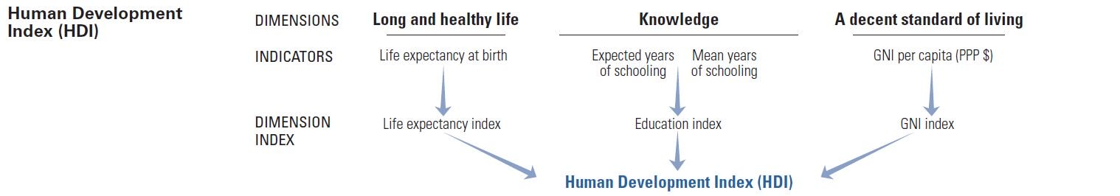

**Image 9:** These are the factors when determining where a country ranks on the Human Development Index. The higher you place in these categories, the better your quality of life in comparison with other countries.

|  |  |  |  |  |  |  |
| --- | --- | --- | --- | --- | --- | --- |
| Rank | Country | HDI Value | Life Expectancy | Expected Years of Schooling | Mean Years of Schooling | GDP |
| 1 | Norway | 0.954 | 82.3 | 18.1 | 12.6 | 68,059 |
| 2 | Switzerland | 0.946 | 83.6 | 16.2 | 13.4 | 59,375 |
| 3 | Ireland | 0.942 | 82.1 | 18.8 | 12.5 | 55,660 |
| 4 | Germany | 0.939 | 81.2 | 17.1 | 14.1 | 46,946 |
| 4 | China | 0.939 | 84.7 | 16.5 | 12.0 | 60,221 |
| 6 | Australia | 0.938 | 83.3 | 22.1 | 12.7 | 44,087 |
| 6 | Iceland | 0.938 | 82.9 | 19.2 | 12.5 | 47,566 |
| 8 | Sweden | 0.937 | 82.7 | 18.8 | 12.4 | 47.955 |
| 9 | Singapore | 0.935 | 83.5 | 16.3 | 11.5 | 83,793 |
| 10 | Netherlands | 0.933 | 82.1 | 18.0 | 12.2 | 50,013 |

**Image 10:** In this chart above you can see which countries are deemed the highest on the Human Development Index. This chart was taken at the end of 2019. Canada is ranked 13th with a 0.922 HDI rating.

A Planet Divided

Developed countries have higher literacy rates, healthier living and better infrastructure (trains, roads, schools that help boost the economy). Many countries industries are growing (especially Brazil). We call these countries **Newly Industrializing Countries**. Developing Countries have lower literacy rates, higher population and generally are in debt to developed countries (Heavily Indebted Poor Countries). They will usually be at the bottom of the Human Development Index (example: Ethiopia).

Development Goals

There are some goals that the world will need to complete in order to improve its own suitability.

* Eliminate extreme poverty and hunger
* Achieve universal primary education
* Gender equality
* Reduce child mortality
* Improve health and various diseases
* Ensure environmental sustainability
* Develop global partnership

Issues with Measuring Living Standards

There are some issues with measuring living standards in developing countries. Firstly, it is hard to track industrialization and goods/services. The reasoning is because currency is not always used in developing countries as they will often barter with one another. This does not symbolize a bad quality of life, but rather they can not gain the recognition that a developed country would.

Quality of Life

Quality of Life includes financial stability, health levels, levels of nutrition, literacy rate and status. In a country such as Canada, you can receive government support. In developing countries, that may not exist which could prevent electricity and safe water from being a staple in your home.

An urbanized world is also typically more desirable, but it also has its issues which can be seen below.

|  |  |
| --- | --- |
| Push Factors | Pull Factors |
| Underemployment | Lots of Labor Opportunities |
| Ethnic Tensions | Medical and Social Provisions |
| Requisition of Land for Industrial Purposes | Greater Access to Food |
| Environmental Impacts (deforestation) | Social Networks |

**Image 11:** “Push” Factors are reasons why an urbanized area may not be best. Despite an increase in employment opportunities, an increasing population size makes those jobs competitive. “Pull” Factors are reasons to join an industrialized country.

Globalization

One issue that is plaguing many countries in the world is **Malnutrition** (lack of nourishment). In order to help combat this issue and various other issues in developing countries (contaminated water, disease) **globalization** has been are the forefront. Globalization is the spread of ideas across many different countries. This would also include advances in communication or technology. Developed countries believe that globalization is the answer because it will give them access to cheaper goods and technology. China and India are beneficiaries of globalization, but other developing countries do not have the same infrastructure and therefore struggle.

**Lesson 8 – The Poverty Trap**

Measuring Poverty

Poverty is measured by people who live off of less than 1.90 a day. As of 2015, 736 million people (10%) live in extreme poverty. This number has drastically reduced over the years and will continue to do so as long as the world continues its trajectory.

The Organization for Economic Cooperation and Development aims to improve living standards for developing countries. The are a big reason why we have seen a decrease in poverty over the years.

The Poverty Trap

Tragically, 800 million people are still malnourished. However, the world has enough of a food supply to not only end malnourishment, but everyone worldwide could have a sustainable diet. The United Nations responded to this issue by providing money to developing countries. However, it completely failed as most of them went through their money instantly and did not fix their issues.

Structural Adjustment Programs were put in place so the International Monetary Fund (UN) could be repaid. They made these governments grow crops for export and let private companies control government services. They then forced governments in Niger (a patricianly bad economy) to put heavy taxes on basic goods. Essentially, these countries were set up to fail since many of these countries have few resources.

Ghana produces 70% of the world’s cocoa, but they sell it to four multinational companies who make most of the profit. Most money on developing countries is spent on repaying debts, not health care which factors into their low life expectancy.

**Lesson 9 – The Vulnerable Ones: Women and Children**

Many developing countries are male-dominated which makes it very difficult for females and children to succeed. They have seen oppression in regards to rights, education and monetary gain.

Women in Developing Countries

In many developing societies labor laws do not exist. Therefore, women often work 12 hours a day and are responsible for supplying the family with food. Education is also not as readily available; therefore, lowering their literacy rates in comparison to their male counterparts. For those women that are educated, they usually have fewer children and get married later in life. This stronger education also aids the children because these mothers understand the importance of sanitation and immunizations.

Niger, which is one of the least developed countries in the world, has a net income of $300 (average citizen) and a literacy rate of 30%. In comparison with Canada, the average income is $52,600 and the literacy rate is 99%. To make matters worse in Niger, they are in the Sahara Desert which makes growing crops extraordinarily difficult. As a result of everything, they are in huge debt to many nations across the world.

Children in Crisis

In many developing countries, children will not make it past the age of five. If they are lucky enough to, they will often be subjected to child labor and minimal opportunities for an education. **United Nations Children’s Fund (UNICEF)** have tried to combat this problem. They launched an index that is specific to children and ranks countries by five categories:

1. Mortality rates of children under the age of 5
2. Percentage of children underweight
3. Children who do not attend primary school
4. Risks from armed conflict
5. Risks for various epidemics (HIV/Aids)

If you are a child in a developing country, specifically in the continent of Africa, you are 13x more likely to die than in Westernized society. With nearly 30,000 deaths per day under the age of 5, UNICEF has determined that almost every one of these deaths is preventable. This is usually due to poor health standards and extreme child labor. Most children are working in agriculture with very little safety measures being considered. Though many countries have tried to put a stop to this, little success has been made in correcting this issue.

Another rising issue in developing countries is people under the age of 18 being brought into armed conflict. This has caused hundreds of thousands of deaths per year.

**Lesson 10 – The Health Crisis**

Our world is improving in regards to healthcare, literacy and ending poverty. However, we still have a major health crisis worldwide in terms of contaminated water and epidemics.

The Need for Clean Water

There are many places in the world that are negatively impacted by inadequate water supply. This is most notable in Africa where extreme weather patterns add to the water crisis. Lack of water also affects both health and agriculture. Wihtout water, crops can not grow and that would be the main source of food for these individuals. Water subsidies (grants from the government to help people or businesses) help only those that can afford to pay, leaving the poor with contaminated water. Cleaning the water supply would reduce all worldwide diseases by at least 10%

Epidemics

Epidemics are an increasing concern in developing countries. Specifically, HIV and Malaria are growing in developing countries. **Malaria:** a deadly infectious disease common in tropical climates and transmitted by a mosquito. 250 million people suffer from malaria worldwide. There is very little medical help in developing countries to help eradicate this problem and it has caused over one million deaths per year (most children).

HIV/Aids has grown into the most serious epidemic. The virus passes from person to person through sexual contact. Blood transfusions or from mother to child during birth. Treatments can extend one’s life, but it is expensive. 33 million suffer with HIV/Aids and 70% of those come from Africa

HIV was transmitted from Chimps in the 1920’s. In Botswana, Africa, life expectancy dipped from 59.0 to 53.0 due to this HIV/Aids pandemic. Millions of children suffer from HIV/Aids. Canada has led the charge to educate individuals in Africa on how to treat HIV/Aids so that its effects are minimal

**Lesson 11 – Improving Living Standards**

**Foreign Aid** (aid from richer and more industrialized countries) has been a primary way to help foster development in developing countries. However, this foreign aid has sometimes failed to reach its goals.

Foreign Aid

Foreign Aid comes in many ways:

* **Official Development Assistance** 🡪 focused on developing the economy and setting up welfare systems
* **Non-Government Organizations (NGO’s) 🡪** Private organizations that directly help the people in need
* **Multilateral Aid 🡪** Focused on large scale projects such as repairing and adding buildings
* **Bilateral Aid 🡪** Money from one country to another
* **Tied Aid 🡪** Aid provided to a country with conditions attached (how they spend their money, must pay back loan by certain time)

How does Canada help?

Pierre Trudeau created a system to help struggling countries prosper. The **Canadian International Development Agency** lends its assistance to the developing world. It develops its plan based on six human needs:

* Basic Human Needs (clean water)
* Women in Developing Countries (improve their lives and reduce poverty)
* Infrastructure (electricity and communication)
* Human Rights/Good Government (respect for human rights and democracy)
* Private Sector (create jobs)
* Environment (protection)

The goal of most government institutions is to really improve sustainable development. Essentially, this means that governments want these developing countries to improve their agriculture, transportation and upgrade their technology. This will help them going forward and make them less reliant on other countries.

Global Problems and Solutions

Non-Government Organizations (example: Red Cross) are an excellent way to help those struggling during these times. They are more valuable than government assistance because it goes directly to the people, rather than the country. The reasoning behind this is because when you give money to a country, usually elites or those in power retain majority of the money for themselves. Luckily, most governments have followed in the same footsteps as NGO’s and put assistance into social programs. Some of these include providing them with a direct water supply and providing them with everyday tools.

**Lesson 12 – Sustainability**

The environment is not necessarily in bad shape, but it is far from being where it needs to be. Water needs are above supply and storms are getting more severe. If we do not do our part, we could do irreversible damage to the environment going forward.

Value of the Environment

Warmer weather can be responsible for forest fires and the rising temperatures can create extreme weather conditions. Most notably, the Canadian arctic is having issues with their sea ice shrinking. This causes a few problems; polar bears will go extinct, shrinking shorelines and transport problems as a result of **permafrost** (soil remaining frozen all year long).

These problems have started to impact governments because the arctic has both travel potential and mineral deposits which will be more difficult to extract in these conditions.

Population Growth vs. Sustainability

With the population increasing on a global scale, it is beginning to put a strain on our resources. 80% of our goods worldwide are being consumed by 20% of the world’s elites. With pollution on the rise as well, the Earth’s **carrying capacity** (the largest population that an environment can support) is in jeopardy.

The population is expected to reach 8 billion within the next decade. This will pose huge issues going forward. Most of our water is used for agriculture and if the standards of living keep improving, so will peoples desire to eat meat, vegetables and dairy. All of this will eventually lead to **deforestation** (destroying forests and replacing them with something else). This land will usually be used for farming, but other infrastructure related items could take their place as well.

**Image 12:** Very little of the land around the Earth can be used for farming. With only 20% of the planet used for this purpose, it will be difficult to sustain ourselves going forward.

All of this can lead to **Global Warming (**the observed and projected increase in the Earth’s average temperature due to burning of fossil fuels and deforestation). Genetically Modified food is also on the rise and could lead to health risks down the road due to herbicides. However, the Canadian government has approved of these actions.

**Ecology** (relationship between living things and their environment) are crucial to the Earth because they take in Carbon Dioxide and release Oxygen. However, a lot of plants and forests are in danger due to industrialization causing **acid precipitation** (precipitation that is high in sulfuric and nitric acids as a result of pollution).

International Efforts

The emphasis on economic growth has caused wasteful consumption habits such as overfishing. 172 countries met at the Earth’s Summit to discuss environmental issues such a toxic chemicals in production (lead in gasoline), alternative energy sources to replace fossil fuels and the scarcity of water. They created the Agenda 21 which was meant to solve these problems. Nothing came from it.

Sustainable Development

**Sustainable Development** (a way to ensure the economy grows while the environment is not damaged) is needed worldwide. Overfishing, using more power than we need, and wasteful habits have added to the problem with our environment.

The world is starting to realize how serious this problem is and this was discussed at the Earth Summit. The Earth Summit, which was a meeting of 172 countries, produced **Agenda 21** (a statement of action for what will be needed to protect the environment). However, little has been accomplished since that meeting and we are still having these problems today.

Farming

Farming is going through a unique problem. Farms are starting to operate similar to factories which means assembly lines and overproducing for profit by large companies. Large companies are also producing Genetically Modified Foods as a way to feed the global population. An issue with this is that it requires the use of pesticides (kill unwanted animals) and herbicides (kill plants) and it could be harmful to humans. A way to counteract this issue is to purchase organic food. However, in Canada approximately 90% of organic food is imported from other countries.

When you import goods from another countries, you are increasing **CO2 emissions** (carbon dioxide emissions caused by burning fossil fuels). Farmers are in a difficult position because they simply are unable to match the lower prices from imported goods.

Forest Preservation

Forests are crucial to the world. 1.7 billion people rely on it for food, shelter and employment. It also protects biodiversity and reduces carbon dioxide. Some programs include replanting trees cut down for paper or creating sectors of land just for this purpose. **Protection Area Strategy** aims to keep 12% of BC’s forests for parks, recreation and wilderness. Stewardship is key from us to ensure these areas always remain sustainable.

**Lesson 13 – Trading Water**

In order to remain healthy, you must drink at minimum 1-2 liters of water every day. Canada has a large supply of this resource, but it is quite scarce worldwide.

The Water Worldwide

Approximately 2.5% of our world’s water is fresh. Almost all the water consumed is surface water which makes up nearly 75% of the consumption rate. Surface water can include streams, rivers, lakes and oceans.

In developing countries surface water is a resource they must rely on. However, surface water has many different issues that include: bacteria, viruses and parasites.

Is our Freshwater Safe?

Shockingly, over 20% of the world’s freshwater is located within one country; Canada. This number would be significantly higher, but a lot of the fresh water comes from glaciers in Canada’s arctic (which is currently inaccessible). Wastewater also tends to get into surface water which assists in the contamination problems. Dangerous chemicals such as Mercury, has been seen in the Arctic region quite often. Additionally, companies will typically build around water bodies and their waste products also gets into the surface water which makes drinking its water quite dangerous.

Though the aforementioned are massive threats to our freshwater supply, the biggest potential issue is overpopulation. With our world growing, the strain on our water systems will only become greater. To help with the growing concerns regarding water, farmers began using an **Aquifer** (layer of rock that holds groundwater).

Conserving our Water

We as a society must do better with conserving our water supply. As technology develops, so will ways to ensure our supply is going to be maintained. However, we must also reduce our water bottle consumption because they add to our **Carbon Footprint** (the amount of carbon dioxide emitted due to the consumption of fossil fuels by a person or company).

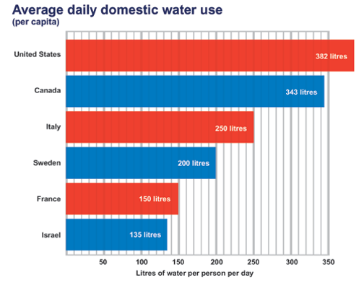

**Image 13:** Canada and the U.S.A are by far the largest in water consumption use. This issue needs to be resolved because they hold majority of the world’s freshwater supply.

**Lesson 14 – Change is in the Air**

Most of the Earth’s atmospheric gasses are located in the **troposphere** (lowest level of Earth’s atmosphere). Most notably, **Greenhouse Gasses** (various gasses in the atmosphere that absorb and emit radiation; including carbon dioxide and ozone) play a vital role in regulating the Earth’s temperature.

The Ozone Layer

Ozone is a type of Oxygen whose main responsibility is to block the Sun’s ultraviolet rays. **Ultraviolet Rays** can cause cancer and are invisible. The Ozone Layer is thinning due to the damage taken on the environment and a particular chemical called **chlorofluorocarbons (CFCS).**

CFC’s are chemicals used in coolants, solvents and aerosol cans that damage our Ozone Layer. Hair spray, air conditions and refrigerators are common examples of CFC’s and they have done over 80% of the damage to our Ozone Layer.

The UN created the **Montreal Protocol** to help combat this issue. The Montreal Protocol stated that any developing country was allowed to use CFC’s until the year 2000. After that, they were no longer permitted to use them and had to switch to a much less harmful chemical called hydrochlorofluorocarbons (HCFC’s). Though this chemical is less harmful, it still does damage to our Ozone Layer. Therefore, all countries agreed to stop using this by the year 2040. Once this change officially happens, the damage to our Ozone Layer will be significantly reduced.

Greenhouse Gas Emissions

As technology continues to be on the rise, so will Greenhouse Gas emissions. This is due to rising oil prices, more electricity use, additional buildings and various other emission uses. Canada is one of the leading countries in carbon emissions.

Our atmosphere is full of gasses and they work similar to a greenhouse. They trap heat energy from the sun and help to create a climate that is sustainable for humans to live on. With constant use of fossil fuels, we have increased the **greenhouse effect** (trapping heat into the Earth’s atmosphere which makes its temperature rise). Climate change is a real issue that has caused four big issues:

1. Climate has become warmer
2. Greenhouse gasses is the main reason for this warmer climate
3. Emissions are on an uncontrollable rise
4. Adaptation strategies are not enough currently

With these four issues, action is needed to stop Greenhouse Gas Emissions. The United Nations created the **Kyoto Protocol** (an international agreement that sets binding targets for reducing greenhouse gas emissions). The Kyoto Protocol included three additional clauses:

1. Carbon Tax 🡪 BC created a tax on fossil fuels to meet the governments goals
2. Cap and Trade 🡪 Any company who exceeds their maximum emissions, must buy “credits”
3. Carbon Sequestration 🡪 Shipment of carbon dioxide to suitable areas below layers of rock

All of these ideas worked and goals were exceeded by a large margin.

Global Warming

As a result of Global Warming, various things like disease will be prolonged and violent storms will become more frequent. This rise in temperature is becoming a concern for plant Earth. Below are some areas that are facing major changes:

|  |  |
| --- | --- |
| **Geographic Area** | **What Climate Change has done** |
| Arctic Regions | Glaciers are melting which increases sea level. |
| Boreal Forests | Dry spells will inevitably lead to longer forest fires. |
| Atlantic and Pacific Oceans | Addition of Freshwater from Ice Sheets have caused destabilized winds and currents. |

The depleting forests is a particular concern because it can create a **carbon sink**. A carbon sink means that a forest is no longer able to store carbon dioxide and will release it instead.

Though the negatives far outweigh the positives, there are some good things that warmer climate will produce. Specifically, growing seasons will be longer which can help with the food supply worldwide. Animals will also live longer in these warmer climates. It is important to keep in mind if the season is too warm, crops will not grow efficiently and more animals means a higher chance of those crops being taken away.

Sustainable Energy Sources

Most leaders around the world realize its time for change and a push for cleaner energy sources has been made. However, what exactly does “cleaner energy sources” even mean? Below are some ideas that world leaders are exploring.

|  |  |  |
| --- | --- | --- |
| **Source** | **Advantage** | **Disadvantage** |
| Hydroelectric Power | Provides a lot of power. Able to reduce electricity use. | Very disruptive to the environment. Can be expensive. |
| Wind Power | Emissions are free. Easy to install as well. | Need strong winds in order for it to be powered. |
| Geothermal | No pollutants or emissions. | Expensive to build and must be installed in active areas. |
| Tidal | Regular source of energy. | Only limited locations and interferes with aquatic life. |

There is no perfect solution for alternative energy sources, but what is important to remember is that we do have alternate means. Whether or not a system of these energy sources could work collectively remains to be seen. However, we are moving in the right direction.