Unit One: Ancient Civilizations

Overview
Introduction
Throughout history there have been excellent leaders, mediocre rulers and individuals in power who did not care for their citizens. We will assess four different civilizations with completely different outlooks on how an empire should operate. Despite major differences, all four civilizations were highly successful and failed in many regards.
Key Questions
- “China was its own worse enemy” Is this statement justified? Why or why not?
- Should religion have an effect on political matters?
- Do democracy and a jury system make Greece the most progressive civilization?
- The Roman Empire had many flaws. Which flaw was most responsible for its collapse?
- Which of the four civilizations was the most successful and why?

Lesson 1 – Geography of China
Civilization (an advanced state of development in human society. The Chinese Civilization can be dated all the way back to 1650 B.C.E when the Shang dynasty was in full effect. A dynasty is a succession of rulers from the same family. However, in Ancient China that would not always be the case as power would shift often.
Geography Affects Ancient China
Regardless of civilizations, geography plays a key role in how they grow and develop. It can work as a natural defense against enemies. Ancient China was lucky because their geography favored them significantly. Below are some of the many advantages they gained due to location.
- High mountain ranges in the western region
- The Tibetan Plateau in the West (highest plateau in the world)
- Desserts in the northeast
- Ocean to the east
- Jungles in the southeast
Notice how directly north there is nothing mentioned? That is because China had a weak point. The northern region consisted of steppes (flat grassland with no trees).
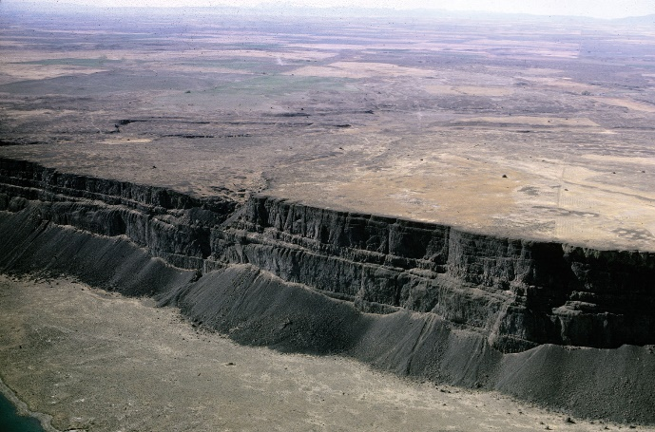
Image One: This is a high plateau. China had this in their western region. Can you imagine an enemy try to scale it? Additionally, China could defend it from higher ground.
China also had two major rivers: Yangtze River (southern region) and Huang He (northern region). These rivers were large and were excellent tools for farming. Unfortunately, the Huang He River in particular floods often and has claimed many lives. However, the Yangtze River is easy to navigate which made transportation much easier.
China also has a favorable climate. The northern region is subarctic which means it has cold winters and dry summers. China’s southern region is subtropical which means it has mild temperatures and lots of rain.

Lesson 2 – A Civilization Begins
There is a chance that a dynasty did exist before the Shang Dynasty (named Hsia), but with a lack of evidence to support this claim, we trace China’s early days to the Shang Dynasty.
The Shang Dynasty Begins
The Shang Dynasty would rule for a long period of time (600 years: 1600-1050 B.C.E.). People were living in the northern region and were farming daily to keep a sustainable diet. The Shang were a group of powerful warriors who took the throne and immediately put changes into place. They would divide the region into smaller parts and put Nobles (rich, powerful people) in charge.
The Northern steppes is where the Nomadic warriors lived. They would often fight the Nobles due to disagreements. The Shang would not intervene in these matters, but rather advised the Nobles to have an army to combat these issues.
These nobles lived in huge houses that were made of stone or timber. Most citizens lived on farms and in the Huang He Valley the often had a surplus (more than they needed) of food. Surpluses were a boost for the economy because people could trade extra food for other resources (bronze, wood etc.)
The Government would typically do little for the people. The peasants would live in hoses roofed with thatch (straw) and dug into the soil. Peasants would work on roads and in the military for no pay. They also had to reinforce the dikes (holds back water) to prevent any flooding.
Image 2: This image shows how they would keep water from flooding. While not 100% effective, it did a good job to prevent a significantly high number of deaths.
The Shang Dynasty may have treated their citizens horribly, but there were a lot of positives. They created a writing system, advanced pottery and mastered metalworking. Most of these metal pieces were designed with animals or gods to represent their faith and devotion to religion. They also perfected silk making (delicate cloth). Silk will eventually become a highly tradeable resource for the Chinese.
The Shang were religious individuals who believed in multiple gods, nature spirits and ancestor spirits. The Shang believed that Shang Di (a higher God) would send harvest in the wake of a battle. However, if your civilization was bad, he would make it a terrible year for crop growth. Nature spirits included the wind, stars and the sun. Most Chinese citizens believed that the Gods would only listen to those in power, meaning the Shang Dynasty had to do their communication.
The Shang had two major beliefs that continue to influence current Chinese society.
- Yin and Yang
  - Yin is Earth, darkness and feminine
  - Yang is Heaven, light and masculine
  - Believed that both had to work together to create a society
- Feng Shui
  - Feng means wind
  - Shui means water
  - Most people would get Feng Shui experts to tell them where to build houses
  - Qi (chi) is the natural force that travels in wind and is held in water
Civilization or Dynasty?
Eventually the Shang Dynasty comes to an end when the Zhou take over. The Zhou dynasty had an issue with the Shang because they lost the Mandate of Heaven (the idea that the ruler must support the gods). Since the Zhou felt the Shang became a Despot (person who ruled with tyranny), they took over the reign of China. The Zhou dynasty used many of the same ideas that the Shang did, but were eventually overthrown by various conflicts. This brought war for 200 years and eventually led to Confucianism, Legalism and Daoism.

Lesson 3 – Civility and Peace
As China was waging war on one another, they decided to search for peace. This led to four individuals (Confucius, Han Feizi, Laozi, Siddhartha) emerging to create peace in society.
Confucianism
Confucius was a philosopher (someone who seeks wisdom about existence and reality). He was adamant that citizens practice tradition and duty as they would help fuel China to peace.
Confucius lived from 551-479 BCE. Confucius constantly preached that everyone was responsible for this turmoil in society. Confucius believed that everyone was basically good, but they needed someone to train them to behave that way. His viewpoint would extend into five main virtues:
- Honest
- Upright
- Charitable
- Loving all Relationships
- Conscientious
Confucius also believed that anyone in power was not above the law and should be required to respect and value their citizens. These relationships that were formed were integral to the success of society. In addition to this, he believed five relationships in particular were important:
- Father and Son
- Older Brother and Younger Brother
- Husband and Wife
- Friend and Friend
- Ruler and Subject
While Confucianism (the system of ethics that should be taught) is not a religion, it is a philosophy for how people should behave.
Legalism
Han Feizi believed that people by nature were bad. Specifically, he constantly preached that people by nature are selfish and greedy. Feizi also claimed that in order for society to progress, strength and ruthlessness were mandatory. If the laws are maintained and the leader is good, everyone should follow what is being said. This would create a peaceful society under the Legalism viewpoint.
Though Confucianism is considered the “better philosophy” Feizi’s ideas were used to punish crimes harshly. Some of the crimes you could face in Ancient China was imprisonment, beatings, exile and death. The most serious crime was treason (betraying your country) which could lead to your entire family being executed.

Daoism
Daoism was based off of the teachings of Laozi. Daoists believed that they needed to follow nature. If they followed nature, they would better understand it. An inability to understand nature would lead to problems in society. Unlike legalism, Daoists believe in living freely without law and customs. This would ensure that everyone behaved naturally.
Daoists also believed in strengthening the Qi within people. In order to do this, they became alchemists (a chemist would be considered scientifically unsound) and looked to achieve immortality (living forever). Daoists also made people consume mercury because they believed that would give you an endless life, however it led to many deaths.
Enlightenment
The final idea that came during this period was Buddhism. Buddhism actually developed in India and came over to China by an individual named Siddhartha. He searched worldwide for answers to suffering and came back having received enlightenment (being awake to a great reality) and became the Buddha.
The Buddha said suffering will always occur if you only focus on yourself and not the well being of others. The Buddha believed in meditation (the act of calming the mind) so that people could concentrate. They also believed in reincarnation (being reborn time after time until you find enlightenment). This was also heavily sponsored by the upper-class elites which led to many monasteries being built.

Lesson 4 – Central Government
Rise to Power
Ying Zheng became the ruler of Qin (a state) at the age of 13. This was immediately after the warring state period ended. When he became a man, he defeated the remaining Zhou kings and conquered every other army surrounding the land. Zheng may not have ruled for a long time, but his goal was clear; China must be united. Zheng would do so under the Qin Dynasty and would call himself Shi Huangdi (first emperor).
The Quin dynasty may have been popular, but they fell immediately for a few reasons. Firstly, despite uniting China they were still taking over a kingdom that was quite hostile. Secondly, after the war the Qin dynasty was understandably weak. Therefore, defending against revolts wars far too difficult.
Central Government
A Central Government is created in China to help them remain a country as opposed to a collection of states. A Central Government is a government concerned with areas that affect an entire nation or empire, such as defense, taxes and the economy. This would mean that Nobles no longer had power. Instead appointed officials took over in each district. There would be many changes that were coming as a result of this government.
- The Emperor redistributed all lands and every peasant family was given enough to be able to pay taxes. Peasants had to help build roads/bridges for free as a trade for compensated taxes.
- He standardized writing so that communication would be easy
- Made trading within China easier
Perhaps the biggest accomplishment was this began the Great Wall of China. While this is a famous landmark, it is important to understand the purpose of building such a monument. While prestige and honor were certainly factors, there were many other reasons why this needed to be built.
- The North of China was too cold to farm. They often raided the south for their riches. This led to many battles between the Northern Chinese and those living in the South.
- The emperor believed that a wall would keep nomads at bay and prevent wars.
This did come with a big negative. Nearly 500,000 conscripted workers built the wall. Many of whom died from exhaustion.
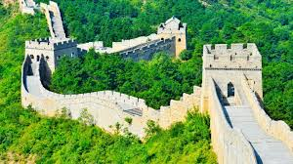
Image 3: The Great Wall of China still exists today. While its main goals were accomplished, it created political strife between the ruling class and the peasants.
The Central Government had many problems with nearly all of its citizens.
- The Emperor was too harsh on his citizens especially the lower class.
- He burned any books that opposed him (Confucianism, Daoism) there were many believers in these philosophies, and they did not appreciate it being dismissed so easily.
- Nobles did not appreciate losing their power and land.
There may have been a series of failures created by this government, but its main premise would build a legacy that would last forever in China. Eventually the first emperor falls and his son is overthrown immediately because his father created too many enemies. This sparked the Han Dynasty which was led by Gaozu. The Han Dynasty aimed to treat their citizens better and follow Confucianism, whilst still keeping most of the same ideas that were used before them.
Sui Dynasty
The Sui Dynasty will eventually take over around 581 CE. Immediately they attack other smaller kingdoms within China as a method to unite everyone under one true leader. They easily dispatch of their enemies and begin their own Dynasty. His name was Emperor Wen and he expanded the capital into the world’s largest city (Chang’an). He was too harsh and lost many citizens. However, they completed the Grand Canal under his reign.
The Grand Canal was one of the most revolutionary ideas they could have created during this time period for a multitude of reasons.
- The canal transported goods, crops and armies
- All small canals linked into one big one under Emperor Wen
- He would eventually link the south to the north (ensuring crops would make it to the North)
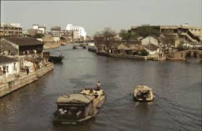
Image 4: This image of a Grand Canal is meant to show how easy it would become to trade and travel throughout China. This was a major issue for hundreds of years and it was solved under this Dynasty.

Lesson 5 - Freedom
We have seen a slow, but progressive growth with each dynasty. But what will happen when a government wants absolute control?

The Tang Dynasty Begins
The Tang Dynasty would emerge during China’s Golden Age (618-907 CE) and rule with an Autocratic Government (a ruler or government with absolute power). Gaozong took over China, but it was his son (Taizong) who changed its complexion. He decided to make China a Cosmopolitan empire (global empire where others could visit).
All surrounding countries (Korea, Vietnam, Tibet) had to pay a tax to China because they were not as powerful. However, China did promise them protection in exchange for this mandatory tax. They also helped the poor by taking away land from the rich and giving it to them. These peasants did have to pay taxes.
Societal Changes
As society began to evolve, foreigners were permitted into China and even given an area to live within the capital city.
Trade naturally increased as foreigners brought in instruments, horses and jewelry. Merchants however did not gain respect in society. According to Confucius, merchants’ sole purpose in life was to make money; which contradicts his “all humans are good” philosophy. The Tang allowed merchants to trade because they realized the value Merchants brought towards the economy. However, they were given low social status.
Women enjoyed this period because they were given more freedom than they have ever seen. They could all receive education, leave their homes and if they were in the upper-class, they could become writers. The only drawback was all farming rules remained in place.
Eventually a woman named Empress Wu Zetian became the ruler of the land. Tang rule stated that if your husband or son (who was in power) was too sick or young to be on the throne, their wife or mother could take over. This is how she gained power and eventually became the sole leader by removing her son from the throne.
Though the Tang dynasty made education available for everyone, it was still favored towards the upper class because they had the money to hire teachers or private tutors. However, there were still great strides made for education because more schools were built, and some were completely free. Additionally, if you completed school you were given an equal opportunity to become a government official as someone from a higher status. The students had to learn about Chinese history, customs and calligraphy (artistic method of writing using ink and a brush). In order to become an official, you had to pass three stages of exams (all getting increasingly more difficult). It is speculated only 3% of citizens passed the final exam.
Finally, the Tang dynasty encouraged the arts in significant ways. They improved the literary system by making books more accessible and recreating any destroyed books from the Qin Dynasty. They offered strong salaries to famous writers/artists and had a massive increase in chairs and stools being made.
The Tang Dynasty would eventually come to an end after getting too popular and being the victims of multiple rebellions. This rebellion once again separated China into a collection of states.

Lesson 6 – The Middle East
The Middle East
The Middle East is a region that contains Saudi Arabia, Israel, Iraq, Iran, Syria and many other nations. Many different cultures and religions live in this region. They include Jews, Arabs, Persians and Turks. Though other religions exist as well, it is dominated by Islam.
The Middle East has had a major impact on the world around us today. Canada adopted the alphabet system from the Middle East and many nations such as Africa and Europe have traded with them in the past.
Geography of the Middle East
The Middle East is quite large in size as it is nearly double the area of British Colombia. The Middle East is quite mountainous and has many fertile river valleys. The Middle East is hot and gets minimal rainfall per year. This warmer climate does create potential for year-round farming. Despite the minimal rainfall, the Middle East is filled with rivers and oases and they are able to extract water from underground. The most important crops that were grown are oranges, olives and figs.
Population in the Middle East is interesting. There is a lot of dessert that divides the nation. Therefore, people will usually cluster around rivers or oases because they provide the best tools for farming. With the ability to grow crops at exponential levels, the Middle East started expanding their trade routes early which helped spread the ideas of Islam.
The Arabs
The Arabs are Semitic people (ancient people that include Jews and Arabs). Another group of Arabs were Nomads, which means they constantly moved from one place to another. Regardless, Arabs were always exploring trade from the Mediterranean Sea all the way to the Indian Ocean and Central Africa. The Arabs also had camels which could travel almost 5 days without water in the Summer and nearly 50 in the Winter. This enabled trading to take place at rapid speed.
The Nomadic Arabs had a different social class system than other civilizations had. They based their system on generosity, bravery and fighting skill. If you were in their clan, you were guaranteed protection or vengeance in the event you were killed in battle. You had to be devoted to your family and were not permitted to be disrespectful to elders.
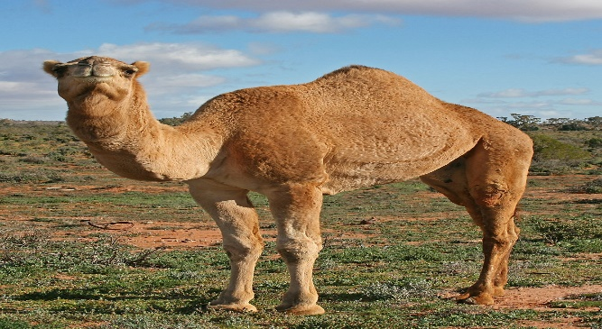
Image 5: This is an image of a camel. These animals were big reasons why the Islamic civilization had the best trading network.
Lesson 7 – Religion Spreads
Muslims (people who follow Islam) believe that Islam was revealed to the prophet (a person who speaks with inspiration) Mohammed in the 7th century.
Mecca (where Mohammed was born) was a place for pilgrimage for Arabic Pagans whose beliefs Mohammed did not accept. Mohammed stressed there was only one God which conflicted with Pagan beliefs. It is also believed that Mohammed had a revelation when on a meditation trip. That revelation revealed there was no God, but rather Allah. This helped convert many people to Islam.
Mohammed then defined Islam through the Five Pillars
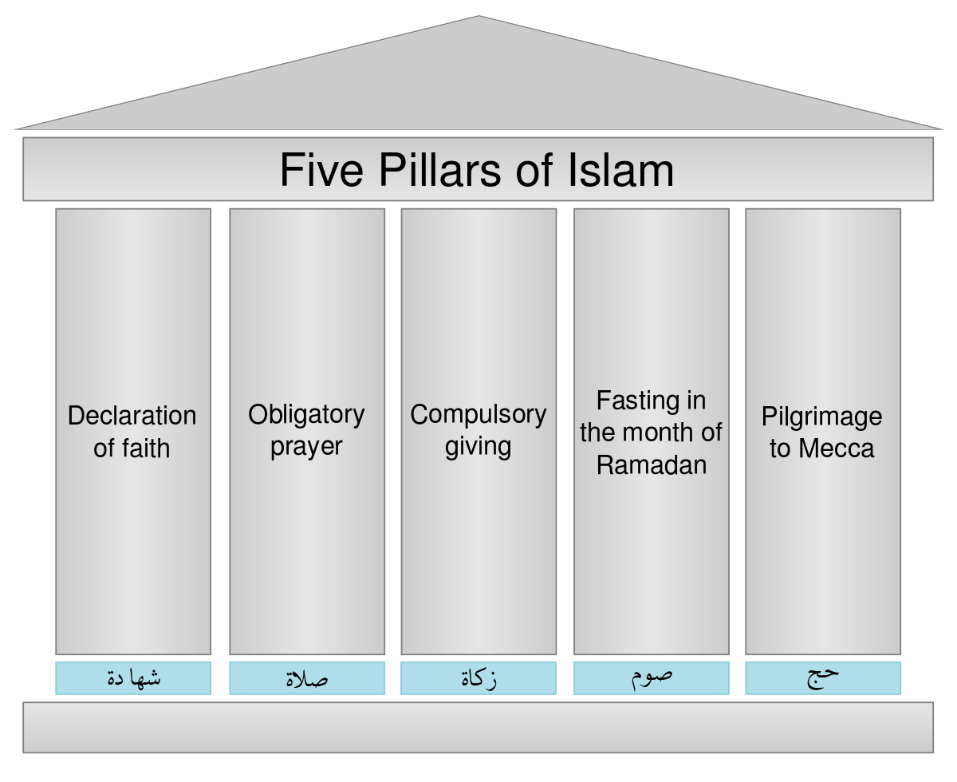
Image 6: These are the Five Pillars of Islam. You had to meet all five if you wanted rewards in this life.
Spiritual Community
Muslims accept that Koran (holy Islamic book) is the word of God. The Koran has never been changed because it is believed to be Gods actual words. Muslims also turn to the Hadith (a collection of teachings by Mohammed) to understand how to live and behave.
In Pegan Mecca they did not appreciate Mohammed’s ideas and executed believers of him. Most of his followers went to Yathrib (ancient city) and had many civil wars. Mohammed managed to solve this civil war and convert everyone to Islam.
Spreading Islam was considered mandatory in Arabia. This would mean by any means necessary which often caused a war. The Arabs would convert people and if you complied, your life was spared, and you were treated well. Should you decline, death or enslavement was instant. If you were a Christian or a Jew, you were permitted to practice your faith but not allowed to convert others. Additionally, you had to pay religious taxes if you were not following Islam.
The Islamic armies were powerful and swept through opposing generals with ease. With each victory in war, the Islamic empire became very wealthy.
Abu Bakr became Mohammed’s successor (because he was his army general). Many Muslims had an issue with that because Mohammed’s daughter’s husband should have taken that role. He eventually will become the fourth successor and first Imam (person who leads prayers in a mosque)
The Umayyad Dynasty will eventually take over after an assassination. They take action immediately by making Arabic the primary language, made coins, expanded trade and added a court system. They made laws more strict and permitted trading across the entire region. This made everyone feel safer and gave them a chance to boost the economy.

Lesson 8 – Lives Change
Muslim society used a Hierarchy (ranking of groups in society, from most powerful to least powerful). Non-Muslims were treated well, but were not permitted to rule. Islamic lives were typically stable, but did not progress in the countryside.
Abbasid Court
The Umayyad rulers will eventually lose power to the Abbasid family. The power of rulers became greater when the Abbasids seized control. They always dressed lavishly and had lots of jewels. The rationale behind dressing lavishly was to impress foreigners. They often won battles and stole everything from whom they conquered. This included treasure, goods and slaves. They also used religion as an excuse to engage in war
Life in the City
Major cities such as Baghdad had over one million people living there. This was a significantly high number at the time. They built mosques, libraries and universities (all admired by the Europeans). The cities were covered with walls as a method of protection. Inside of these walls’ peasants lived on the edge in small and cheap places. The rich lived far away from the walls and inside of palaces.
Scholars of the Abbasid Dynasty really wanted to advance science and technology. They wanted to learn about other cultures and even had Greek books in their libraries. Ibn Sina (also called Avicenna) described anesthesia in his medical book (Canon of Medicine). This advancement in science was so valuable that this book would be used for nearly 600 years.
They were not permitted to show animals and humans realistically in their paintings (considered sinful). They also expanded calligraphy (patterned objects such as tiles, carpets and buildings got better designs). The rich always supported the arts because they wanted their city to be more beautiful. It was also believed that the more beautiful a city was, the more prestige it had.
Women did not have equal rights to men. Specifically, they had to cover themselves up and had to be accompanied by a male guardian. This was an interesting development because Islamic civilization was progressing and nearly every regard but saw regression in their treatment of women.

Lesson 9 – Tolerance vs. Intolerance
The Islamic Civilization is going to visit Spain with the intention of conquest. It is important to note that Spain is dominantly Christian and Jewish at this point.
Arab Conquest
The Iberian Peninsula (southwest Europe that is now Portugal/Spain) was under control by the Germanic peoples (specifically Visigoths). The Islamic armies would conquer North Africa and eventually majority of Spain. Despite the conquest, they still treated the Christians and Jews with respect because they believed their religions had a lot of similarities (worshipping one God).
Umayyads Alive?
When the Abbasid rulers defeated the Umayyads they had one intention; “destroy them at all costs.” They nearly accomplished this goal, but were unaware of a few surviving members in Spain. Abd-al-Rahman and his brother Yahiya would both have children and his family would reign for nearly 300 years. The Abbasids would also encourage intermarriage which often led to their significant others converting to Islam.
The surviving Umayyad rulers wanted to have national identity (image a nation has of itself). They also turned a Visigoth cathedral into the Great Mosque of Cordoba. This new mosque would act as a place of worship and a cultural learning center.
Women had lots of rights under this empire. They often went to university and worked high paying jobs as copyists (makes copies of famous books). Additionally, non-Muslims were also allowed in government which was uncommon during these times. Their justice system was also excellent as it factored in Islamic law and local laws to create a fair sentence for an individual.
Spanish Reconquista
After a series of ineffective leadership, civil unrest began in Spain. Spain would be divided into a bunch of territories and they would often spark war with one another. This would lead to the Christians wanting to take back what they felt was theirs. They called this the Reconquista (reconquest of Christian territories). This religious war would last for a long time and lead to significant discrimination.
Discrimination
The Christians started winning the religious war and forced non-Christians into conversion. They also forced all Muslims and Jews to work certain jobs and wear distinctive clothing.
The Ottoman Empire will emerge in the 15th century from Turkey into Europe. The Ottoman Empire had early teachings of the Islamic Civilization and allowed Jews/Christians to freely express themselves. The Ottoman Empire was powerful and managed to take over Constantinople (which was a big city dominated by Christians). In order to combat this issue of conquest in Europe, Spain’s two major rulers combined forces to drive everyone (non-Christian) out of Europe.

The Jews had two options under the new ruler Ferdinand.
- Baptism a religious ritual where someone becomes a member of the church
- Banishment kicked out of the continent permanently
Majority of Jews chose banishment and went to the Ottoman Empire. The Jews were highly intelligent and did many things for Spain. After their explosion, Spain’s economy would deteriorate over time.
Muslims were also given the same two options. Most chose to stay and accepted Christianity. However, most practiced their faith privately with other Muslims. If you spoke Arabic or practiced your faith, exile was instant and in rare cases death would be considered. This religious intolerance had underlying positive effects as well. While their economy was hurt, their discoveries in science, navigation, astronomy, medicine and architecture lived forever.
Discrimination did not end there. Pope Alexander VI gave King Ferdinand the ability to use force to convert others. Ferdinand used torture devices that were meant to cause harm as a way to convert. Should the torture process take too long, death would be the final option.
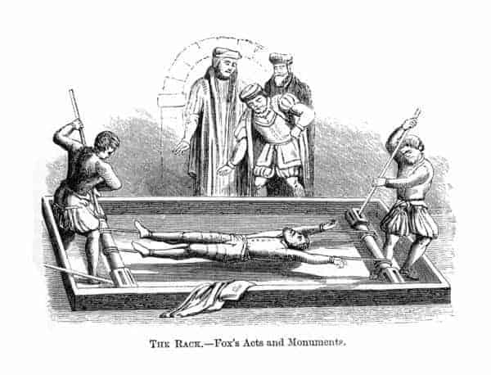
Image 7: This torture device, “the rack,” would pull your arms and legs away from one another slowly. This would cause excruciating pain and would last until you converted or died from your injuries.

Lesson 10 – Geography of Greece
Climate
Ancient Greece was located in southeastern Europe along the coast of the Mediterranean Sea. Greece was filled with mountains, seas and plenty of islands which helped form their government and acted as a barrier between cities.
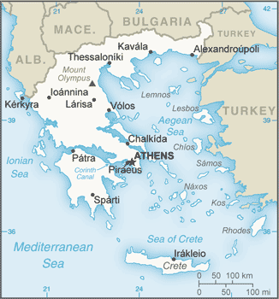
Image 8: This is a map of modern Greece. Greece’s location will eventually be quite useful down the road.
The first place in which the Greeks would settle was near the Aegean Sea. City-States (a city that forms an independent state) would form along the coastline. When traveling from city to city (or island to island) the Greeks would use this sea. Additionally, it acted as an excellent resource due to its higher number of fish.
Greece was full of mountains (nearly 80% of its land). This was both a positive and a negative for many islands. It made journeys far more difficult which would require extra resources. However, it acted as a barrier/defense mechanism against any outside invades or rivaling city-states. Greece has hot summers and mild winters. On the surface, it would seem that Greece is a perfect area for farming, but other issues would prevent them from reaching success in agriculture.
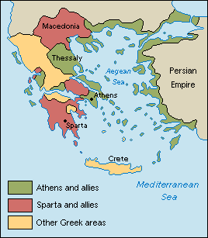
Image 9: Ancient Greece had two major empires; Athens and Sparta. With Greece being a collection of city-states, this would eventually lead to a long-term rivalry between the two empires.
Farming
Farming in Ancient Greece will be far more difficult than it was in Ancient China or the Middle East. While their climate was not a major issue, the amount of usable land for crops was. It is estimated only 20% of the land could be used for farming. Greece was able to grow a variety of crops, but their main staples were barley, grapes and olives. Grain crops, such as barley and wheat, were planted in October and harvested in April or May. Olives were harvested November through February. Grapes were normally picked in September.
Barley acted as the main crop for the Ancient Greek farmer due to is variety of uses. For example, barley could be made into porridge or into flour that would later be used for bread. Olive oil would serve two purposes; cooking and oil lamps. Grapes also had a variety of uses that ranged from eating them whole, drying them into raisins or producing wine. It is important to note that wine was not permitted to be drank whole, but rather mixed in with water.
Image 10: Porridge was one of the main foods that was consumed by the Ancient Greeks. It was filling, nutritious and tasty.
Greece had a fair amount of respect for their peasants. Anyone working on a farm was permitted to keep any surplus of food for consumption or to trade at the local market. This system was fair, but not effective because most farms could only be small to medium sized. Large farms were rare in these times because crops were too unpredictable.
The climate was hot, with mild winters and plenty of rainfall. This rainfall however was often irregular; which meant that crop failure would happen every few years. This “crop failure” was far more common than the Greeks could prepare for. It was believed that every four years the wheat crops would fail and the barley crops would fail every 10 years.

Lesson 11 – Greek Philosophy
Ancient Greek philosophy became popular throughout 500-300 B.C.E. Their philosophy covers ethics, politics, nature, biology, logic and aesthetics (art, beauty). The three most famous philosophers in Greek history are Socrates, Plato and Aristotle.
Socrates
Socrates (born in 470 BCE) is considered to be one of the individuals who discovered philosophy. Socrates never wrote down any of his knowledge which make sus rely on other people’s point of views. Socrates came up with the Socratic Method (a form of inquiry and discussion between individuals based on asking and answering questions with the purpose of coming up with an idea). The purpose this served was to help people reach their own conclusions by always questioning their thoughts. Socrates claimed that humans always rely on reasoning, so if we do not question ourselves, how can we truly know who we are?
Plato
Plato (born somewhere between 428-423 BCE) was a student of Socrates. Plato discovered the Academy in Athens (the first institution of higher learning in the Western world). He also contributed greatly to philosophy. Most notably, Plato proposed the Theory of Forms. This was focused on ethics and permanent/change. The ethical dilemma is “how can humans live a fulfilling life in an adapting world when everything they love can be taken away?” Additionally, how can a world be both permanent and changing? Plato had an answer to discover this issue. That solution would be to understand the world from two different realms; physical and mental. By detaching ourselves from a materialistic world we can find value in ourselves.
Aristotle
Aristotle (384-322 BCE) was a student of Plato. He joined Plato’s academy at eighteen and stayed there or twenty years. He created the theory of universals, which poses the questions do properties exist? Specifically, Aristotle wanted to know of these things had any similar characteristics or qualities. He claimed that everything was instantiated (all property needs to be had by an object). This means everything exists within something; nothing is separate. Simply speaking, this means everything is connected by color, shape, texture etc.
Democracy
The Athenian leader Cleisthenes introduce a new type of government in 507 BCE. This system would be based around the principle “rule by the people” or more commonly known as a democracy. This would mark the first time a democracy was introduced to the world. This system would be compromised of three different institutions:
- Ekklesia a governing body that created the policies
- Boule a group of representatives for the citizens (usually 10 people)
- Dikasteria the court where citizens would defend themselves
The only people who were permitted to vote were men and they had to be above the lower class (slaves).
Jury System
Greece would have another major contribution to the world. Greece would invent the jury system in the 6th century and it would act as the basis for all legal decisions going forward in Athens. Interestingly, anyone could bring another person to court. It worked fairly similar to a modern-day court system as you needed witnesses, a strong testimony and needed to jury to believe you.
You did have to follow a process in order for the courts to hear what you have to say. Firstly, you need to post a written notice on or near the courthouse that stated the names of both parties, the charges and if you have been in court before. You would originally present your case to a judge first and if they felt your case was strong enough, there would be a trial. At the trial, a jury would be assigned. The requirements to be a juror were quite strict:
- You had to promise to be fair
- Over 30 years of age
- Athenian citizen
They did not follow our modern 12 juror format. Most trials had around 100 people and if it was a serious crime it could be up to 500. It is important to note that because this was a “majority rules” scenario, Athens would usually favor an odd number of jurors. The jury decision was final and could not be overridden by a judge. However, the Judge/plaintiff would hand down the sentence as the Jury had no say in this matter.

Lesson 12 – Internal Affairs
Sparta
Spartan culture was based around loyalty, military service and determination. As early as 7 years old, Spartan boys had to enter a rigorous military training-based program whilst simultaneously obtaining an education. This training was based around three basic principles:
- Duty
- Discipline
- Endurance
In contrast with many other societies, being a warrior required extensive training. Many armies such as Ancient China and Islam relied on volume of soldiers to overwhelm the opponent, however Sparta was not as big of an empire and relied on being “experts at war.” Since military training required extensive hours per day, all manual labor needed to be completed by the slave class.
Spartan women were not permitted to join the military but were given almost absolute freedom. They were permitted to do a variety of jobs from farming to owning homes. They were also not considered inferior to men (except for military based purposes) and had to be treated with respect. They were permitted to marry whomever they wanted and could receive a full education. They could also learn how to be a warrior, but still could not engage in war.
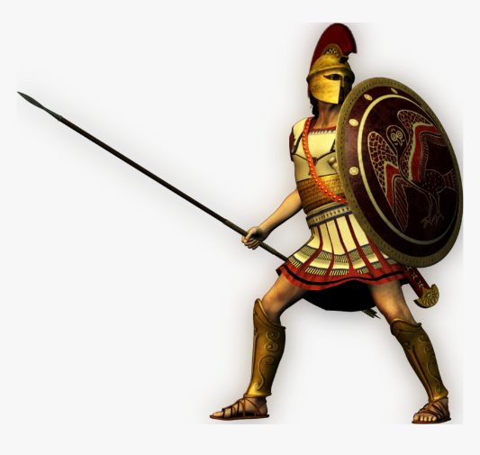
Image 11: This is what a Spartan solider would typically look like. Their armor was difficult to penetrate and their shield acted both as a defense mechanism and a weapon.
Spartan society worked fairly similar to most civilizations. They had a hierarchy which consisted of only three groups. At the top were the Spartans (considered full citizens), followed by the helots, or slaves (not full citizens). The Perioeci (third class) were off of the hierarchy. They were traders/craftsman and were respected in society.
Slaves were treated brutally. They were beaten, forced to be intoxicated or killed if they were intelligent. This was done to ensure an uprising could not take place. An internal conflict would be a disaster for Sparta in their quest for Greece.

Athens
Athens will have a completely different outlook on how to run a civilization than Sparta. Sparta was focused on building warriors and Athens was focused on building its city. Athenians were into building beautiful public spaces, shops and investing in the arts.
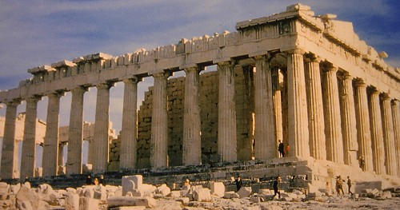
Image 12: This is of the most famous Greek monuments the Parthenon. This was built in 447 BCE. Nearly 2,500 years later and this still stands.
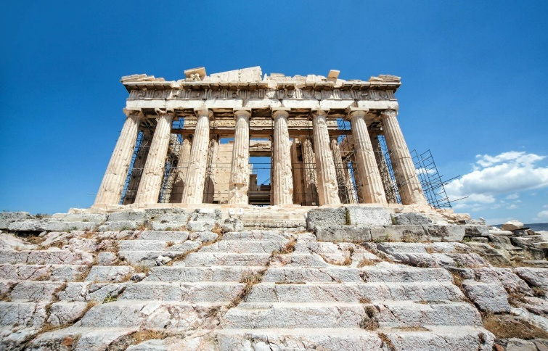
Image 13: The Acropolis was also built nearly 2,500 years ago. Architecture was very important to the Athenians and this would only be the beginning of what they could bring to the world.
Athenian society worked far differently than their counterparts. Men had to obtain an education and women were only allowed to be educated at home. Women also had to bear children and take care of house related responsibilities. Women did not enjoy as much freedom as Spartan women did.
Sparta was always led by a king (sometimes two) whom was a member of a royal family or a great warrior. Athens believed in a democracy (giving the power to the people). To be a king in Athens, the citizens had to elect you. When new laws or policies had to be put into place, citizens had to attend an assembly and vote. It is important to note that only 18 people could vote and slaves/women were not given that opportunity.
Slaves were fairly common in Athens. Though they were mistreated, they did gain a bit more freedom than what Sparta gave them. However, they could be bought and sold at any time.

Peloponnesian War
The Peloponnesian War was a battle between Sparta and Athens (431-405 BCE). These two empires were due for a collision course for a multitude of reasons. The three most notable reasons were:
- City-states began fearing a growing Athens
- Under their leader Pericles, Athens became a Naval powerhouse
- Athenian settlers were moving into various city-states
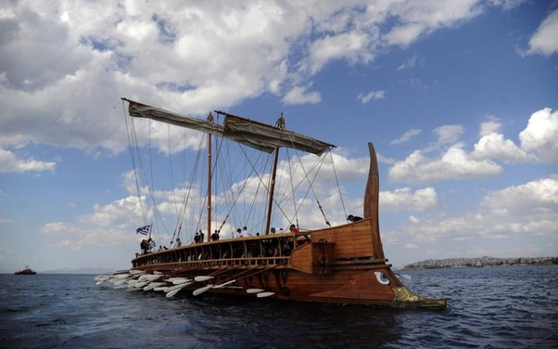
Image 14: This large Athenian ship had tons of individuals rowing which made movement fast. Combined with trained soldiers, this became a naval force to fear.
Athens would gain a lot of negative attention from their city-states. The Delian League (which created an alliance of city-states) gave Athens a lot of money for protection. Majority of that payment went into making Athens beautiful. To make matters worse, any city-state that even raised an ounce of opposition was immediately dealt with by Pericles. This led to a Spartan uprising.
Athens and Sparta would venture into warfare. Sparta had a clear advantage on the land, but Athens had a significant advantage on the water. The strategy for both nations was based around these notions. Sparta would gain quick control of the countryside so that they could block all boats from entering and resupplying Athens. Athens strategy was to overwhelm them inside their city walls. Pericles strategy backfired quickly because the plague broke out and with his city filled with individuals, it took many of their lives (hence depleting their army). This plague mixed with Sparta’s overwhelming forces caused Athens to fall.
This war destroyed the economy, crops and citizens of Greece. It was not going to be long before someone took notice, that individual would be King Phillip II of Macedonia. King Phillip would also bear a son that would be forever etched in history; Alexander the Great.

Lesson 13 – Alexander the Great
Rise to Power
Alexander the Great was born in 356 B.C.E. His father was King Phillip II and his mother was named Olympias. Alexander was given a formal education at the Aristotle Academy where he was advised to make all non-Greek citizens slaves. However, Alexander rejected this idea because he wanted to build relationships with other foreigners. Specifically, he attempts to build an alliance with the Persians. This makeshift alliance would only be temporary.
Alexander would eventually return to Macedonia after finishing school. He immediately was forced to subdue rebellions and assisted his father in a victory over Athens and Thebes. However, the relationship between this father and son was not the best. King Phillip took on a new wife and was potentially looking for a different heir. Alexander feared this issue and resolved conflict with his father. Shortly after, it is speculated that Alexander hired a guard to assassinate King Phillip. Regardless, this guard was successful and killed the King, thus handing the throne to Alexander.
The Reign Begins
Alexander would attempt to unite the city-states and show he was the new leader. He was met with resentment, but was still followed and believed in. His warriors were well trained, his strategies were nearly flawless and he himself was a highly skilled warrior. Alexander would attack multiple territories that would include Persia, Egypt and all the way into India (though he stopped here). Alexander claimed all territories rather easily and the King of Persia had no other option but to fight Alexander himself. The King of Persia, Darius, loses this battle and Alexander claims a large portion of the world.
After the King of Persia fell, the Macedonian army assumed they were victorious and could return home. However, Alexander pushed further east where he was able to defeat many formidable foes. Many of the armies he defeated were in Iran and he was able to expand Greek culture with the new knowledge he obtained.
After Alexander the Great had conquered almost all of Asia, he pursued the final opponent; India. India had a mighty army and used elephants in warfare to a high success rate. Alexander would emerge victorious despite a smaller army and this was considered the biggest victory of his military career. This war would ultimately prove to be his last. Despite wanting to press further, his army was to beat up and wanting to go home. Alexander was able to figure out that there was more of the world to explore (that was previously unknown to Greece). However, Alexander was proud of his army and agreed to return home.
Post War Alexander
Alexander had a new-found respect for the Persians and this time worked on cooperating with them. Many Macedonians were skeptical of this arrangement because they were considered to be “barbarians.” Alexander would eventually fall to either poison or natural causes at the age of 32.

Summary of Alexander the Greats Conquest
- He conquered Asia Minor (present day Turkey)
- Alexander took over Syria by defeating the Persian army at Issus and laying siege to Tyre (Lebanon).
- He then went on to conquer Egypt.
- Alexander then defeated the mighty armies of Babylonia and Persia.
- He then began a campaign against India.
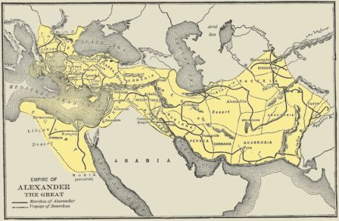
Image 15: This is how much of the world Alexander the Great had conquered. What would have happened if he continued?

Lesson 14 – Greek Mythology
Greek Gods

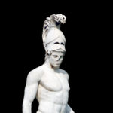
Apollo was the son of Leto and Zeus. Apollo was also the twin sister of Artemis and know for his high skill in archery. His alliance with the nine Muses (goddesses known for art and music) was well known.

Ares was the son of Zeus and Hera, whom hated their own child. Eros (Cupid) was his child and Aphrodite was his wife. Most notably, Ares was known as the God of War where he represented to negative side of battle.
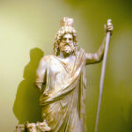
Dionysus was known as the God of the Vine. After teaching adulthood, he wandered the earth teaching men about the culture of the vine. Specifically, he was the God of Wine and the last God to enter Olympus.

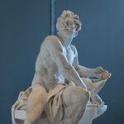
Hades was known as the God of Wealth. This was because he possessed the precious metals of Earth. His hat was believed to make its holder invisible. His wife was Persephone and he forced her to be his queen after kidnapping her.

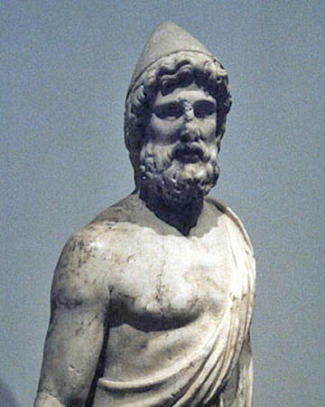
Hephaestus was considered to be an ugly God despite everyone else being considered beautiful immortals. He was hard working as he made the immortals their dwellings, furnishings and weapons. He is the God of Fire.
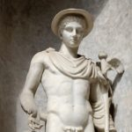
Hermes was considered a “trickster” because he was cunning and clever. He was considered to be the Gods “messenger,” because he would communicate with his citizens or other civilizations.
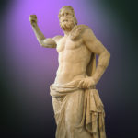
Poseidon was given the status of a God once the Titans fell. His primary weapon was a trident (three-pronged spear) and he is widely used in art today. Specifically, he was the God of the Sea and the protector of all waters.
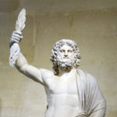
Zeus was also the father of the famous Greek hero Hercules. His name means “sky,” and his weapon of choice was the Thunderbolt. He is considered to be the King of the Gods.
Greek Goddesses
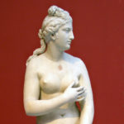
Aphrodite was the goddess of fertility, love and beauty. During the Trojan War, Aphrodite supported Paris. Working alongside Cupid (her child), she persuaded Zeus to fall in love with another woman named Europa.
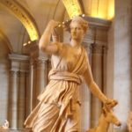
Artemis was the daughter of Zeus and Leto and the twin sister of Apollo. She was known for being the God of the Wildlife. She advocated for the rights of women and made their lives better. Specifically, she helped them obtain marriage rights and kept killing young animals to a minimum.

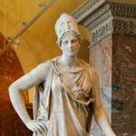
Athena was the goddess of war and the counterpart of Ares. She was the guardian of Athens and considered to be the good side of war.

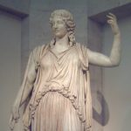
Demeter was the daughter of Cronos and Rhea. She was the goddess of harvest and was responsible for the Thesmophoria (an annual festival of fertility held in honor of Demeter).
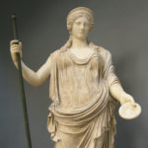
Hera was the queen of the Olympian Gods. She was a protector of the heroes and never forgot anyone’s name or the injury that they endured.

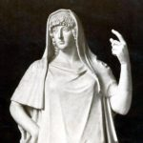
Hestia was the sibling of Demeter, Hades, Poseidon and Hera. However, not much is known about Hestia as she is constantly overlooked. Homer, whom was the most famous poet/author at the time, completely omits her from his works.
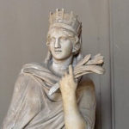
Tyche was the goddess of chance, fate and fortune. She was responsible for representing both the positive and negative effects that these could bring. Ancient Greeks thought she was responsible for all unexpected events regardless if they brought happiness or sorrow.

Lesson 15 – Rise and Fall of Rome

Climate of Ancient Rome
Ancient Rome had the perfect Climate for farming purposes. They had fertile soil, a perfect balance of rain/sunshine and the climate was never too cold or overly hot. Their transportation system was strong for that period of time. They used the Mediterranean Sea as a network of trade with the outside world. This trade network made conquest easy as well and gave Rome new ideas.
Perhaps the biggest asset Rome had was a powerful army. Their navy was unmatched, and the army had an abundance of troops. As Rome began Imperialization (taking of territories from other nations), it made the empire even more rich as they stole resources.
Ideas are Exchanging
The Romans loved learning ideas from other civilizations. They learned from Egypt, the Middle East and Africa. They further developed the concept of philosophy (the pursuit of wisdom through reason). Their architecture (the art and science behind designing buildings) lived for centuries. The Romans appreciated how the Greeks operated and used some of their values and learning styles. The Romans developed aqueducts (an artificial channel for transporting water)
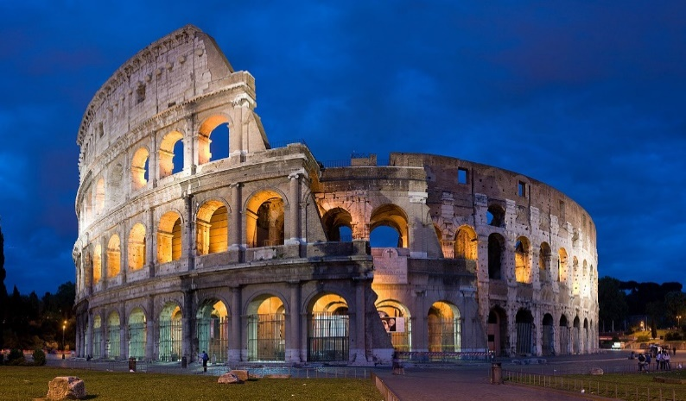
Image 16: This is the Roman Coliseum. It was built in 70AD and still stands today.
A Legacy Lives on
The Romans left a legacy that few civilizations could match. The Romans built theatres, arenas and temples and had efficient plumbing systems to provide water to all citizens. They made the common language Latin and they developed an efficient judicial system to protect its citizens many Canadian laws were developed based off of their ideas. Pax Romana: Roman Peace that existed in the first and second centuries because people feared fighting Rome without wars, Rome got far stronger

Rome Collapses
There were a lot of reasons for why Rome collapsed. Below are the biggest reasons why the empire fell.
- Germanic peoples migrated and refused to pay taxes they also attacked often
- The Roman Empire’s citizens embraced all religions which weakened the government’s power
- The empire was too large to defend
- Never had a political system to determine its new leader led to lots of issues amongst citizens
- Travelling brought diseases which Rome had no answer for
- Rome spent too much money on entertainment and luxuries
- Weak emperors did not defend the empire properly
- Slaves were used to supply goods and services which impacted small businesses negatively

Lesson 16 – Charlemagne

What Happened to Rome?
The Roman Empire was still somewhat intact after its fall. Despite it being much smaller in size and not as powerful, they still had Celtics (Western Europeans made of Irish, Scottish and Welsh) living on their lands and paying taxes. For a while, Rome was actually peaceful. However, all of this comes to an end when Germanic peoples invade and take the land and resources.
Without a government, nobody to repair roads and increasing crime rates Rome would become a fraction of what it was. Its one million population dwindled down to 30,000. Though traders stopped by, the Romans had few goods they could provide them and not enough money to even gain interest. Rome’s strong education system also faded away as people became increasingly illiterate.
All of this would lead to an individual named Charlemagne who tried to rebuild what little of an empire that was left.
The Franks
One of the Germanic peoples, the Franks, conquered Gaul (a Roman province which is modern day France). This society was all about freedom and they loved war. Often, most citizens would walk around with a throwing axe ready for combat. In the 5th century the Merovingian family would rule for nearly 300 years. Clovis the I, whom is considered the greatest leader of that time, founded France and its capital city Paris.

Social classes were in this early French society. They had the wealthy and the poor (peasants/farmers). They were treated with some respect as they were promised a piece of Manor land in exchange for giving produce to the landowner themselves. This would mark the Feudal System (Unit Two). Though they gained more respect in society, the rich could steal their crops with no consequence and the weather made life even harder for farmers.

Clovis the I eventually passed away and distributes his kingdom amongst his children. This This was a critical misjudgment on his part for three big reasons:
- His children were completely incapable of running a medium sized kingdom
- They murdered their own citizens in cold blood
- They fought with another

They also were unable to protect their citizens from external attacks, provided a lack of education that Clovis the I had been doing and hardly built anything. The King had no viable system for collecting taxes and had no idea how to build roads and highways. Everything Clovis the I had done was being completely undone by his descendants.

Charlemagne

Charlemagne’s focus was to rebuild a destroyed Europe. Unlike his previous rulers, Charlemagne was focused on improving society. His mindset focused on helping the citizens as much as possible. Charlemagne wanted peace and in order to achieve that he invaded any opposing neighbor and the city of Rome. Charlemagne was appointed king and thus it began the Carolingian Empire.

The Carolingian Empire was much different than the Romans were. They lived in small villages that were fortified. Charlemagne put a focus on trading (which improved) but did not have a Mediterranean Sea network in operation.

Charlemagne allowed local governments to have freedom, but he sent out messengers to ensure his citizens were getting the same treatment. Charlemagne hated how peasants were treated and created an entire set of laws that would revolve around their freedom. Tragically, Charlemagne had to reward Lords for defending him in warfare by giving them slaves. Most of them continued to abuse their peasants. Though Charlemagne was considerate of his own people, he was merciless to opposing nations. When he defeated the Saxons, Charlemagne asked them to convert to Christianity. They refused and he killed 4,000 of them in cold blood.

Charlemagne then set his focus on rebuilding a destroyed economy. He introduced a new coin, denarius, and set severe penalties for anyone who made fakes of this coin. Charlemagne rebuilt bridges, roads and made travel much safer. He then created a safety net for any Jewish trader coming into his empire.

Charlemagne did not stop there as he set his sights on improving education. He built new schools for his citizens to be educated. He focused on improving architecture by building churches and palaces in France. Charlemagne had completed what no person in history had before him, he completely rebuilt a destroyed civilization. Unfortunately, his descendants would immediately fight one another and undo all of the work he had accomplished.

Lesson 17 – The Vikings

Anglo-Saxons

When the Romans left Britain in the 5th century warriors from Germany moved in. They referred to themselves as the Anglo-Saxons. Most Anglo-Saxons were farmers. Men always had to carry weapons in the event of an attack. They were a progressive society as they had laws and trials by jury.
The Anglo-Saxons were a smart civilization and used everything they learned to make society grow. This enabled them to be excellent story tellers and create epics (long poem about heroic deeds) such as Beowulf. They traded for copper and iron but had few coins to acquire items they needed. This led to a massive bartering system where they would trade their own items for other people’s items. This helped fuel their economy quite well.
Their society is filled with strong warriors who opted not to leave their cities (rarely they would explore other areas) to acquire new ideas or trade items. For a while, this society grew in size, strength and knowledge, but all of this will be disrupted by a new group of warriors known as the Vikings.
Viking Society

The Vikings are one of the most interesting sets of warriors in history. They raided nearly every single European city and almost never took their land. It is important to note that they did steal resources. Vikings did not believe in the word mercy and ruthlessly attacked everyone who crossed their path. It got so bad that French monarchs paid Vikings to leave them alone (hundreds of pounds of gold).

Vikings were from Scandinavia (modern day Norway, Denmark and Sweden). They lived at the end of fjords (a long, narrow saltwater bay). Despite being a society known for strong male warriors, they did have high respect for Viking women. Though they were forced to weave, they had more rights than most civilizations at this time. They could own property, sue and seek divorce. They were even left in charge to run society when the males were invading others.

Viking families typically owned one or two slaves (known as Thralls). Unfortunately, they gained no respect in their society and were permitted to be killed at anytime by their owners. The Vikings were quite advanced in arts as they produced art centered around their Gods (Odin, Thor and Freya). They were well versed in poetry and built powerful ships. Vikings eventually get wiped out by European monarchs who become stronger and more organized.
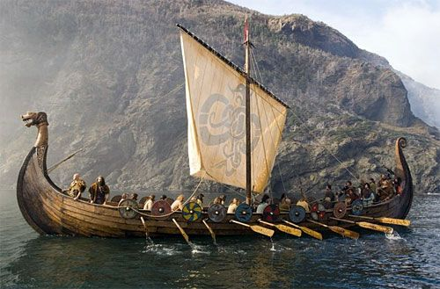
Image 17: This Viking Ship was fast, could transport a lot of troops and hold an abundance of resources. It made for quick invasions.
Lesson 18 – Religion

Religion in Rome was polytheistic (worship multiple Gods). If you practiced a religion that was different from Rome, you were allowed to do so as long as you paid taxes. This enabled paganism to be practiced everywhere until the turn of the 4th century. In 313 CE Christianity emerged (which worshipped only one God). This would be followed by an increase in followers for Judaism and Islam.

Judaism

Judaism began in the Middle East and it is considered to be the oldest Monotheistic religion. According to their traditions, God made a covenant (religious agreement) with Abraham who was considered to be the founding father of Judaism.

The Jews also believe that God gave instructions to Moses on how to follow his will. These instructions are on the Torah (Jewish holy book). This book includes history, stories and poetry about the origins of the Jewish people.
Judea (Jewish kingdom which is now Israel) existed for thousands of years. The Jews had an uprising against the Romans in Jerusalem and were immediately squashed. This forced the Jews to leave the land. The Jewish religious life focused on synagogues (a place of worship) and was led by a Rabbi (religious leader or teacher). Throughout Europe however, the Jews were thriving and making better lives for themselves.
This progression would quickly come to an end when Christianity becomes the official religion of the Roman Empire. The Jewish people were constantly attacked because the Christians believed they crucified (execution on a cross) Jesus. This hostility would remain, but the Jews would still find success in the banking/trading industries.
Christianity

Christianity would begin to influence Western Europe significantly. Christianity originated from the Middle East by the apostles (descendants of Jesus). Jesus expressed that the most important commandments were to love God and your neighbors. Jesus expressed that the spirit of religious law should take a greater focus. This argued against what the Romans and Jews believed, and a strong leader could lead a rebellion. Jesus was arrested and crucified.

The word of Jesus spread anyways and did so quite quickly. St. Paul wrote much of the new testament and went from place to place preaching the words of Jesus. This meant taking a greater focus on improving the lives of the poor. Christianity began to merge as the dominant religion throughout Europe. Rome usually did not mind a religion gaining traction in their empire, but they took exception to Christianity because it would take a focus off of the Roman King. Many people who openly expressed this faith were publicly executed. In 313 CE, Emperor Constantine legalized Christianity and let citizens openly express their faith.

Christianity even made its way to Northern Europe where most Pagans resided. This was due to missionaries (people who spread the word of the church). While their preaching was successful, they unknowingly were building a new empire. One that was more powerful, dangerous and dominant.

