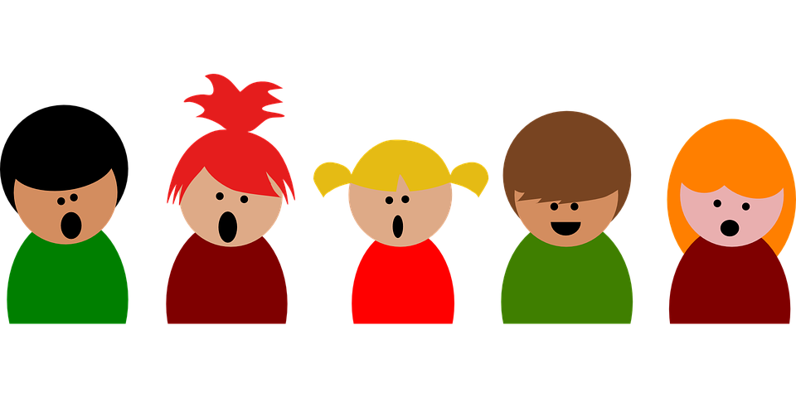
Early Primary Ear Training #1
Listen to the You Tube video and figure out the name of the song. If you cannot remember the name, put down some of the words in the song. Send this response sheet to: teresa.jukich@burnabyschools.ca

1.______________________________________

2.______________________________________

3.______________________________________

4.______________________________________

5._______________________________________

