DOWN BY THE BAY
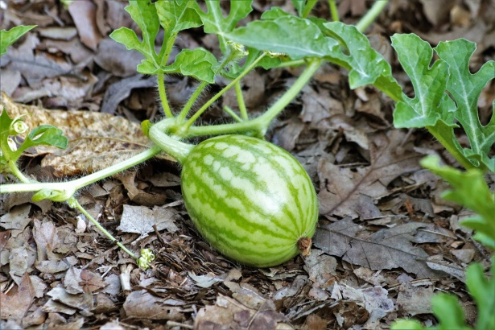
A Songbook by:
______________
Click on this link to view video: https://youtu.be/Dj1ZJL0W4qk

DOWN BY THE BAY
Down by the bay,
Where the watermelons grow,
Back to my home,
I dare not go,
For if I do,
My Mama would say,
“Have you ever seen a fly,
Wearing a tie?”
Down by the bay.
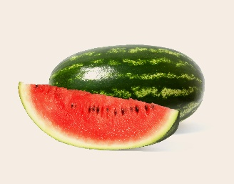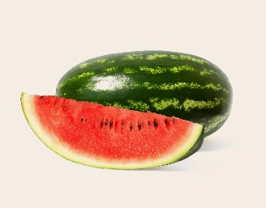

Down by the bay,
Where the watermelons grow,
Back to my home,
I dare not go,
For if I do,
My Mama would say,
“Have you ever seen a pig,
Dancing a jig?”
Down by the bay.

Down by the bay,
Where the watermelons grow,
Back to my home,
I dare not go,
For if I do,
My Mama would say,
“Have you ever seen a goose,
Kissing a moose?”
Down by the bay.

Down by the bay,
Where the watermelons grow,
Back to my home,
I dare not go,
For if I do,
My Mama would say,
“Have you ever seen a whale,
With a polka dot tail?”
Down by the bay.

Now it’s time for your verse! Make up your own! Remember, the last words must rhyme!
Example – whale and tail, or goose and moose
Down by the bay,
Where the watermelons grow,
Back to my home,
I dare not go,
For if I do,
My Mama would say,
“Have you ever seen a ____,
______________________?”
Down by the bay.
Draw a picture of one of my verses, or your own verse!

