Science 8 Name: ____________________________

Chapter 1: Microscopes

Learning Objectives for this lab:

- Learn proper care and handling techniques of the microscope.
- Identify and understand functions of selected microscope parts.
- Become proficient at focusing a microscope.
- Learn microscope terminology.
- Learn to use the microscope as a measuring tool.

Contents of this laboratory handout:

- Introduction 2
- Care of the Microscope 35
- Parts of the Microscope 36
- Focusing the Microscope 39
- Key Terminology 40
- Exercises
- Exercise 1: Calculating magnification 41
- Exercise 2: Examination of the letter "e" 41
- Exercise 3: Depth of field, silk fibers 43
- Exercise 4: Effect of changing objectives 43
- Exercise 5: Preparing a wet mount 44
- The Stereoscopic Dissecting Microscope 45
- Estimating the size of microscopic objects 46
Introduction

In this laboratory we will learn how to use one of the most valuable tools in the biologists’ toolbox: the microscope. Much of biology occurs at too small a level to see with the naked eye. We need magnification to see a whole new world that exists at this tiny size, and the microscope provides that magnification in an elegant manner.

Two basic types of microscopes are used in biology: the compound light microscope and the electron microscope. Compound light microscopes use ordinary light to magnify, compared to electron microscopes which use a stream of electrons. Although different in appearance, both of these microscopes perform the same function: to magnify objects.

The development of the microscope can be traced back to the first century A.D. Roman author and philosopher Seneca, who noted that a jar of water positioned properly would make writing appear clearer and larger in size. The ancients at Nineva, the Romans, Chinese, and Greeks may have used lenses for reading. In 1558, Swiss naturalist Conrad Gesner wrote of the use of magnification in biological investigation.

Perhaps the best known of the early microscopists was Antony van Leeuwenhoek. A master lens grinder, Leeuwenhoek made his own microscopes and spent most of his life observing and describing the then virtually unknown microscopic world (microscopic being any substance or structure too small to be viewed with the naked eye). His contributions include sketching the three major groups of bacteria; capillary circulation in an eel’s tail; muscle fibers; insect anatomy; plant tissues; and one of the first people to view human sperm beneath a microscope. Leeuwenhoek also made observations of tartar taken from his teeth, in which he described living “beasties” in this material (we know today that this is bacteria). In one of his poorer choices for observation, Leeuwenhoek viewed a small gunpowder explosion beneath one microscope. It is reported that this experiment left him blinded for several days!
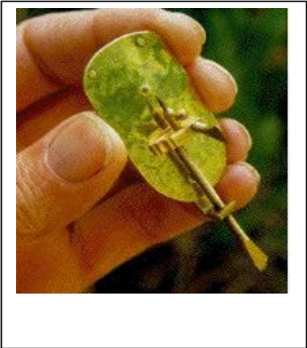

A beautiful replica of a Leeuwenhoek microscope, made by Alan Shinn of Berkeley California.



After looking at plaque from the teeth an old man who had never brushed, Leeuwenhoek reported:

"an unbelievably great company of living animalcules, a-swimming more nimbly than any I had ever seen up to this time. The biggest sort. . . bent their body into curves in going forwards. . . Moreover, the other animalcules were in such enormous numbers, that all the water. . . seemed to be alive."

Care of the Microscope

The microscopes you will be using are compound light microscopes. They are sophisticated and expensive instruments and must be used with care. Mistreatment of microscopes may result in the need for costly repair work as well as your loss of user privileges.

To ensure the continued use of these microscopes, the following rules will be strictly adhered to.

- Carry the microscope upright with two hands. Once removed from the storage cabinet, the microscope must always be held upright. Place your dominant hand on the arm of the microscope with your other hand supporting the base of the microscope. Care should be taken not to bump your microscope on objects such as chairs, tables, or walls. Gently place your microscope on your laboratory table and remove the protective plastic cover.
- Inspect the microscope before use. All parts should move easily. If they do not, do not force them! Do not attempt any repairs! Report all damage, missing parts, or anything else to your laboratory instructor.
- Only clean the lenses with lens paper. The optical parts of the microscope are precision lenses and scratch easily. The only acceptable method of cleaning them is through the use of lens paper. Lens paper can be found on the bench at the front of the room. If you cannot find any, ask your instructor. DO NOT use paper towels, shirtsleeves, handkerchiefs, or Kleenex to clean lenses. Never remove oculars or other parts from the body tube of the microscope.
- Do not push the microscope across the table. When sharing a microscope with others, never push the microscope across the table top. Instead, trade places with them. Sliding results in vibrations to the microscope that may result in the loosening of screws, or misalignment of parts.
- Unplug carefully. Use care when plugging in and unplugging the microscope from electrical outlets. When unplugging, always pull gently on the plug at the outlet. Do not attempt to unplug the microscope by pulling on the cord away from the plug.
- Replace microscope properly. When finished with the microscope, turn off the light, remove the last slide from the stage, and wipe any water or other materials from the stage. Next, be certain that the lowest power objective is clicked into position, and racked up to its highest point. Neatly wrap your electrical cord (your instructor will demonstrate the proper way to do this), and place the plastic cover over the microscope. Return the microscope to its proper numbered slot in the cabinet.
Parts of the Microscope

In order to operate a microscope properly and effectively, it is necessary to have an understanding of some of the various parts of the microscope and their functions. The microscope you will be using is shown in either Figure 1 or Figure 2. With the help of your instructor, identify and learn the following parts listed in Table 1.

Table 1
Microscope Part | Function
Arm  Base  Ocular or Eyepiece  Body Tube  Revolving Nose Piece or Turret  Objective Lenses  Stage  Substage Condenser  Iris Diaphragm Lever  Light  Mechanical Stage  Coarse Adjustment Knob  Fine Adjustment Knob | Supports the body tube and lenses. Use the arm to carry your microscope.  Supports the entire microscope. Broad and heavy, the base gives the instrument stability.  The lens in the upper part of the microscope. Monocular microscopes have one ocular, while binocular microscopes have two oculars.  Holds the ocular at one end and the nosepiece at the other. A prism housed in the body tube helps to reflect light towards the eye.  Located at the lower end of the body tube. A revolving device that holds the objectives.  Located on the revolving nosepiece. There are four lenses: 4x or scanning power; 10x or low power; 40x or high power; and oil lens. Only one objective may be used at a time. The selected lens is rotated into position by turning the nosepiece.  The horizontal platform upon which the slide rests.  Lens found beneath the stage that concentrates light before it passes through the specimen to be viewed.  Small lever beneath the condenser. Allows the observer to regulate the amount of light passing through the specimen.  Provides illumination of the specimen. Located beneath the condenser and iris diaphragm.  Small circular knobs adjacent to or below the stage. Allow the observer to move the slide across the stage either forward or backwards or laterally.  Located on either side of the arm. Moves the stage (or body tube) up or down to the approximate correct distance. This knob should only be used when using the low powered objective.  Located within the coarse adjustment knob. Moves the stage (or body tube) up or down small distances. Allows fine focus of the specimen.

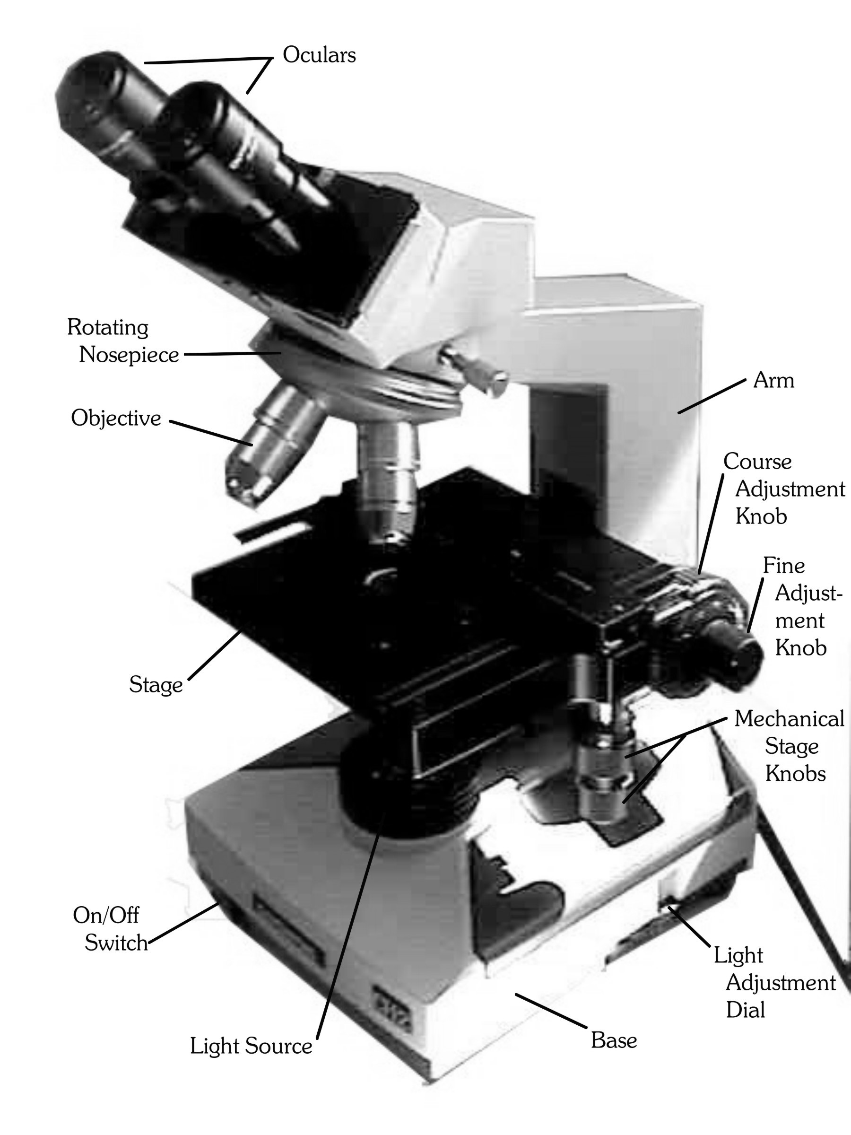
Figure 1: The binocular, compound, light microscope.

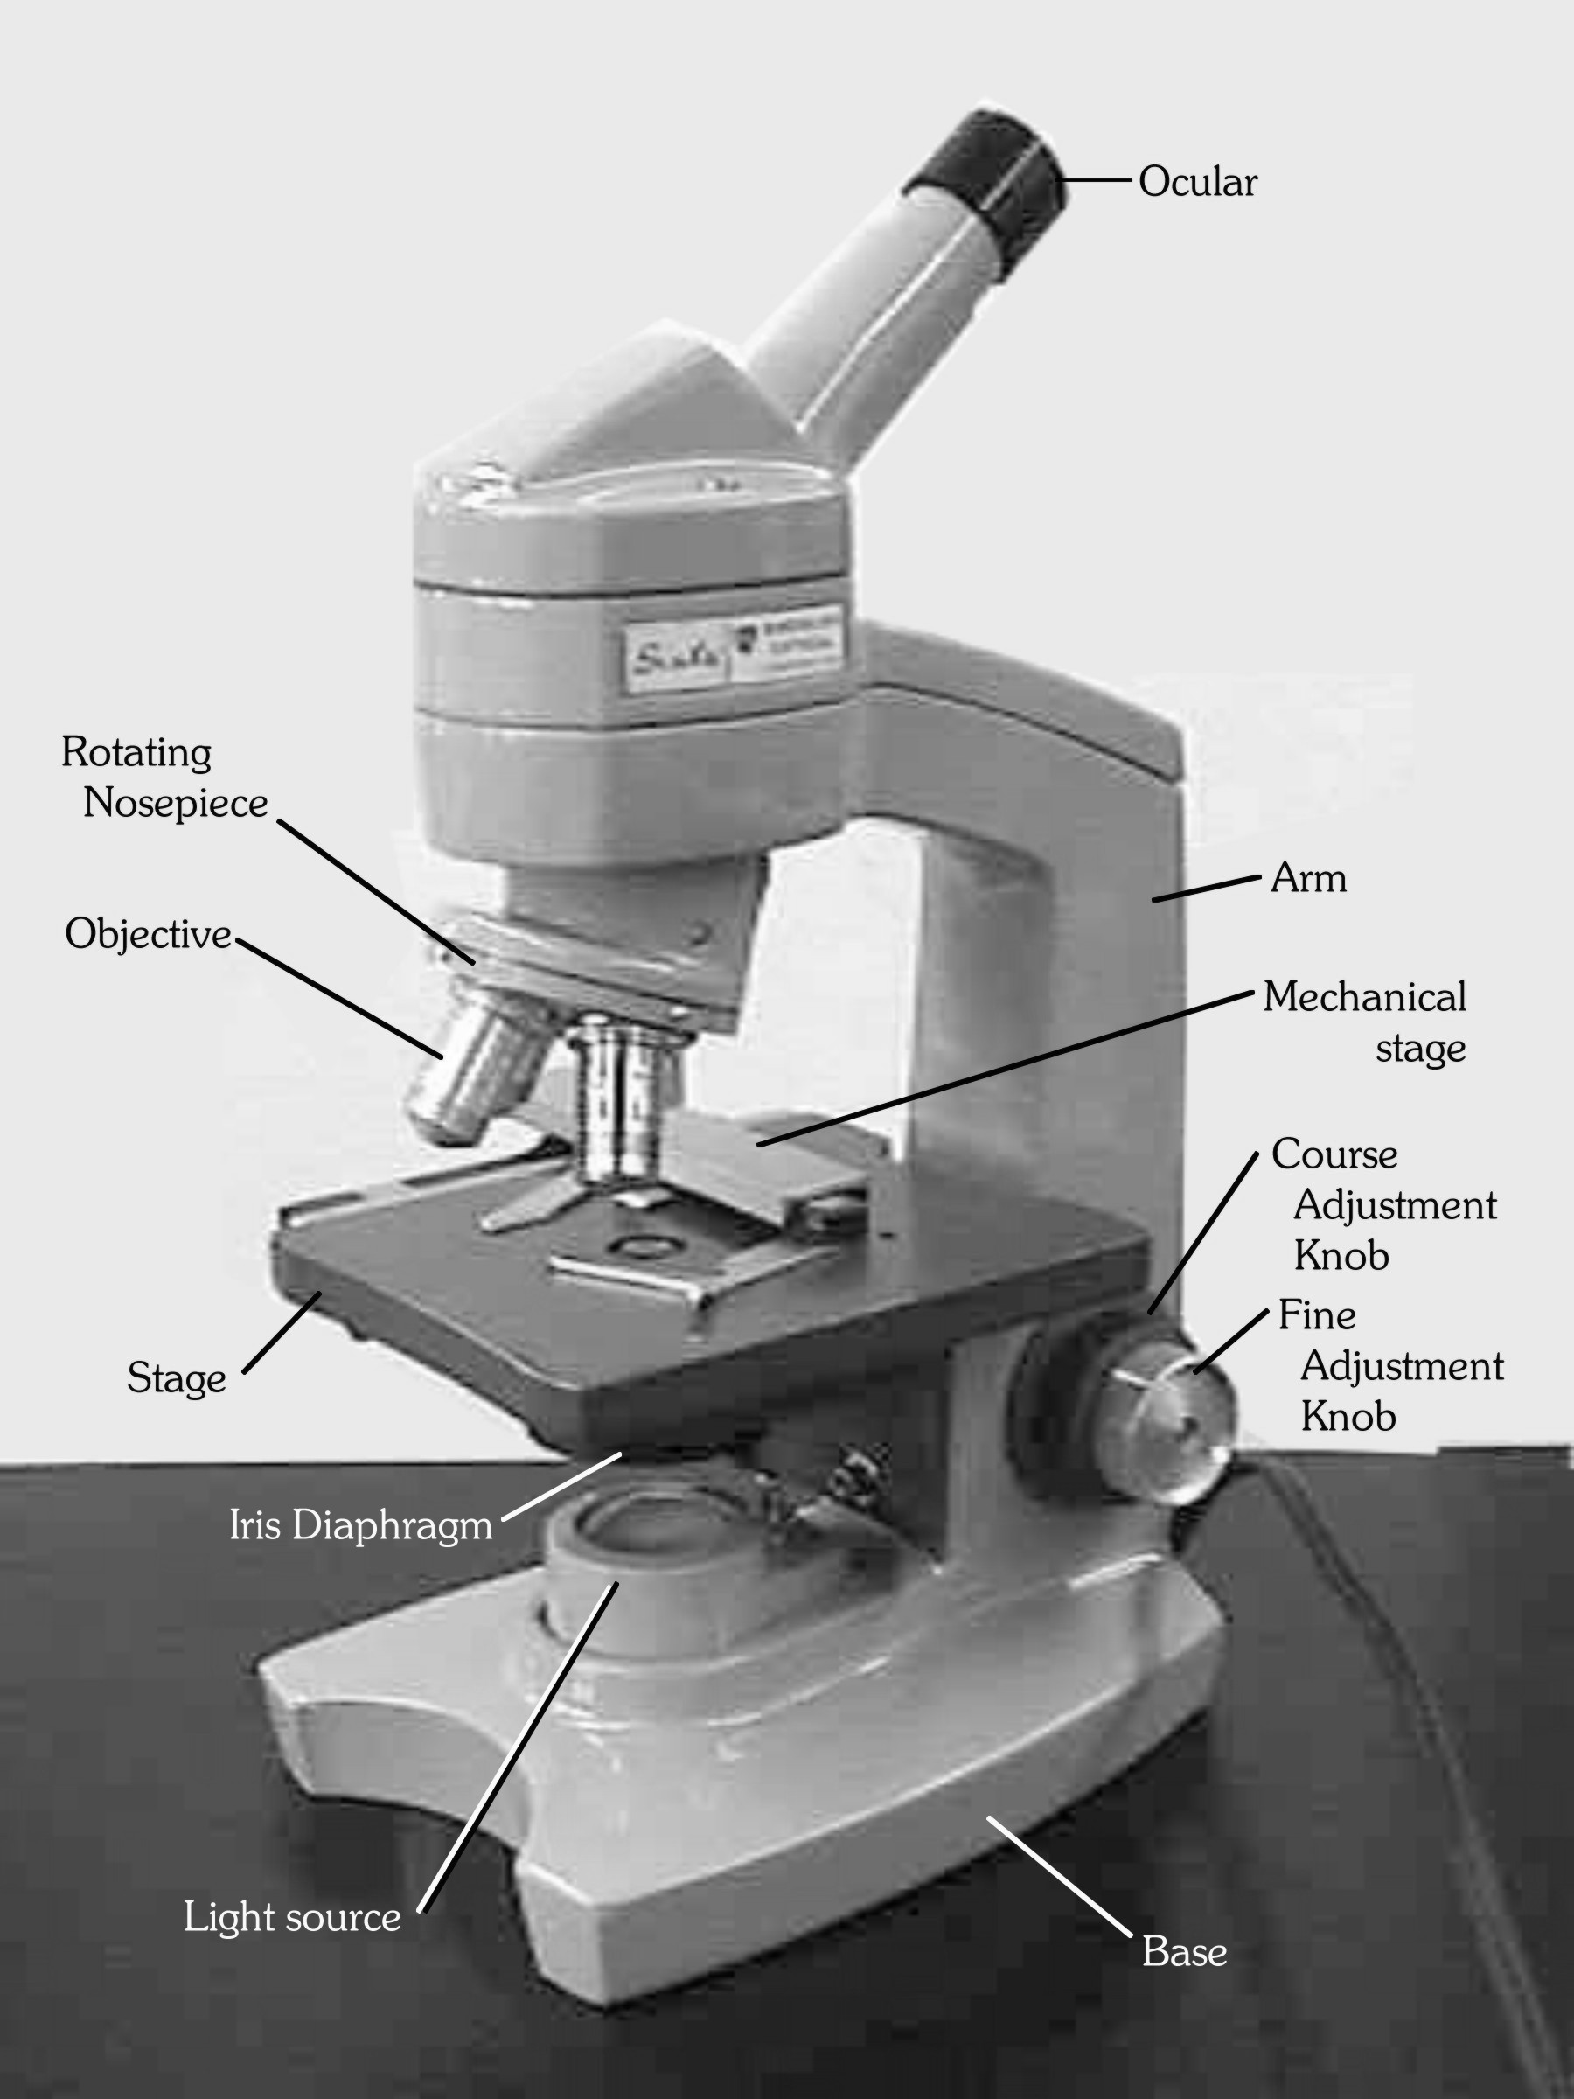
Figure 2: The monocular, compound, light microscope.

Focusing the Microscope

Before starting Exercise 1, there are a few important ideas and details to keep in mind when focusing the microscope.

- Always begin viewing every slide using the scanning power (4x) objective. Never begin an observation with the low or high-powered objectives. Attempting to focus on specific objects without first finding the specimen under scanning power is usually a waste of time and effort. Once the object is found under scanning magnification, you may increase magnification by rotating the low powered objective into place.
- As you view a specimen under scanning, low, and high magnifications, note that the image remains nearly in focus from one magnification to the next. Most light microscopes are parfocal, meaning that the image remains nearly in focus as you change lenses. Note also that the image remains centered after the high-powered objective is in place-the image is parcentered.

What's this?
Step #4. Repeat steps #2 and #3 as you work up to more powerful objectives.

Step #1. Scan
View the slide with the scanning objective. Find something interesting.
Step #2. Center
Move the slide so what you want to see is centered in the field of view.
Step #3. Increase Magnification
Move to a higher power objective. View object at higher power.
If you go to a higher power and lose the object, it may be because Step #2 was omitted.

- When focusing with the high-powered objective, never use the coarse adjustment knob. It is very easy to break slides or damage objectives by doing this. Only the fine focus knob can be used at this time. When using this lens, always focus away from the microscope slide. To do this correctly, rotate the coarse adjustment knob so that it nearly touches the slide while viewing this whole process from the side-not while you are peering into the ocular. Once you have done this, focus up and away from the slide.
- Don’t forget the iris diaphragm! Adjusting light levels with the diaphragm will usually improve contrast, providing the observer a clearer view of the specimen.
- When using a binocular microscope the distance between the two oculars (interocular width) can be adjusted by moving the ocular tubes towards or away from each other. Using the scanning lens, look through and adjust the oculars so that a single field is seen. Focus on the specimen. Close one eye and then the other. The specimen should be in focus through each ocular. If they are not equally in focus, it will be necessary to focus each ocular individually. If your instructor has not already demonstrated how to do this, ask for assistance.

Key Terminology
Field (Field of View) - The circular area that can be seen when looking through the ocular.
Depth of Field - The thickness of an object which is all in sharp focus at the same time.
Working Distance - The space between the bottom of the objective and the top of the slide.
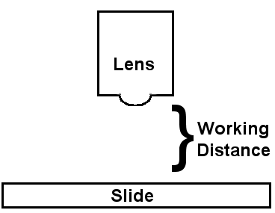
Resolution - The minimum distance where you can see the separation between two points. In practice, it refers to how clearly you can see details in the microscope.
Binocular light microscope: A microscope with two oculars—one for each eye. Using both eyes to see in your microscope will not only be easier on your eyes but will also give you more depth perception. However, your eyes have to both be in focus on the same item at the same time, or you will get a bit of a headache. To be sure you are in the best focus with both eyes, first only focus with your right eye using the fine focus knob. Then adjust the focus of your left eye with the adjustment that is on the left ocular itself and not with the focus knobs. Take your time to do this every time and you will get much more out of your microscope experience.
Compound light microscope: Modern microscopes that use two or more lenses to magnify an object are called compound light microscopes. Because the microscopes Leeuwenhoek used had only one magnifying lens, his microscopes were considered to be simple light microscopes. The appearance of a true compound microscope dates from the late 16th century when Zaccharias Janssens of Holland discovered that by combining lenses and manipulating distances between them, objects could be enlarged.
Interocular width: This is the distance between the two oculars of a binocular microscope. When you are using a binocular microscope, you need to adjust the distance between them to match the distance between your own two pupils. Every person has a particular spacing between their eyes, so if you want to see using both eyes, you need to be sure that your oculars are adjusted properly. Once you find the appropriate interocular width, you can write down the number for it so you can quickly adjust it in the future.
Monocular light microscope: A microscope with only one ocular. When using this type of microscope, try not to squint the eye you are not using. Instead, cover that eye with your hand, keeping your eye open as if to view the skin of your palm up close. This will help prevent you from getting a headache or from having temporary blurry vision in that unused eye.
Exercise #1: Calculating Magnification

It is often useful to know the exact amount of magnification of a particular object or organism viewed beneath the microscope. That is, how many times is the object enlarged. Total magnification can be calculated by using a simple formula:

Total Magnification = Ocular lens power x Objective lens power

Please complete the following to determine total magnifying power of each of the objective lenses.
Magnification of the ocular lens alone =

Table 2:
 | Magnification of each Objective Lens Alone | Total Magnification  (Objective ^{x} Ocular)
Scanning Power
Low Power
High Power

Exercise #2: Examination of the letter “e” slide. Place a check in each box as you complete the step.

- Obtain a prepared slide of the letter “e” and place it on the stage. Secure the slide into position with the mechanical stage (if you need assistance with this ask your instructor).

- Plug in the microscope and turn on the light source.
- Make certain that the scanning (4x) power objective is clicked into place, and that the stage is as far from the lens as possible. This is your starting position. Use this position when you begin examination of any slide. Also, remember that this is the position that the microscope should be in before you return it to the cabinet.

- Using your mechanical stage, center the letter “e” over the condenser lens.
- While looking into the ocular, use the coarse adjustment knob to bring the letter “e” into focus. Use the mechanical stage (or your fingers if there is no mechanical stage) to move the slide so that the letter is in the center of the field of view. Use the fine adjustment knob to “fine tune” the image. Try adjusting the light with the iris diaphragm lever. How does this change the image?

- Observe the position of the letter “e” as it appears in the field. Now observe the letter “e” as it actually is on the slide. Note differences. Does the microscope flip the "e" upside down, backwards, or both?

Before continuing with the letter "e", please answer the following questions:

Under scanning magnification:

How many times has the letter “e” been magnified? ____________

What is the working distance in millimeters ____________

Move the slide away from you. What happens to the letter when seen through the microscope?

_____________________________________________________________________________

- Move the slide towards you. What happens to the letter when seen through the microscope?

_____________________________________________________________________________

- Move the slide to the right, then to the left. What happens to the letter when seen through the microscope?
_________________________________________________________________

Continue viewing the letter "e".

- Center the letter “e” in the field.
- Look at your microscope from the side (not through the oculars) and rotate the revolving nosepiece so the low power (10x) objective clicks into place.

- Focus the letter using the fine adjustment knob (use of the coarse adjustment knob should not be necessary).
Please answer the following questions:

Under low power magnification:

How many times has the letter “e” been magnified? ____________

What is the working distance in millimeters ____________

F. Compared to scanning magnification, does the letter appear larger? _______________________

G. Compared to scanning, can you see more detail in the letter or the paper it is printed on? ________

Continue viewing the letter "e".

- Center the letter “e” in the field.
- Look at your microscope from the side (not through the oculars) and rotate the revolving nosepiece so the high power objective clicks into place.

- Focus the letter using the fine adjustment knob (use of the coarse adjustment knob should not be necessary).
Please answer the following question:

Under high power magnification:

How many times has the letter “e” been magnified? ____________

What is the working distance in millimeters ____________
Exercise #3: Examining depth of field: Cross Fibers (aka Silk Fibers)

Obtain a slide that reads "silk fibers." Following the same procedure as in Exercise #2, place the slide on the stage and focus using scanning magnification. The center of your field should be at the point where the three fibers cross each other. Please answer the questions below.

1. Focus up and down using your fine focus knob. Under scanning magnification, are all three fibers in
focus at the same time, that is, are they all in the same focal plane? Yes No

2. Can you see the entire length of a fiber? Yes No

3. Can you easily tell which fiber is on top and which is on the bottom? Yes No

Now rotate your nosepiece so that the low powered objective clicks into place. Answer these questions.

4. Focus up and down using your fine focus knob. Under low magnification, are all three fibers in focus
at the same time, that is, are they all in the same focal plane? Yes No

5. At which magnification is there a greater depth of field? Low Power Scanning Power

6. Can you see the entire length of a fiber? Yes No

7. Has your field of view increased or decreased? Increased Decreased

8. Do you see more detail in each fiber? Yes No

9. Has your resolution increased or decreased? Increased Decreased

Use your iris diaphragm to alter the amount of light passing across the fibers. Note how changing the position of the diaphragm helps to enhance (or decrease) your ability to view objects

Exercise #4: Changing objectives changes how an object is viewed. Please use what you have learned in the above exercises to complete this Table. In the Table, draw in arrows to show how an increase or decrease in magnification will change the five listed components. Use an up arrow (⬆ ) to indicate an increase, a down arrow (⬇) to indicate a decrease, or a horizontal arrow (⬅➔) to indicate no change.

 | Field of View | Depth of Field | Resolution | Working Distance | Light Intensity
How does it change with increasing magnification

Exercise #5: Preparing a Wet Mount

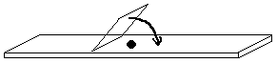 Many of the slides viewed throughout the semester will be of the prepared variety. That is, like the letter "e" and the silk fiber slides, the slide is ready to be viewed with no prior preparation. Occasionally, however, it will be necessary to prepare slide samples, especially when viewing fresh cells, tissues, or living organisms. When viewed beneath the microscope, water or other liquid should surround living material. For these observations a wet mount must be made. To prepare a wet mount (shown in Figure 4), simply place the specimen to be viewed on a clean microscope slide. Place a drop of water onto the specimen while the slide sits on a flat surface. Next, place the edge of a clean coverslip at one edge of the drop and slowly lower the coverslip onto the drop at an angle (in the same manner as lowering the lid of a cedar chest or the hood of a car). Lowering the coverslip at an angle assures that no air bubbles will be trapped beneath the coverslip that may obscure view of the specimen. Air bubbles can be distinguished from other objects by their large, dark, circular outline. If bubbles can be seen beneath the coverslip, rinse your slide and coverslip and begin again. If water leaks from beneath the coverslip onto the stage, gently wipe the excess water with a paper towel Coverslips are extremely sharp and must be handled with care to avoid cut fingers. Your laboratory instructor will demonstrate the process of making wet mounts.

Figure 4: Preparation of a wet mount.

Study of Pond Water

The purpose of this exercise is to allow the student to practice some of the techniques learned in the above sections. Using an eyedropper, add a drop of pond water to a clean slide and place a coverslip on the drop using the wet mount technique outlined above. When obtaining the sample of water, be certain to procure the drop of water from the bottom of the jar so that the drop contains some of the bottom sediments..

What to Look For?

The careful observer will find an abundance and diversity of life in a single drop of pond water. Slowly scan the slide using scanning magnification. Your sample will include not only living organisms, but also a variety of non-living objects such as plant debris, sand grains, and mud. Practice following moving organisms using your mechanical stage. Once a particular organism is in focus under scanning magnification, increase your magnification by clicking the low and then high-powered objectives into place. Try to identify those organisms that are heterotrophic and those that may be autotrophic. In the space provided below, practice sketching some of the organisms that you view. Most importantly, take your time when making observations!

Stereoscopic Dissecting Microscope

Due to the small working distance of the compound microscope, large or thick specimens are difficult to view. A dissecting (stereoscopic) microscope provides a much greater working distance and is able to accommodate large specimens such as insects, fungi, algae, or plants. With its larger working distance, there is room to move specimens around on the stage.
Due to the thickness of specimens observed with the dissecting microscope, light will not transmit through the specimen. Therefore, dissecting microscopes project light onto the specimen from above. You don't shine a light through it, you shine a light on it.
The dissecting microscope is a binocular scope. Each of the two oculars views the specimen at a different angle, providing a three-dimensional image with a large depth of field. Compound microscopes, in comparison, provide only a two-dimensional image. Advantages of a dissecting microscope are often offset by lower magnification and resolution than a compound microscope.
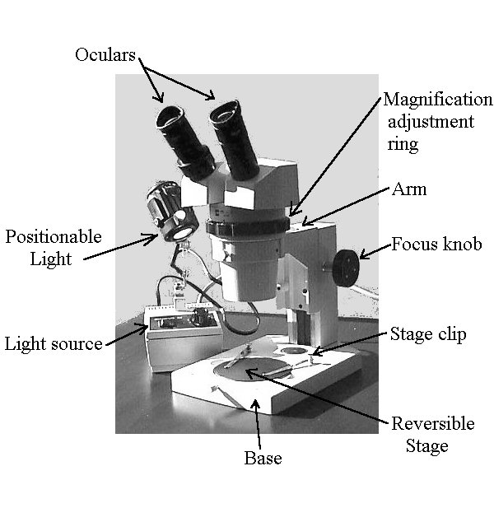
Examine the dissecting microscopes on display in the laboratory and review the various parts of the dissecting microscope in Figure 3.
Figure 3: The dissecting light microscope.

Estimating the size of microscopic objects

Diameter of the Field

Introduction: Microscopic measurements are generally made in micrometers (um). It is possible to make a good guess of the size of a cell in the microscope if you know the diameter of the entire field which is visible when you look in the microscope.

Metric conversions:
1 meter (m) = 100 centimeter (cm)s = 1000 millimeters (mm) = 1,000,000 micrometers (μm)

Equations for conversions:
To convert meters to centimeters: multiply by 100
To convert meters to millimeters: multiply by 1000
To convert centimeters to millimeters: multiply by 10
To convert centimeters to meters: divide by 100
To convert millimeters to meters: divide by 1000
To convert millimeters to centimeters: divide by 10

Procedure using estimation:

Low power (using 10X objective)

Put a clear plastic ruler on the stage of the microscope in such a way that the metric edge of the ruler is
visible along the diameter of the field. Draw a diagram showing the appearance of the ruler in the
microscope field which is provided below.

Estimate the number of millimeters that are visible to the closest tenth. This is the diameter of the field
in millimeters. Convert this diameter of the field to micrometers.

Ruler

Low Power Field

Diameter of the low power field in millimeters (mm): _________________

Diameter of the low power field in micrometers (μm): _________________

Assuming that the low power objective is 10X and the high power objective is 40X, images will be magnified 4 times more with high power than with low power. Because objects will appear four times larger the high power field will be approximately ¼ the size of the lower power field. Indicate below the approximate diameter of the high power field.

Diameter of the high power field in micrometers (μm): _________________

Procedure using a stage micrometer:

A stage micrometer has lines on it which are exactly 0.01 mm (10 μm) apart. Place a micrometer on the stage of your microscope. View the lines under both low power and high power to determine the diameters of the low power and high power fields in micrometers.

Diameter of the low power field in micrometers (μm): _________________

Diameter of the high power field in micrometers (μm): _________________

Comparison of estimation and actual measurement:

Were your estimates and actual measurements of the lower power and high power fields the same?

List some factors, which might be responsible for any differences:

Size approximation of Paramecium

Now that you know the diameter of your high power field it is possible for you to determine
the approximate size of various cells. You only need to imagine how many of the cells would fit across the diameter and then divide the diameter of the field by that number. Observe a prepared slide of Paramecium, a ciliated protozoan, under high power.

Determine the approximate number of organisms you could connect end-to-end, across the diameter of the field: _________________

The diameter of the high powered field in micrometers is (see above): ___________________

The approximate length of Paramecium is (diameter of field ÷ number of cells): ___________

