4.2 Ionic & Covalent Compound Naming - Note Outline
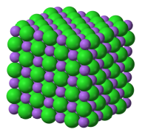
Ionic Compounds:
- are made up of ________________________ arranged in a crystal structure.
(________________________________)
Covalent Molecules:
- are made up of atoms ______________________________________.
(___________________________)

Naming Ionic Compounds: name of an ionic compound = positive ion negative ion-ide
- Ex.1: magnesium and oxygen
- positive ion negative ion-ide Magnesium ox + ide
- _______________________________

- Ex.2: what is the name of Ca₃N₂?
- Ca = calcium; N = nitrogen Drop the end of the negative ion and add –ide
- _______________________________
- Ex.3: What is the name of BaCl₂?
- _______________________________

Writing formulas for Ionic Compounds
Remember: ______________________ must = ___________________________.
Ex.1: What is the formula for magnesium phosphide?
Drawing Formula Diagrams: More Examples:
- Lithium nitride

- Barium sulphide

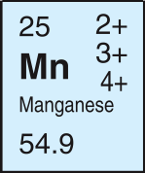
Ionic Compound with a Multivalent Metal
- Multivalent: some transition elements have ____________________________________.
- ___________________________ are used after the metal name to indicate which ion was used

Ex. 1 What is the formula manganese(III) sulphide?
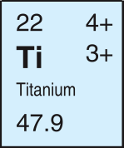
- This manganese is Mn³⁺ Sulphur is S^{2–}
- Lowest common multiple of 3 and 2 is 6
- 2 Mn³⁺ ions and 3 S^{2–} ions
- _________________________

You try!
What is the name for TiF₄?
- Titanium can be ______ or ______ Fluorine is ______
- From the ratio in the formula you can find out it is _____________
1 Ti⁴⁺ ion and 4 F– ions
- _____________________________________________

Polyatomic Ions
- are made up of several atoms joined together by _________________________.
- The whole _______________ has a + or – charge, not individual atoms.
- Ex.1 What is the formula of sodium sulphate? Na⁺ and SO₄^{2–}
_________________________
- Ex.2: What is the name of the compound KClO? K⁺ = potassium ClO– = hypochlorite
_________________________
- Ex.3: What is the formula for Calcium nitrate? ` Ca²⁺ and NO₃⁻
_________________________
* Note the brackets around NO₃ show there are two of the nitrate ions present

Naming Simple Covalent Compounds
- Prefixes are used before the atom name to indicate the _____________________ in the molecule.

- Ex.1 What is the name of the molecule Si₃P₆? __________________________________

- Ex.2 What is the chemical formula for the molecule trinitrogen tetrachloride? ________________

How do you know which type it is?
- To determine whether a compound is ionic or covalent:
- Examine the formula
- ________________________________ start with a metal or the ammonium ion
- ________________________________ start with a non-metal

