Modelling Energy Transfer: Building a Rube Goldberg Machine
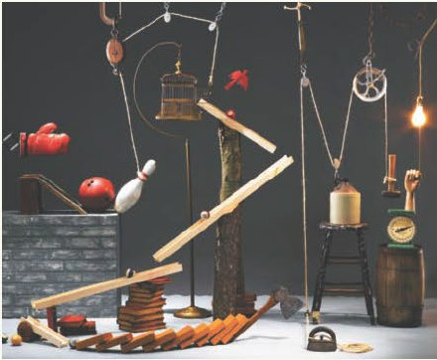
Rube Goldberg was a prize-wining cartoonist famous for his drawings of fun machines that perform simple tasks in the most complicated way imaginable. Rube Goldberg machines usually employ a lot of different energy transfers and transformations to get the job done.
Question
How can you design and build a machine that uses many different energy transformations and transfers to perform a simple task?
Procedure
- Choose a task you want to carry out. You could turn off a light, open a door, pour a bowl of cereal, turn off an alarm clock, hammer a nail or pop a balloon. Be creative — and unique.
- Design your machine. Brainstorm a series of actions that will complete your task. Make a pin pop a balloon. Send a toy car down a ramp. Make dominoes fall.
- Sketch your design, complete a list of materials that you will need, and record any safety precautions. You can use almost anything to create your Rube Goldberg machine.
  - Here are some ideas: dominoes, fans, PVC pipe, magnets, duct tape, marbles, cups or bowls, miniature toy cars, paper towel tubes, string.
- Have your parent/guardian approve your sketch, materials list, and safety precautions. Collect the materials you need and build your machine.
- Test your machine, making any required modifications to improve its performance.
  - As you create your machine, follow your design and place your materials where you think they need to be. Practice makes perfect, so don’t expect your Rube Goldberg machine to work perfectly the first time you try it. There will be plenty of trial and error — and that’s OK. Adjust your materials and keep at it.
Resources to help you brainstorm
- https://boyslife.org/hobbies-projects/projects/159359/how-to-make-a-rube-goldberg-machine/
- https://tinkerlab.com/engineering-kids-rube-goldberg-machine/
- https://www.youtube.com/watch?v=iemItSAT9Ew

Process and Analyze
- Attach a copy of your design and a video of the final product in action!
- Identify each different energy transfer and/or transformation that occurs when you run your machine.
  - Example: When the ball rolled down the ramp potential energy was transformed into kinetic energy
  - Example: When the dominos fall into one another they are transferring kinetic energy to each domino

Evaluate and Communicate
- a) Did your machine perform its task as planned? Explain.

- How might you change your design to improve its performance?

