GUIDED INQUIRY
Islands and Species
Suppose there is a small group of islands off the west coast of South America, just below the equator. They are volcanic and have existed for more than five million years. About half a million years ago, a pair of rats was washed off the main coast of South America. One rat was male and one was female, and both look like present-day rats.
Clinging to a large tangle of logs, the rats drifted out to sea and came ashore on one of the islands. Over thousands of years, the offspring of those rats colonized all the islands in the group. In this investigation, you will design a rat that is adapted to one of the islands.

Question
What are the characteristics of the rat species living on your island, and how do those characteristics reflect natural selection and adaptation?

For the Speciation Assignment this is your designated Island:
Island A | Island B | Island C | Island D
- Thomas  - Anmol  - Jaden  - Adriano  - Allyssa  - Sean D  - Jenna  - Keagan B  - Iker  - Andrew  - Daniel  - Queenie | - Ralph  - Niamh  - Stefan  - Merik  - Waheed  - Paco  - Timothy  - Justin  - Marcus  - Regene  - Ivy  - Laurence | - Jannat  - Sean L.  - Kiana  - Banji  - Luke  - Ericka  - Rafeel  - Pol  - Emi  - Paul  - Emma  - Luca | - Emil  - Kevin  - Simran  - Dakshveer  - Tristan  - Braeden  - Kellie  - Keagan P  - Juhwen  - Lucas  - Haris  - Hazel  - Alicia

Island A
The island is fairly flat, with an occasional hill. The ground is soft dirt, and several species of shrubs grow toward the centre of the island. There is no animal life on land, but the water is teeming with fish. The island is surrounded by a coral reef, which keeps the predators out. The shore is sandy with no algal growth. Fresh water is available.

Island B
The island has a rocky shoreline. Many tidal pools dot the island along the shore where the wave action is somewhat sheltered by rock outcrops. The tidal pools host barnacles, chitons (primitive molluscs), abalone, sea urchins, and crabs. Algae grow all around the island, but growth is quite sparse in the tidal pools where the land and aquatic animals feed. The current is quite strong along the rocky outcrops where the algae grow best. Fresh water is available.

Island C
The island is somewhat barren. A few species of cactus thrive on the bare rocks. A species of large cactus-eating tortoises inhabits the island. A species of very large birds nests on the island annually. They build their nests on the rocks, and protect their eggs from the Sun by standing over the nests with outspread wings. The nests are always on the windy side of the island, which is cooled by offshore breezes. Fresh water is available.
Island D
The island is an extinct volcano. Vegetation on the island changes, depending on the altitude. Grasses grow at the base. On the lower slope of the volcano, the grasses give way to low shrubs. Halfway up, tropical plants and trees dominate the landscape. At this altitude, the island experiences frequent rain showers. Two species of birds inhabit the island. One is a raptor that preys on the smaller birds. The other fishes the waters approximately half a kilometre offshore. Both nest in trees. Fresh water is available.
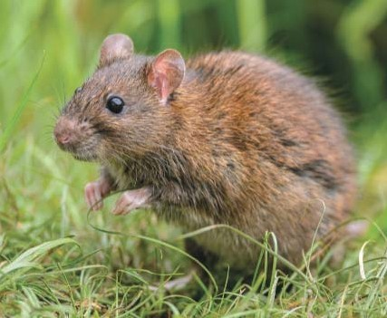
Procedure
- Learn about specific characteristics of rats, including their size, coloration, living and feeding habits, and predators. List the characteristics of a modern rat as your ancestor rat.

This photograph shows a modern-day brown rat.

- Imagine that clinging to a large tangle of logs, the rats drifted out to sea from the mainland and came ashore on your island.
- Consider the features of the island that you have been assigned. List what types of food are available, what types of predators exist, and so on. Draw a sketch of your island, showing its geography and other features. (complete drawing on a separate piece of paper-just a rough sketch)

- Thousands of generations later due to selection factors, a new species exists. Draw what you think this rat may look like. Ensure to use question 3 to help you. (Draw rat on your island that you previously have drawn)

Analyze and Interpret
- How many adaptations to living on its island does your rat have, compared with the ancestral rat?

- If you gave your rat a NEW trait, how is that possible? (Think about how new traits appear in a population)

- List the adaptations of your rat. Explain how each adaptation helps the rat survive the environment.

- Choose one adaptation, and describe a possible path for natural selection.(Think about how traits are selected for)

- Imagine your rat was washed away by the tide and landed on one of the other islands.
  - Infer its chances for survival. Explain your answer.

