Artificial Selection (Selective Breeding)
Using class notes and pages 55-57 in textbook, answer the following questions:
- What is Artificial selection?

- What is the difference between Artificial selection and Natural selection?

- Explain how the food crops we see today are related to artificial selection. Why do farmers use selective breeding?

- Give 3 positive consequences of artificial selection

- Give 3 negative consequences of artificial selection

- What is monoculture? What are some pros and cons of monoculture?

Poster Assignment
All the major crops that we depend on for food have been domesticated over thousands of years. These crops include rice, wheat, squash, potatoes and beans. Choose one of these crops, or a domesticated plant or animal of your choice and research using the Gale database, the internet or library books.
You will create a poster documenting how your organism has changed over time through selective breeding. Be sure to include the original ancestor, the modern offspring and a few variations in between. Compare the original and current forms. Describe at least three traits that humans appear to have selected for.
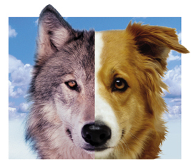
Your poster will be marked for content accuracy, colour, creativity and effort.

Gale Database: https://www.galepages.com/41bcss/resources
Login: Burnaby
Password: Burnaby

