Alien Babies Online Assignment

Purpose
- To examine genetic inheritance: how traits are passed on from parents to offspring.

Background
Every family has observable characteristics, or traits, that are passed on from parents to their children. We can categorize these traits in two different ways: as genotype and phenotype. A person’s genotype is the set of genes that they carry (what their DNA ’says’). Their phenotype is their observable characteristics (what we can see). Different versions of the same gene are called alleles. To keep things simple, we give the genotype a two-letter code. You will be given codes to use in your exercise.
Flower | Phenotype  (colour) | Genotype  (two-letter code – case sensitive!)
A | Red | BB
B | White | bb
C | Pink | Bb

The following chart gives an example of genotype and phenotype for three different-coloured carnations: red (A), white (B) and pink (C).
Each letter of the two-letter code is an allele. Remember that you get two copies of each gene: one from mom and one from dad. Note that the red flower got two copies of the same allele, while the pink flower got two copies of different alleles.

Materials for each group

- 2 alien ‘parents’- Ms Hemingway has designated each person an alien
- Pen or pencil
- Scissors
- Cup or Bowl
- Crayons or pencil crayons (Can be coloured digitally if you want)

Procedure
- Set up a time to meet your partner on Teams or through communication of your choice. Find out which Alien you have been assigned. Assign one alien to be the “mom” and the other the “dad”. You will be “crossing” these two aliens to create a baby!
- Based on phenotypes (what we see), figure out the genotypes (what the DNA really says) of your alien. Do this by circling the appropriate phenotype for each trait in Table 1. The corresponding genotype is listed. Write this code in the genotype column. See the example here:
What we see |  |  |  | Genotype  (case sensitive)
B. Hair Colour | Red = HH | Pink = Hh | White = hh | Hh
C. Hair Curl | Curly = MM | Wavy = Mm | Straight = mm | MM

- Each “Parent” using their alien will fill out Table 1. Look at your alien, circle what you see and write the corresponding genotype.

Table 1
Trait What you See | Phenotypes |  |  | Genotype  (case sensitive)
B. Body colour | Orange = BB | Pink = Bb | Blue = bb
H. Hair colour | Red = HH | Pink = Hh | White = hh
M. Hair curl | Curly = MM | Wavy = Mm | Straight = mm
A. Antenna | 2 = AA | 1 = Aa | None = aa
E. Eye colour | Brown = EE | Green = Ee | Blue = ee
N. Nose | Trunk = NN | Parrot = Nn | Button = nn
L. Hairy arms and feet | Very hairy = LL | Some hair = Ll | No hair = ll
R. Tongue roll | Roller = RR | (Rr = Roller) | Non-Roller = rr

** If your alien can roll their tongue you can choose between RR and Rr

- Once you have filled in Table Write the corresponding alleles for each trait (one letter per box) in Table 2. Each letter represents an allele version of that gene. See the example here:
 |  | Genotype
Trait
 |  | Version 1 | Version 2
B. Hair colour |  | H | h
C. Hair Curl |  | M | M

Table 2.
Trait | What the DNA says  Allele 1 Alelle 2
B. Body colour
H. Hair colour
M. Hair curl
A. Antenna
E. Eye colour
N. Nose
L. Hairy arms and feet
R. Tongue roll

- From Table 2 Flip a coin to determine which allele each parent will donate to the offspring. Each parent will need to flip a coin to determine what allele they are giving the “child”. Record Results from BOTH parents in Table 3.

Table 3. Name of Mom:___________________ Dad:_______________________
Trait | What the DNA says  allele from “mom” alien allele from “dad” alien |  | What we see
B. Body colour
H. Hair colour
M. Hair curl
A. Antenna
E. Eye colour
N. Nose
L. Hairy arms and feet
R. Tongue roll

- In the last column of Table 3, record the what we would see (phenotype). Use Table 1 to help you with this.

- Using the information in Table 3, draw a detailed and coloured picture of your offspring with the appropriate traits based on their genotype. Be certain to use arrows and clearly label all 8 traits of your offspring. See below

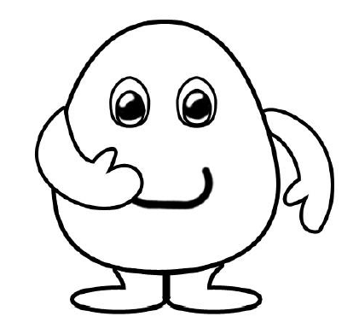

Discussion Questions:
- Why did you flip a coin to determine what allele was being passed on to the offspring?

- What is the difference between a phenotype and a genotype. Give an example of each.

- What is the difference between dominant and recessive?

- What is the difference between Heterozygous, Homozygous dominant and Homozygous recessive? Use an example.

- Can you ever tell a person’s genotype by looking at them? Give evidence to support your answer.

