Inclusion Project Self Reflection
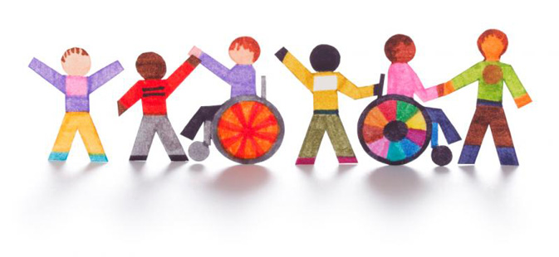
Reflect on the project that we just completed with the Access class.
- How do you feel now that the project is complete? Was it what you expected?

- What is something you felt went really well with the project? What is something you would like to see changed for next year?

- What is something that surprised you during this project?

- How did this project contribute to yourself as a leader?

- Do you feel like you made a positive impact in Burnaby Central? If yes, give an example of how.

- Would you like to see this repeated in the future?

- What was your favourite moment of the project? Think of a specific memory.

- Would you like to continue working with the access students in the upcoming week? What suggestions do you have to reconnect with our access students in the upcoming months?

