Let Us Sing Together

Let us sing together, let us sing together, one and all a joyous song.
Let us sing together, One and all a joyous song.
Let us sing again and again. Let us sing again and again.
Let us sing again and again. One and all a joyous song.

Let us eat together, Let us eat together, What is on the menu today?
Let us eat together, What is on the menu today?
Let us eat some 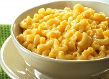 mac & cheese.
This Photo by Unknown Author is licensed under CC BY-NC-ND
Let us eat some 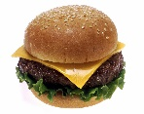hamburgers please,
This Photo by Unknown Author is licensed under CC BY-SA
Sushi, pizza, sandwiches, chips! What is on the menu today?
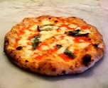
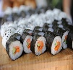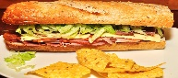
This Photo by Unknown Author is licensed under CC BY-SA

This Photo by Unknown Author is licensed under CC BY-SA
Let us wash together, Let us wash together, What is on my fingers today?
Let us wash together, What is on my fingers today?
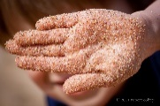
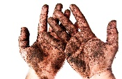
Sticky fingers covered in sand, dirt and germs all over my hands

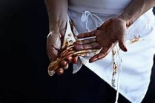
Food and stuff, get it off if you can, What is on my fingers today?

