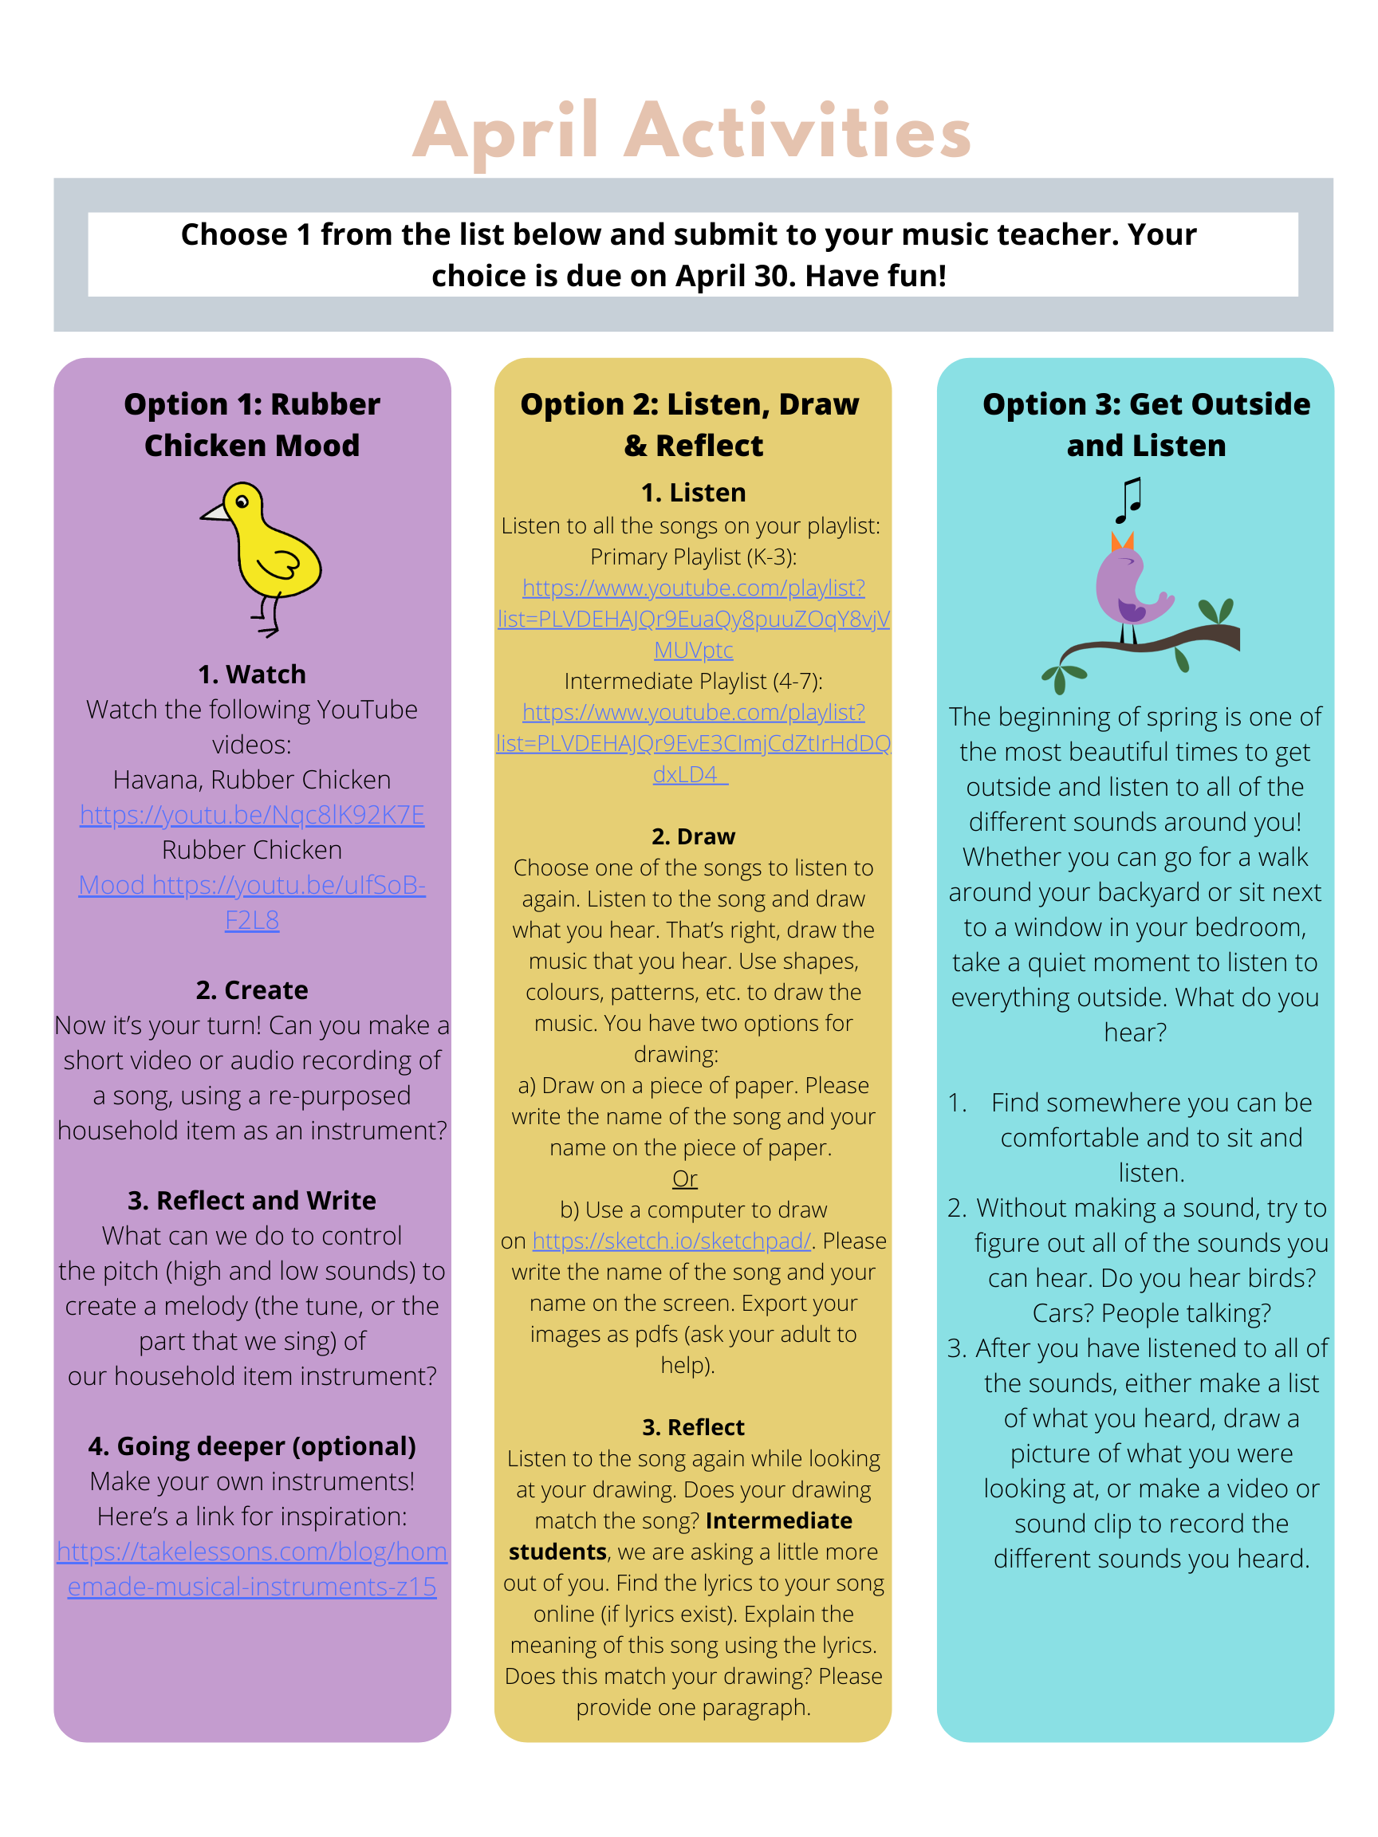
You only need to pick 1 of the 3 activities from up top to submit. Have fun!
Email your response to: amanda.hicks@burnabyschools.ca
Clickable Links:
1. Rubber Chicken Mood
Havana Rubber Chicken: https://youtu.be/Nqc8lK92K7E
Rubber Chicken: https://youtu.be/uIfSoB-F2L8
Going Deeper: https://takelessons.com/blog/homemade-musical-instruments-z15
2. Listen, Draw & Reflect
Playlist: https://www.youtube.com/playlist?list=PLVDEHAJQr9EuaQy8puuZOqY8vjVMUVptc
IO Sketchpad: https://sketch.io/sketchpad/

