Getting Started Elementary  Student Portal | 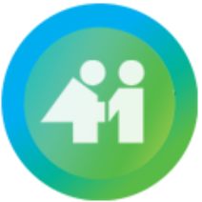 |  | School District 41 (Burnaby)
 |  |  | MyEducation BC

Is my child’s information secure?
MyEdBC protects student information by following the rules and regulations of the School Act and Freedom of Information and Protection of Privacy Act (FIPPA). Users only have access to their own information.

You can only view, not edit, your child’s demographic data. If you find it is outdated or incorrect email your school.

How do I access the system?
You can log on to MyEdBC’s Student Portal from any computer that connects to the internet.

www.myeducation.gov.bc.ca/aspen/login.do

Your login and password information will be sent home on a index card. Once you receive this information please go to the Second Street Website at https://secondstreet.burnabyschools.ca/ and follow the instructions below.

- Find the MyEdBC link at your school website.
- Enter your LoginID (7 digit pupil number) and Password.
- The first time you log on, you will be prompted to change your password

How do I navigate in MyEdBC?

The student portal in Burnaby school district is a single page that allows students and parents in grades K-7 to view published report cards from MyEducation BC.

Where do I find report cards?
When report cards are prepared they will appear as PUBLISHED REPORTS on the PAGES top tab.

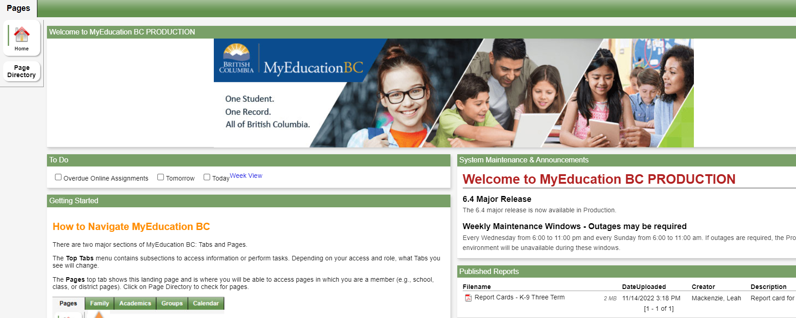
Click to download or open
What if I need MORE help? | How do I change my password?  Click your NAME in the upper-right corner of the screen, then click Set Preferences.  Here you can set several of your user preferences  Remember you are logged into the STUDENT account for your child DO not change their district email address to a personal email address.

