Name:______________________

MARBLE MAZE CHALLENGE
Today you will create a maze for a marble on a paper plate or shoebox. You can use any type of materials to create obstacles for the marble to move from the start to the finish of your maze.

Materials Needed
- shoebox, paper plate, etc.
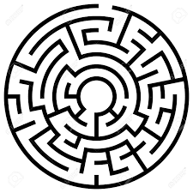
- Various household supplies (cardboard, straws, cotton balls, string, pipe cleaner, clay, etc.)
- Glue
- Scissors
- Marble, small tinfoil ball, etc.
- Watch or timer

Introduction:
Have students reflect on what makes a good maze, what makes a maze difficult, what materials would be helpful in creating your own maze.

Tips:
Be sure to have some places in the maze that are the “wrong way/ dead end.” This was add an extra challenge for whoever tries it.

Make sure that the space between obstacles is wide enough for the marble to move freely.

Be as creative as possible in the ways your construct your maze!!!

If you need help with visualizing this activity check out this youtube
https://www.youtube.com/watch?v=tR7o5g369FU

Activity Sheet

Step 1: Make a Plan: Before you begin to create your maze, draw a sketch of your maze below.

Step 2: Consider which materials will work best for the different parts of your maze. Now get to work making your maze.

Step 3: Test Your Maze. Try to move your marble through the finished maze. If you need to make changes (something doesn’t work), now is a good time.

Step 4: Find two people in your household to do the Marble Maze Challenge and time them.

Record how long it takes them to get the marble though the maze.

Person 1: ________ time Person 2: _________ time

Now that you have had your maze tested by different people, what changes could you make to make it more challenging? Or if it was too challenging, how can you make it easier?

