H A N D O U T 8 .1
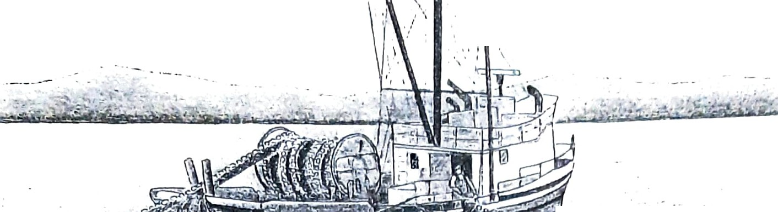ADULT SALMON
' ' \: .

Salmon swi m to the ocean to gro w into ad u lts. Some live in the ocean for one yea r. Others live in the ocean for many years.

Salmon find many smaller fish to eat in the ocean. They grow very large.

Their bodie s become silver and grey. They are-hard- to see in the ocean.
Seals, whales and large fish catch sal mon and eat them. Human fishers in fishing boats catch many salmon.
Like many birds, salmon can t ravel a very long way . Often they swim in big groups called schools. But they come back when their travel is finished.
No one knows how salmon find their way home. Scientists think they use all their senses to find the way.
Salmon remember the scent of the water where they were born. The scent of their home river in the ocean tells them they are almost home.

- . .
, , 3'
.
'

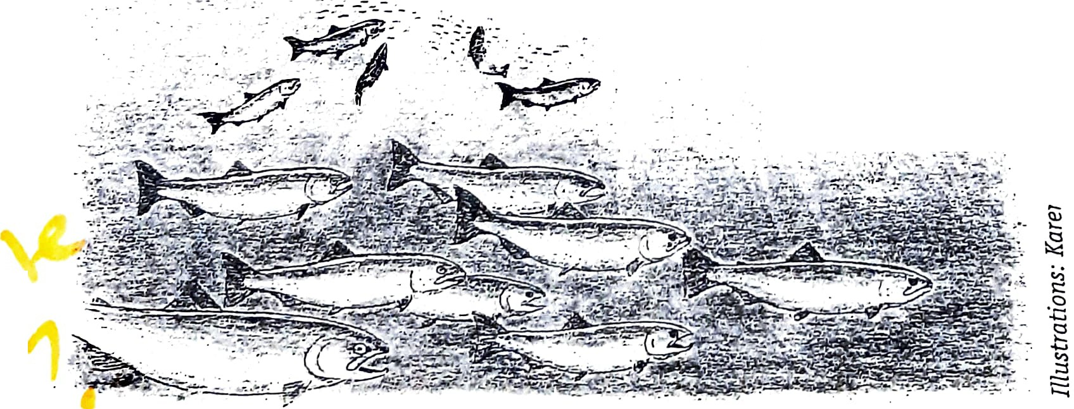
-- , :_.., - r.
, ,·:' ,., _:: : _· t\:: .·•:

-:. J ; ,. -.,_;_,:
"-

· _ -:. · §
..
;::::

UNIT 8: Adult Salmon 99

