Monday June 15, 2020
Activity 131 Reading Bingo 10

- Pick one reading bingo box to try today

Activity 132 Silly Starters Write About

- Write three interesting sentences about a puppy that causes a lot of trouble
- Please post your work on Freshgrade

Activity 133 Financial Literacy

Explain your thinking and post work on Freshgrade

- Would you rather buy…?
- 10 books for $20 or 5 books for $20

- Would you rather buy…?
- 3 boxes of Lego for $30 or 6 boxes of Lego for $50

Activity 134 Plant Life Cycle

- Please watch the video below
- Title: Stages of Plant Life Cycle
- Link: https://www.turtlediary.com/video/the-life-cycle-of-plants.html
- Choose one of the following activities to complete
  - Complete the cut and paste worksheet
  - draw your own plant life cycle diagram
  - use loose parts to recreate the plant life cycle

Tuesday June 16, 2020
Activity 135 Reading Bingo 11

- Pick one reading bingo box to try today

Activity 136 What Plants Need

- Please watch the video
- Title: How Does a Seed Become a Plant?
- Link: https://www.youtube.com/watch?v=tkFPyue5X3Q
- Complete the Plant Needs and Have Worksheet
- Post a photo on Freshgrade

Activity 137 Financial Literacy

Explain your thinking and post your work on Freshgrade

- Would you rather buy…?
- 2 paint sets for $5 or 5 paint sets for $15

- Would you rather buy…?
- 12 chocolate bars for $12 or 5 chocolates for $10
Wednesday June 17, 2020
Activity 138 Reading Bingo 12

- Pick one reading bingo box to try today

Activity 139 Silly Starters Write About

- Write five questions you would ask a monster that is always crabby
- Please post your work to Freshgrade

Activity 140 Financial Literacy
- Go around your home and look for different items that you can assign a value (price) to
- Write down the item name and the value (price) you would give it
- You can print price tags to stick on the item if you would like
- For example: doll for $5, shoes for $10, shirt for $4, etc.
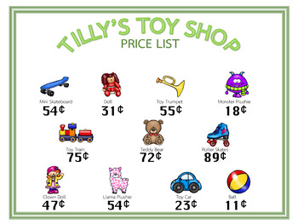
- Post a photo of your items with prices on Freshgrade
Thursday June 18, 2020
Activity 141 Reading Bingo 13

- Pick one reading bingo box to try today

Activity 142 Silly Starters Write About

- Write about your friend who is a toy that wants to be a person
- Please post your work on Freshgrade

Activity 143 Think Outside the Box
- Use the image to create something that it reminds you of or create something from your imagination
- Post a photo of your creation on Freshgrade if you would like
- 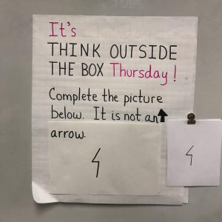
Friday June 19, 2020
Activity 144 Reading Bingo 14

- Pick one reading bingo box to try today

Activity 145 Silly Starters Write About

- Describe what it would be like to live next door to a pet that is full of energy
- Please post your writing on Freshgrade

Activity 146 Financial Literacy

- Set up a small store either on a table or on the floor with different items and place price tags on each item
- Have your siblings or parents pretend to buy the items using either paper money or real money
- You can practice giving back change
- When they are done buying you can switch roles with your parents so they are the cashier and you are the buyer

