READING BINGO
Read a book written by Robert Munsch | Read a book or story that takes place in the future | Read a book that has the letter “Z” in the title | Read a book that has 3 words in the title | Read outdoors in a quiet, comfortable spot
Read a book about a topic of interest | Read a book that takes place in Canada | Read a book that you love to read with your family | Read choosing your fav reading bingo activity | Read a book to a family member over zoom/ facetime
Read a book and give it a rating out of 5 and a review | Read a book that is silly or makes you laugh | 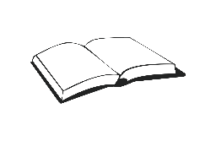  This Photo by Unknown Author is licensed under CC BY-SA | Read a book with amazing or colourful images | Read a book and re-tell the story to a family member
Read a book about a country/ city you would like to visit | Read a book with an odd amount a pages in it | Read a book and design a new front cover of the book | Read a book with non-human characters | Read a book that has rhyme or poetry
Read a book about a physical activity | Read a book based on a fable or folk-tale | Read a book about two characters who do not get along | Read a graphic novel or short story | Read a book with a flashlight

