Monday May 11, 2020
Activity 57 SEL Calendar 7

Please complete a daily activity from the calendar. Capture a photo or write a short summary of what you did for the day and post it to Freshgrade.

Activity 58 Record a Reading

Please record yourself reading a book that is a good fit for you and answer 5 comprehension questions on a sheet of paper then post it to Freshgrade. The five comprehension questions are: who are the characters in the book, where did the story taking place, what happened in the story, why do you think it happened, and when did the story take place?

To find a good fit book open a book to any page, read the words on the page, count the number of words that you cannot read, use your fingers to help you decide if this is a good fit book. If you cannot read one word that’s okay, if you cannot read two words that’s still okay, if you cannot read three words you may need some help, if you cannot read four words then it is too tough to read and if you cannot read five words it is too hard. If this book isn’t the right one that is okay! We are practicing so that one day we can read it easily! Don’t give up and keeping trying Please remember you have the option to use Razkids and Epic if you don’t have physical copies of books at home.

Activity 59 Measurement 11 Circumference of a Circle
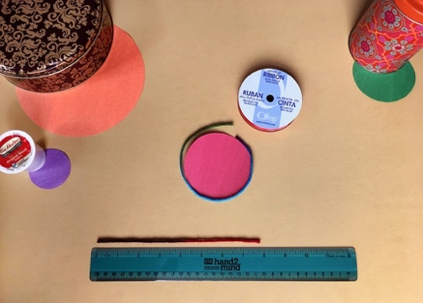
For this activity, you will need:
Find 5 circular objects
Paper
Scissors
yarn or string
a ruler
a pencil
a notebook

Once you have the five circular objects…
  - Trace each one onto a piece of paper and cut them out with a pair of scissors
  - Measuring the circumference of each circle with a piece of yarn or string (measure around the paper similar to the picture)
  - Stretch out the piece of yarn on top of the ruler and write down the measurements in centimetres (cm) on the circle
Tuesday May 12, 2020
Activity 60 SEL Calendar 8

Please complete a daily activity from the calendar. Capture a photo or write a short summary of what you did for the day and post it to Freshgrade.

Activity 61 Spelling Patterns 5

Please use the template below if you would like or continue writing the words however works best for you! Please post completed work to Freshgrade.

Activity 62 Measurement 12

Non-standard units of measurements are units that are not commonly used to measure, such as blocks, paper clips, tooth picks, parts of the body, cubes or string etc.
Watch the videos:
https://www.youtube.com/watch?v=riKk3b8KlZI
https://www.youtube.com/watch?v=lXqf1nA2Tl0

When Measuring with non-standard units keep these helpful tips in mind:
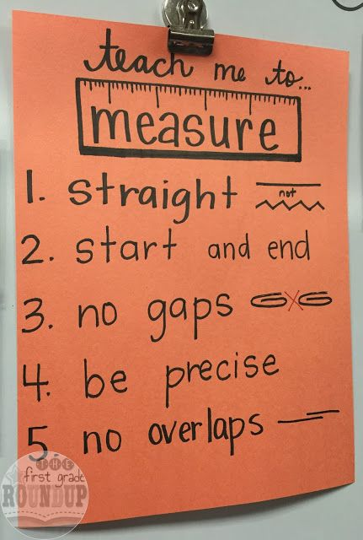
- Draw 3- 5 pictures that are different sizes on separate pieces of paper
- After you have drawn your pictures, select a non-standard measuring tool that are the same size (blocks, cubes, paper clips etc.)
- Estimate how many of these objects you will need to measure each of your images. Write down the estimation on your paper next to your image (remember an estimation is not always going to be correct, use your sense of sight and touch to make an informed guess).
- Measure your images using the non-standard tool of your choice
- Write down the measurement underneath your estimation
- Questions to discuss and ponder: What did you notice about the importance of estimating? Why is it important to observe to make an informed guess? How does it feel to estimate without knowing the answer first? How does practice with non-standard measurement support our understanding when using standard units?
- Post picture to FreshGrade
Wednesday May 13, 2020
Activity 63 SEL Calendar 9

Please complete a daily activity from the calendar. Capture a photo or write a short summary of what you did for the day and post it to Freshgrade.

Activity 64 Silly Starters Write About

- In your journal or on a separate sheet of paper list five uses for a spoon that tastes like chocolate
- Post your work to Freshgrade when complete

Activity 65 Measurement 13

Non-standard units of measurement are helpful for us to visualize the length or height of something in our minds.
For example, lately we have been asked to stay 6 feet apart from other people. But what if you don’t know how big 6 feet is? We use non-standard measurement to describe this. So, we might say to keep a distance of a hockey stick, an average man, a bed, 2 Stanley cups, a sofa, 2 shopping carts or a cougar. All these objects are about 6 feet (or 2 meters) apart. Sometimes it’s easier to visualize the objects than to visualize standard measurement like a ruler.
Activity: Can you create a poster that shares to others to keep 6 feet apart? What object(s) will you use? You can search for something that is 6 feet using the internet, or you can find it using a ruler or measuring tape.
Thursday May 14, 2020
Activity 66 SEL Calendar 10

Please complete a daily activity from the calendar. Capture a photo or write a short summary of what you did for the day and post it to Freshgrade.

Activity 67 Spelling Patterns 6

Please use the template below if you would like or continue writing the words however works best for you! Please post completed work to Freshgrade.

Activity 68 Measurement 14

Keeping Time
- Set a timer for 20 seconds
- How many jumping jacks can you do in 20 seconds?
- Count them
- How many could you do in one minute?
- How did you figure it out?

- Set a timer for 10 seconds
- How far can you run in 10 seconds
- Measure the distance

- Set a timer for 30 seconds
- How high can you count in 30 seconds?

Activity 69 Think Outside the Box

- Use the image below to create something that it reminds you of or create something from your imagination
- Post a photo of your creation on Freshgrade if you would like
