Tuesday April 28, 2020
Activity 32 Spelling Patterns 3

- Please watch the video about spelling patterns
https://www.youtube.com/watch?v=H-1o7EXpTIk https://www.youtube.com/watch?v=deUTRW1MTgg
- When you are finished watching, write down some words that follow these spelling patterns (please don’t use the words from the video)
- Post a photo of the words you thought of

Activity 33 Measurement 2

Basic Referent
- Without using a ruler, draw a line that is as close to 10 cm as you can
- When you are done drawing your line, find a ruler and measure it
- How close were you?
- How did you do it?
- What can you find that’s about the same length?

Basic Referent
- Get a piece of string
- Without measuring, cut a piece that measures one meter
- Find a measuring tool and measure your string
- How close were you?
- What can you find that’s about the same length?

Wednesday April 29, 2020
Activity 34 Silly Starters Write About

- In your journal or on a separate sheet of paper write a silly story about an elephant that can talk
- Ensure that your ideas are written in a complete sentence and that you include characters, setting, beginning, middle, and end
- Post your work on Freshgrade

Activity 35 Measurement 3

Height
- Measure your height in centimeters
- How tall are you?
- Measure someone else in your family
- Compare your height to your family members
- Who is taller?
- By how much?

Arm Span
- Measure your arm span in centimeters
- Your arm span is the distance from your outstretched fingers on one hand all the way to the outstretched fingers on the other
- How far can you reach?
- What are some things that are as long as your arm span?

Thursday April 30, 2020
Activity 36 Spelling Patterns 4

- Please watch the video about spelling patterns
https://www.youtube.com/watch?v=ILyAP0yoP3k
https://www.youtube.com/watch?v=zOLM38qvp20
https://www.youtube.com/watch?v=v7UmfJQjgbE
- When you are finished watching, write down some words that follow these spelling patterns (please don’t use the words from the video)
- Post a photo of the words you thought of

Activity 37 Measurement 4

Arm span and height
- Compare your arm span and your height
- What do you notice?
- What relationship exists?
- Now measure one of your family member’s arm span
- What do you predict will be true about family member’s height?
- Try it!

Hat Size and Arm Span
- Get a piece of string
- Cut a piece that is the same length as your arm span
- Use that string to measure about your head
- What do you notice?
- What relationship exists?

Activity 38 Think Outside the Box

- Use the image below to create something that it reminds you of or create something from your imagination

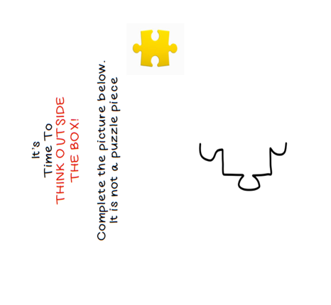
Friday May 1, 2020
Activity 39 Silly Starters Write About

- In your journal or on a separate sheet of paper write a letter to a friend about an island that is invisible
- Post your work to Freshgrade when complete

Activity 40 Measurement 5

- Find 10 objects in your house, a ruler, pencil and paper
- Line them up from tallest to shortest
- When you are done lining them up use the ruler to measure them
- When you are measuring something you want to put one end of the object right at the first line on the ruler then line the other end of the object along the ruler
- See what number the end of the objects lines up with on the ruler
- Write down the measurements of the objects along with the unit of measurement
- Millimeter = mm, centimetres = cm, kilometers = km, meters = m
- Please post a picture of your work on Freshgrade

