Grade 4-5 MACC CLASS SUPPLY LIST – SUNCREST – Ms. DeTerra
In the MACC 4/5 class, many items are shared supplies, and our supply list is different from the intermediate grades in Suncrest. We do not have individual desks, and we do a lot of collaborative work.
ALL STUDENTS in grades 4 and 5 need to bring supplies listed, unless indicated otherwise in the list.
Thank you in advance for your help finding and labeling supplies as needed to support our MACC learning!
The folllowing items do not need names on them, AND ARE SHARED IN THE CLASSROOM. Please see attached pictures on the next few pages, so we can have consistent supplies that last. Thank you!
- 2 black fine line sharpie markers
- 2 black ultra-fine line sharpie markers
- 5 packages of pencils (at least 10 per package)
- 1 package of at least 10 coloured felt markers wide tip
- 1 package of at least 10 coloured felt markers thin tip
- 1 package of coloured pencil crayons
- 1 pair of durable, sharp, adult scissors (not student, blunted scissors) -- ONLY IN GRADE 4 PLEASE!
- 1 wood, clear plastic, or metal ruler (30 cm) – no bendable rubber rulers please – ideally marked with both metric and imperial measurements, centimetres and inches – ONLY IN GRADE 4 PLEASE!
- 2 large regular glue sticks
- 1 small bottle of tacky glue (not white glue, please see picture)
- 1 set of multi-coloured, fine-tipped, white board markers – no eraser or spray needed
These items should be labeled clearly with a name, and are generally kept IN THE BACKPACK. Please see the blog for pictures of items for consistency and to have brands that last for the year.
- 1 SOLID BLUE 3-ring, plastic binder, 1” -- needs to be in good shape if you are re-using from last year!
- 6 dividers for that 3-ring binder, LABEL BEFORE BRINGING WITH: Unit, Math, LA, French, Art, Other
- Three duotangs: Green for Reading, Yellow for LA, Purple for Music – LABEL WITH NAME AND SUBJECT
- 1 quality pencil sharpener with storage for shavings
- 1 math set – must have a protractor and compass
- 1 standard small calculator
- 1 watercolour set (I have a box to store these in the classroom, but put a name on it please)
- 4 erasers (white vinyl please, no pink ones) – put a name on each individual one and have them available to use through the year.
- Optional – mechanical pencils. If a child brings a mechanical pencil, they are in charge of it. We have regular pencils to use in the classroom.
- Optional -- A mini, soft pencil bag to put erasers, small things, and pencil sharpener inside your backpack bag.
You will receive a spiral agenda from the school during the first month of school, for a fee, which will be collected in September.
I will provide your child with a composition notebook, no fee, in which we will do all of our writing. So, no lined paper is required in the binder, thank you!
Please do not bring: zipper binder or other large divider for the backpack, pencil box, ink pens, dictionary, thesaurus, French dictionary, any toy supply items, such as large erasers or fancy pens, or any other personal art supplies that you are not willing to share. Thank you for your support!
MACC Supplies Photos, Grade 4/5 Suncrest

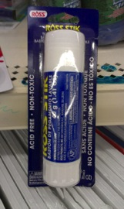 2 Glue Sticks

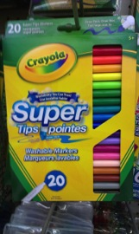
Set of Fine-tip Markers
And one set of 10 coloured thick markers

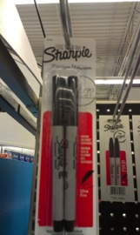 2 ultra-fine tip sharpies

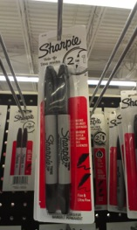 2 fine-tip sharpies

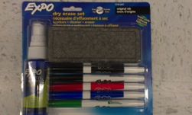

Set of white board erase markers, fine-tip
Eraser and spray are not needed.

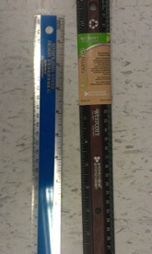
1 ruler, wood, metal, hard plastic, not rubber.

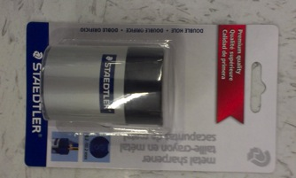

Pencil Sharpener – This is best brand!

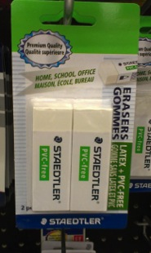 4 erasers, white

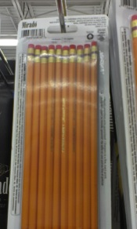

5 packs pencils

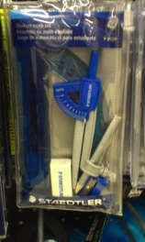 Math set with protractor

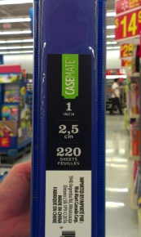

3, 1 inch simple, 3-ring binders --- one blue

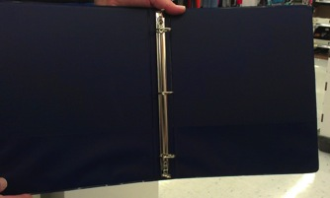

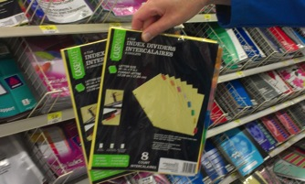
Dividers

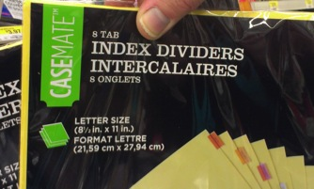

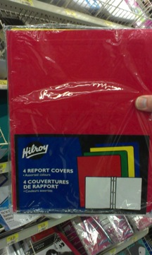

Duotangs

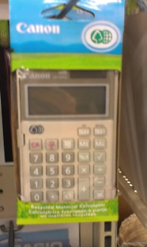

a simple calculator

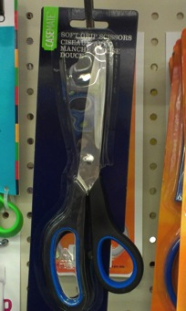

1 pair of adult, sharp scissors (not blunt tips) – GRADE 4 ONLY

1 package of tacky glue, 4 oz

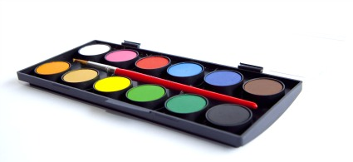

1 set of watercolours

