Grade 4-5 MACC CLASS SUPPLY LIST – SUNCREST – Ms. DeTerra
In the MACC 4/5 class, many items are shared supplies, and our supply list is different from the intermediate grades in Suncrest. We do not have individual desks, and we do a lot of collaborative work.
Some items will be shared and not have names on them. Other items will be individual and do need names.
Supplies tend to be used A LOT during the school year, so the shared supplies generally need to be replenished each year. Thank you in advance for supporting our shared supply approach.
Please see the list below:
These items don’t need names on them, thank you, as they will be shared. Please see the attached pictures on the next few pages, so we can make sure to have consistent supplies and brands that last. Thank you!
- 2 black fine line sharpie markers
- 2 black ultra-fine line sharpie markers
- 5 packages of pencils (at least 10 per package)
- 1 package of at least 10 coloured felt markers wide tip
- 1 package of at least 10 coloured felt markers thin tip
- 1 package of coloured pencil crayons
- 1 pair of durable, sharp, adult scissors (not student, blunted scissors)
- 1 wood, clear plastic, or metal ruler (30 cm) – no bendable rubber rulers please – ideally marked with both metric and imperial measurements, centimetres and inches
- 2 large regular glue sticks
- 1 box of kleenax
- 1 small bottle of tacky glue (not white glue, please see picture)
- 1 set of multi-coloured, fine-tipped, white board markers – no eraser or spray needed
- Package of 4 DUOTANGS, one of each colour Red, Yellow, Blue, Green
- 2 erasers (white vinyl preferred)
These items should be labeled clearly with a name. Please see the blog for pictures of items for consistency and to have brands that last for the year.
- 1 SOLID BLUE 3-ring, plastic binder, 1”
- 1 package of 8 dividers for 3-ring binders
- A portable, sturdy folder to take notices to and from home, to be kept in backpack
- 1 pencil sharpener with storage for shavings
- 1 math set – at least have a protractor and compass
- 1 standard calculator
- 1 watercolour set
- white out (non-liquid preferred)
Please do not get a zipper binder. You will receive a spiral agenda during the first month of school, for a fee, which will be collected then. I will also provide your child with a composition notebook, no fee, in which we will do all of our writing. So, no lined paper is required in the binder, thank you.
Please do not bring a dictionary, thesaurus, French dictionary. Please do not bring any toy supply items, such as large erasers or fancy pens. Please do not bring any other personal art supplies that you are not willing to share. Thank you for your support!

MACC Supplies Photos, Grade 4/5 Suncrest

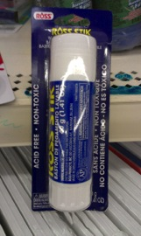 2 Glue Sticks

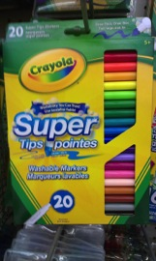
Set of Fine-tip Markers
And one set of 10 coloured thick markers

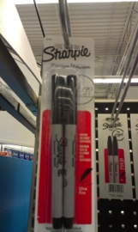 2 ultra-fine tip sharpies

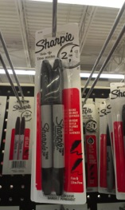 2 fine-tip sharpies

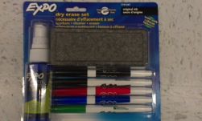

Set of white board erase markers, fine-tip
Eraser and spray are not needed, but it is okay if it comes with it.

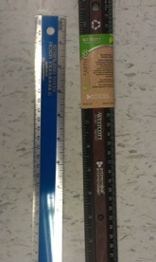
1 ruler, wood, metal, hard plastic

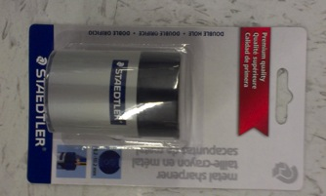

Pencil Sharpener

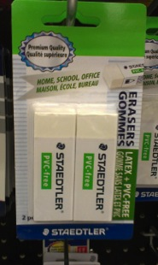 2 erasers, white

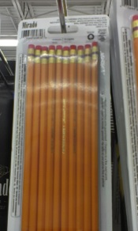

5 packs pencils

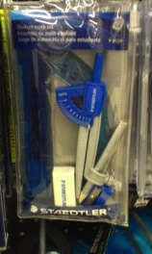 Math set with protractor

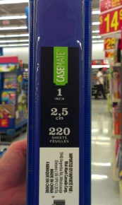

3, 1 inch simple, 3-ring binders --- one blue

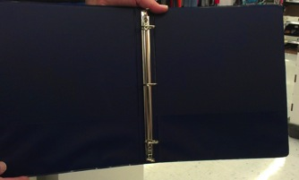

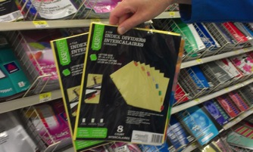
One package of 3-ring binder dividers – with 8 sections each

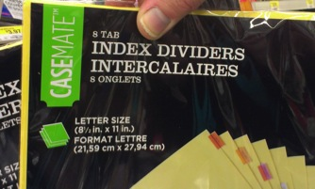

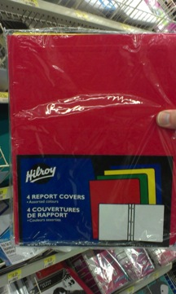

Package of 3-4 report covers or duotangs: 1 red, 1 yellow, 1 green, and 1 blue

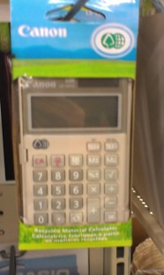

a simple calculator

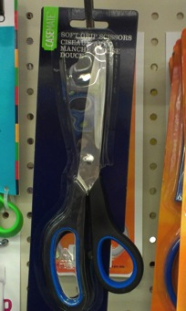

1 pair of adult, sharp scissors (not blunt tips)

1 package of tacky glue, 4 oz

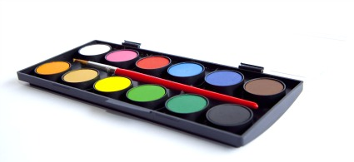

1 set of watercolours

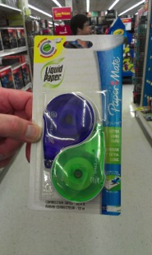

white out strips (not liquid)

