[](http://www.bing.com/images/search?q=filla+a+bucket+pics&view=detailv2&&id=AA4740209C7FD4016D16ECD218FF657589897F9C&selectedIndex=0&ccid=KBQMh2v4&simid=608029316845275126&thid=OIP.M28140c876bf893b1dd84aa740ece3d80o0)Positive Peaceful

Aubrey

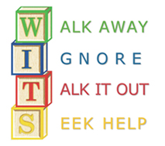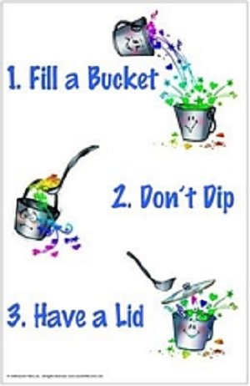

**BUILD YOUR “SUPER” POWERS**

**WALK AWAY or IGNORE the little things**

**--it may have been an accident**

**--reacting often makes things worse**

**--it’s probably not about you**

**TALK IT OUT if it keeps happening or it’s serious**

**--make eye contact**

**--calmly and clearly say *“I feel _____ when ____”***

**--sounding *mad*, *bossy*, or *whiny* does not work**

**--remember you are only in charge of yourself**

**--respect the *person* who made the mistake**

***--* believe that the person can make things right again**

**SEEK HELP if it still keeps happening or very serious**

**--report to an adult who can help talk it out**

**--we all need help to talk things through sometimes**

**--reporting is not the same as tattling if you’ve walked away, ignored or talked it out first**

**--learning to solve problems positively and peacefully gives you super powers for the rest of your life**



