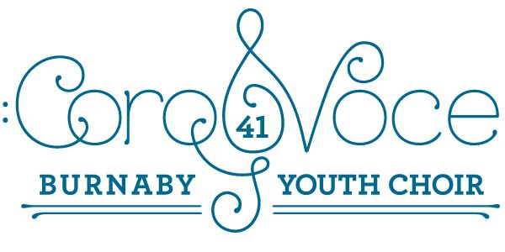
CoroVoce Tour on Thursday, May 9
April 22, 2024.
Dear Parents/Guardians:
CoroVoce will be on tour all day on Thursday, May 9. Members need to be at South Slope Elementary by 8:30 a.m. They can be picked up at 3:30 at the end of the day. We have a chartered bus to take us to our performance sites. Here is the schedule of schools:
9:30 a.m. – South Slope
10:45 – Edmonds Elementary (tentative)
1:15 – University Highlands
2:00 – Confederation Park Elementary
Students need to wear their t shirts and black pants/tights/skirts and pack a healthy lunch, snack, and a water bottle. Please try to avoid sending your child with any “nut” products as we have members in our choir with food allergies.
If parents/guardians would like to attend one of these performances, please join us at one of the schools, but check in at the office please.
There is no cost to parents/guardians, but we do need a consent form signed and returned by April 29.
There is also a form you can send off to your child’s school to excuse them from attending on that day. Please give this to your child’s classroom teacher and let the office at your home school know as well.
Thank you again for your tremendous support of our choir!
In song,
The CoroVoce Team
(please return by April 29)
I give permission for my child, _____________from ________________Elementary School, to attend the Corovoce Tour Date on Thursday, May 9.
__________________________________ _____________________________________
(parent signature) (phone number/email address)
April 22, 2024.

Dear ___________________Secondary/Elementary School:

Corovoce is the District Youth Choir in Burnaby. We rehearse every Monday at South Slope Elementary and will be going on a school tour to South Slope, Edmonds, University Highlands and Confederation Park Elementary schools on Thursday, May 9.
I,________________________(student name) from Div. ____, will be absent from school all day on Thursday, May 9.
I will:
- Let the office know of my all day absence.
- Make sure I catch up on any work I miss that day.
- Make sure I have any duties that I’m responsible for covered that day. (ie library monitoring etc…)
Thank you for allowing me to attend this tour day!
_______________________________
(student signature)
The Corovoce Team appreciates you allowing our members to go out on this tour date! Thank you!
In song,
Ms. Fierro, Ms. Ishii, Mr. Nguyen

