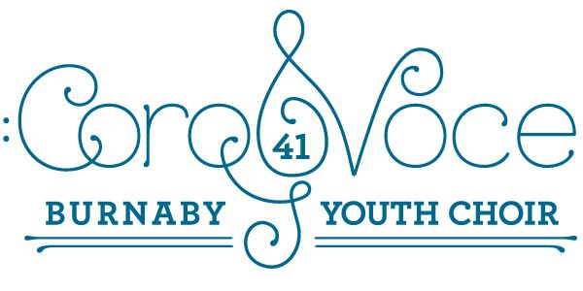
Important Memo Regarding December!
Tickets – These will be available online soon using school online cash and can also be purchased starting November 21. If you purchase online, please let your child know how many tickets were purchased so we can give you your tickets. Some tickets may also be available at the door the night of the show, but this is not guaranteed. Everyone who sits in a seat needs a ticket. ($5)
Lengthening the rehearsals for the next three weeks
We have an ambitious repertoire and now that we are closer to the performance, we believe we need some extra time to work on our songs. We will be rehearsing from 3:30 to 5:15. Please stay if you can, or slip out quietly if you are not able to stay.
A reminder of our extra rehearsal at Kitchener Elementary on:
Tuesday, December 6 from 3:30 p.m. to 5:15 p.m.
We will be rehearsing our mass numbers with Picollini. Please try and be there if you can!
The Shape of the Concert Day (December 12)
A reminder that students need to be at the theatre, in their white collared shirts and black slacks, or skirts by 3:30 p.m. We will rehearse our numbers, then the mass number until 4;30 and then students will be dismissed to their parents. Please supervise your own children, or make arrangements for other parents to supervise them until 6:00 when they are expected to be in one of the “green rooms” ready to warm up.
Hair, Make-up, and Footwear – We expect our choir to look as polished as their songs. All members need to have neat, tidy hair, and off the face as much as possible. Some light make-up and lip colour would help to brighten the face, but are not absolutely necessary. In terms of footwear, we are asking for black dress shoes or boots, or anything that is not a casual runner.
Performance at the School Board Tuesday, December 13.
Please continue to save this date. More details to come. Dress code will be the same as for our concert.

Looking forward to a wonderful concert!!
Your CoroVoce Team!

