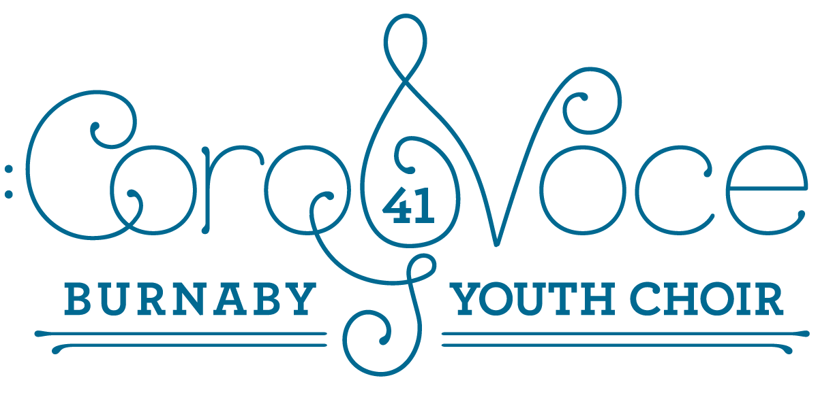
Welcome to Choir!!
We are so glad you have joined us for this season and are looking forward to creating beautiful music together. Please take a look over the included information in this notice with your parents/guardians.
INTRODUCING YOUR COROVOCE TEAM FOR 2022/2023!
Ms. Fierro (aka Mrs. Jukich – Fierro) – Conductor
Ms. Fletcher – Supreme Guest Conductor
Ms. Ishii – Accompanist
Ms. Little - Manager
THE COROVOCE BLOG AND E-MAIL – is the best way to communicate with you all about important information and updates you need to be successful in this choir. You should subscribe to our blog. Copy and paste the link here. http://sd41blogs.ca/jukicht/
Or, simply go to the South Slope Website, click on staff, scroll down to Mrs. Fierro, Corovoce blog and you’re in!
CALENDAR – Included in this packet is a calendar for the fall season. Please check it carefully and add the dates to your own calendars so you stay on top of all current information. We realize families are busy and so we have given you lots of time to make sure you are able to fulfill your commitment to our group. If you spot a major conflict between your calendar and ours, please let us know by email as soon as possible.
ABSENCES – Just as missing multiple sports practices can have an impact on your own abilities and your team, missing too many choir rehearsals will adversely affect your ability to participate in choir. We need you here at rehearsals!! However, if you are feeling sick we encourage you to stay home and get well. Just send us an email and let us know.

MUSIC AND FOLDERS – Please handle your music with care. It is very expensive and we’d like to use it again in a few years. DO write notes in pencil, however, on your music to help you remember rehearsal tips and repeats, or changes etc…We have some folders for your music that we can provide for you to keep your music safe. We may also have the opportunity for you to purchase and keep your own folder. Stay tuned.

PRACTICE….IT’S NOT JUST MONDAY FROM 3:30 TO 4:45. – You will need to spend some time each week working towards memorizing your notes and words. We make MUSIC when we have internalized all the notes and words, and we sing from our heart, connecting with each other, and the music. Go online to listen to other choirs sing our songs as most of our arrangements can be easily found on YOU TUBE, or use your piano to remind your ear of the notes in your part. The numbers will also be posted on our blog. It’s important to spend some time at home reviewing what we have done during our rehearsal. We have quite an ambitious repertoire for Christmas and only 8 rehearsals before the concert!

OUR VENUE IS SOUTH SLOPE ELEMENTARY SCHOOL– Our home this year is my home school, South Slope Elementary. It’s directly behind Metrotown, near the corner of Rumble and Sussex. It also says BCSD on our sign which is the BC School for the Deaf.
Address - 4446 Watling Street, Burnaby.
Phone – 604 296 – 9062 or my cell 604 831-4080
Place – Gym
We have a parking lot beside the school and the gym is right there so you are welcome to drop off and wait for your students outside the gym. Please be on time picking up as your Corovoce Team also needs to get home to their families.

THE FEES - Corovoce is a District sponsored event and the $75 fee covers you for the entire year. It helps pay for music, venue rentals, t-shirts and professional development for the team. Please pay online using OnlineSchoolCash, if you possibly can, or bring cash or a cheque made out to the Burnaby School Board as soon as you can. The link is available on the blog, or by going into OnlineSchoolCash and clicking on the District Items tab.

WE ARE VOLUNTEERS – Your Corovoce Team members are all volunteers. Some of us are still teaching and giving up our own time to work with your children. Some of us are retired, and still giving back to the District. NO ONE is getting paid! All we ask is that your children be kind to each other and the Team, respectful of the space we are using, and share their love of singing with the world!
We look forward to an exciting and fantastic year together! Thank you in advance for helping us make beautiful musical experiences with your child!
In song,
Ms. Ishii, Ms. Little, Ms. Fletcher, Ms. Fierro

COROVOCE CALENDAR FOR FALL 2022
Monday, September 26– First Rehearsal at South Slope!
3:30 – Come into the gym and line up with your registration form filled out.
- Make your name tag! Introduce yourself to 3 new friends.
4:00 – Vocal Warm Ups!
4:15 – Preview of music.
4:45 – Choir is dismissed to parents/guardians
Monday October 3– Rehearsal at South Slope 3:30 – 4:45
Monday, October 10 – NO REHEARSAL - THANKSGIVING
Monday, October 17 – Rehearsal at South Slope 3:30 – 3:45
Monday, October 24 – Rehearsal at South Slope 3:30 – 4:45
Monday, October 31 – NO REHEARSAL – HALLOWEEN….too scary.
Monday, November 7 – Rehearsal at South Slope 3:30 – 4:45
Monday, November 14 – Rehearsal at South Slope 3:30 – 4:45
Monday, November 21 – Rehearsal at South Slope 3:30 – 4:45
Monday, November 28 – Rehearsal at South Slope 3:30 – 4:45

Monday, December 5 – Rehearsal at South Slope 3:30 – 4:45
****please bring your music to this rehearsal as we will be collecting it and handing out our spring repertoire.
TUESDAY, DECEMBER 6 – Joint Rehearsal at KITCHENER 3:30 – 4:45
***while this is an optional rehearsal, and we understand students may not be able to attend, we hope to have as many there as possible.
MONDAY, DECEMBER 12 – “Together Again” Our joint concert featuring Sounwave Handbell Choir, Corovoce, and Piccollini.
6:30 p.m. Michael J Fox Theatre
3:30 – DRESS REHEARSAL – Come in your WHITE TOPS AND BLACK LEGGINGS, PANTS, SKIRTS promptly at 3:30. We rehearse first, then we have the mass rehearsal of our joint numbers.
4:45 – Pick up your child outside the theatre and take them for a small dinner or snack or just a break.
- Return by 6:00 to the Green Room at MJF.
6:30 – Concert – “Together Again”
Monday, December 19 – Winter Break – No rehearsal
Next Rehearsal is Monday, January 9, 2023!!!

