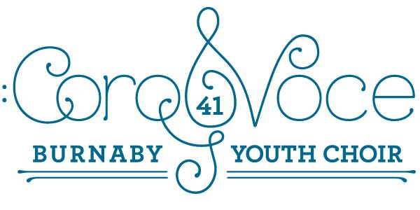

March 5, 2020.
Dear CoroVoce Members:
We look forward to seeing you this Saturday, March 7 at 12:30 at the New Westminster Christian Reformed Church. (8255 13th Avenue, in Burnaby)
You will need:
- White collared top, black pants, tights, skirt, and dress shoes
- Water bottle
- Healthy, nut-free snack
- Book, or quiet game to play
We will each have some time in the venue to rehearse separately, then we will rehearse our numbers together. At 2:30, we will open the doors for the audience, and begin at 3:00 p.m. We anticipate the concert will be completed before 4:30 p.m.
All of your hard work has paid off. We wish everyone a great show! Keep Laura Hawley in your mind as you sing our amazing “Maple Key” and “The Sun is Mine”, and “Earth Voices”. We will make her proud!
In song,
The Team (Ms. Ishii, Ms. Little, Mrs. Fierro, Ms. Fletcher)

