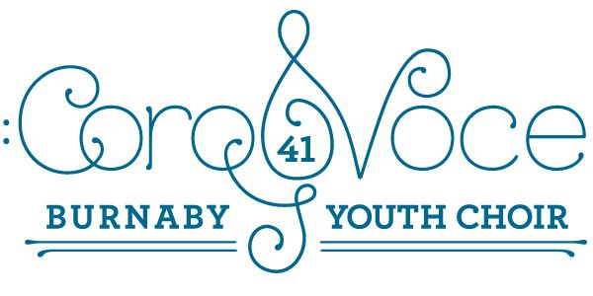
Important Memo Regarding December!
Tickets – still available from us on December 5. Some tickets will also be available at the door the night of the show.
A reminder of our extra rehearsal at Kitchener Elementary on:
Tuesday, December 3 from 4:00 p.m. to 5:15 p.m.
We will be rehearsing our four mass numbers with Picollini and Soundwave. Please try and be there if you can!
The Shape of the Concert Day (December 9)
A reminder that students need to be at the theatre, in their white collared shirts and black slacks, or skirts by 4:00 p.m. We will rehearse our mass numbers, do a quick run-through of our own repertoire, and be dismissed to parents at 5:15. Please supervise your own children, or make arrangements for other parents to supervise them until 6:00 when they are expected to be in one of the “green rooms” ready to warm up.
Hair, Make-up, and Footwear – We expect our choir to look as polished as their songs. All members need to have neat, tidy hair, and off the face as much as possible. Some light make-up and lip colour would help to brighten the face, but are not absolutely necessary. In terms of footwear, we are asking for black dress shoes or boots, or anything that is not a casual runner. We realize proper shoes are harder to find, but I did see some black flats for girls in the Superstore this week.
Thursday, December 12 – usual rehearsal at South Slope. We will be moving on to our Spring Repertoire as we will be meeting with the composer, Laura Hawley, early in January and need to get going on her pieces.
Thursday, December 19 – usual rehearsal at South Slope, but we will end singing a bit early to have a pizza celebration!!! Usual dismissal time at 5:15.

Looking forward to a wonderful concert!!
Your CoroVoce Team!

