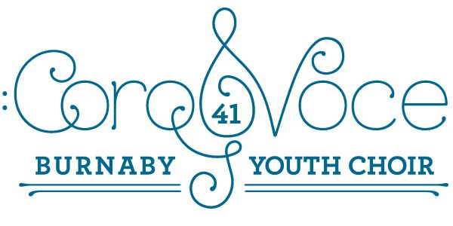
October 17, 2019
IMPORTANT NEWS REGARDING THE SPRING SEASON! Save the Dates!
Dear CoroVoce Families:
We have some exciting news to share regarding our Spring Season. Before I became conductor, our former director, Angela Adam, began a process to commission a song to be written specifically for our choir, and Coast Sound Choir in Coquitlam. Much fund-raising was done to make this happen and we are so fortunate to be the benefactors of this venture. The piece, “The Maple Key”, written by Canadian composer Laura Hawley, is in the final process of being revised, and will be debuted by both choirs on Saturday, March 7. More details will be forthcoming, but it is important for you to save these dates and times before your calendar fills up in the spring! This will also allow you enough time to make arrangements to move around lessons or sports activities in order to be in attendance.
THURSDAY, JANUARY 23 – Rehearsal at Evergreen Cultural Centre in Coquitlam from 4:00 p.m. to 7:00 p.m. (we may all meet and take the Sky Train together…..)
SATURDAY, JANUARY 25 – Rehearsal at South Slope Elementary from 10:00 a.m. to 1:00 p.m.
SATURDAY, MARCH 7 – Debut performance of “The Maple Key” in conjunction with Coastal Sound, within a show entitled, “Roots Before Branches”. The show is at 3:00 p.m., but you may be asked to be there earlier that day. It’s at the New West Christian Reformed Church.
If you have any questions, please send me an email at: teresa.jukich@burnabyschools.ca
Regards,
The CoroVoce Team

