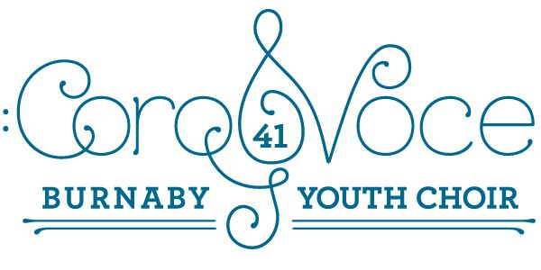
April 11, 2019
Dear CoroVoce Parents/guardians:
It’s hard to believe that we’ve almost come to the end of our season. Thank you so much for all you’ve done to make our choir run so smoothly this year! Here are the dates and information you need for the end of our season.
Wednesday, April 17 – Concert – “We Are One” 6:30 p.m. Michael J Fox Theatre
Students need to be in their t shirts and black pants/tights/skirts at 5:00 p.m. You need to have eaten something substantial before this because there will be no dinner break this time. We will rehearse our finale at 5:15, then if there’s time, run through bits of our songs. We will then return to the green room where we will be able to get a drink, go to the restroom, and get ready for our performance. Tickets may be available at the door.
Thursday, April 18 – Tour Day!
Please be at Cascades Elementary (4343 Smith Ave.) in the music room by 8:30 a.m. We will leave at 9:00 a.m. sharp!! Here is our performance schedule:
9:30 a.m. – Nelson Elementary
11:00 a.m. – Aubrey Elementary
1:00 p.m. – Brantford Elementary
2:00 p.m. – Cascades Elementary
After our performance at Cascades, parents need to pick up their children at 2:45 p.m.
THERE IS NO REHEARSAL FOR OUR CHOIR THAT AFTERNOON!!!
Thursday, April 25 – “Show and Glow” or “Juice and Cookies Performance”
Rehearsal at Moscrop will begin at 3:30 as usual. Wear your T Shirt!! We will collect our music, do a reflection piece, warm up, and perform in the multi purpose space at 4:15 p.m. After our performance, parents are welcome to stay for juice and cookies and celebrate our great season!
We are all looking forward to the amazing performances coming up!
In song,
The CoroVoce Team

