ELEMENT SUPERHERO PROJECT

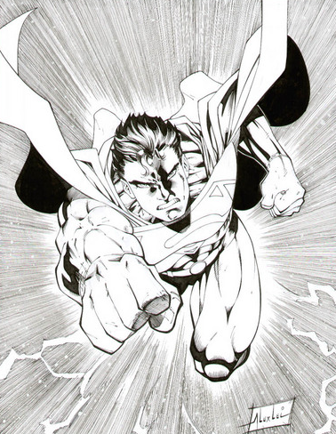

You have been hired by Elements of the Universe, a comic book publisher, to create a new superhero whose appearance, characteristics and powers are based on an assigned element in the periodic table.

Directions:
Students will conduct research to find information regarding their assigned element. Students will create an Element Superhero that illustrates this information through a written story about the superhero and a drawing of the superhero. The worksheet will be turned in with the Superhero and the student will do a brief presentation to the class using either PowerPoint, Prezi or other method.

Use the following websites to find out qualities (both physical and chemical) about the element assigned:

http://www.chemicalelements.com/ (This site should be used to figure out how many electrons are in each shell)

http://periodic.lanl.gov/default.htm

http://www.ptable.com/

http://www.popsci.com/files/periodic_popup.html

http://www.lenntech.com/periodic-chart.htm

http://library.thinkquest.org/12909/main2.html

http://www.webelements.com/

http://www.uky.edu/Projects/Chemcomics/ ** has pictures if you need inspiration**
YOUR ELEMENT SUPERHERO PROJECT MUST INCLUDE THE FOLLOWING SECTIONS:

- TITLE: (Slide 1)Creative name of superhero. Name of your element and your
elements' symbol and your Name.
- Historical perspectives. This section should include a brief description of how
your superhero acquired their element power. You must state somewhere in your
story WHERE,WHEN and WHO discovered your element/superhero. Find a
picture of your discoverer, if WHERE, WHEN and WHO is unknown then state the
approximate time when your hero was discovered/created. This is the person
responsible for creating your hero/element.

DESCRIPTION OF ELEMENT SUPERHERO:
This section should include a brief description of what your superhero looks like and how he/she uses, or lives with their element power.
- Physical description: What does your element/hero look like? What does it feel like? Color? Solid, liquid or gas

- You may want to describe where does your superhero element live (where in nature can it be found). What are their superpowers? Does your superhero element have a hideout? What are their strengths? What is their weakness? Who is their arch nemesis (evil super villain)? What additional element(s) could combine with your superhero to make their more powerful?

Use the following questions to help guide you?
- What is your element’s Boiling point, Freezing/Melting Point?
- What is their atomic mass
- Atomic number?
- What family are they in? Alkali metals? Alkali Earth? Transition Metals? Lanthanides and Actinides? Non-metal? Metalloid? Noble Gas?
- What is the density of your superhero?
- Are they malleable, ductile or brittle?
- Are they a conductor of heat and electricity?
- What's your superheroes’’ state of matter at room temperature (20 degrees Celsius)?
- What do they commonly combine with and/or what do they react with?
- Is it highly reactive or non-reactive?

  - Story must include 8 characteristics/properties of the element (at least 2 must be chemical properties)
  - Underline each property in your story
  - Written story must be at least 1 page in length

Examples of Properties:

1. If your element has a high melting point, you might say that your super hero can move through fire to save others.

2. If your element is a gas, you might say that your superhero can sneak through a crack into a room.

3. If your element explosively reacts with water, you might say that your super hero uses water to create explosions to stop his/her enemies.

Be Creative with your character and use your imagination!!!

Use the websites on this handout and/or book sources to find out qualities (both physical and chemical) about the element.

DRAWING OF YOUR ELEMENT SUPERHERO

This section should include a drawing (in color) of your Element Superhero on a clean sheet of WHITE paper.
-Drawing must incorporate at least 5 of the characteristics/properties of the element. You will need to note the properties on the back of the drawing.
-Drawing must correspond to the qualities of your superhero. For example, if sulfur is your chosen element, the superhero’s uniform or hair or skin, ect. must be yellow since sulfur has a characteristic yellow color.

You may also use Hero Machine 2.5. or Hero Machine 3 These websites will allow you to customize your character with unique characteristics and powers derived from your element.

Links= http://www.ugo.com/games/superhero-generator-heromachine-2-5

Links= http://www.heromachine.com/heromachine-3-lab/

PROPER FORMAT
-TYPED!!!! 12 font. Times New Roman.
-If you do not have a computer/printer available I will accept a NEATLY handwritten project.

Students MUST refer to the evaluation rubric to determine what detailed information must be incorporated into the story and drawing! It prepares you for the final product!

What do I turn in?

1. Element Research
2. Element Superhero Drawing
3. Element Superhero Story
4. PowerPoint or Prezi Presentation or Other

***EXTRA CREDIT****

Create a SIDEKICK (partner) for your Element Superhero. The sidekick should be another element that your original element frequently forms compounds with. EXAMPLE: If your Element Superhero is Captain Chlorine, a good sidekick would be Sodium Man!! [Because Sodium (Na) frequently combines with Chlorine (Cl) to form NaCl.]

To receive the EXTRA CREDIT you must include both a DRAWING and a ONE PARAGRAPH description of your sidekick. See “DESCRIPTION OF ELEMENT SUPERHERO” on page 2 for guidelines.

